Thermal analysis of Ampreg-21 Epoxy and Bi composite material using the Cone Calorimeter
Hlongwane Moses¹, Mokoana Vincent¹ and Asante Joseph¹
¹Department of Physics, Tshwane University of Technology, Pretoria, South Africa
E-mail: Asantejko@tut.ac.za
Abstract. Organic polymers with inorganic reinforced composites are in daily use both domestically and industrially - in coating, adhesives, primers, aeronautic utilities, electro-optical devices and sensors, among others. These polymer-based materials are competing with metallic alloys in terms of cost and functionality (durability, strength, and other physical and chemical properties). However, the effect of heat on some of these polymer-based composites, brings some undesirable changes that affect product functionality. In addition, inorganic additives to organic epoxy resin have shown promising flame-retardant effects and increasing electrical conductivity. One particular epoxy polymer, Ampreg 21TM, with Bi inorganic fillers of different weight percentages (0; 0.46; 0.90; and 1.38 wt%) was the focus of this study. The Dual Cone Calorimeter was set to irradiate the samples with 35 and 50 kW/m² external heat fluxes, yielding the thermal performances of the binary composites in terms of: the heat release rate (HRR), fire spread index (FIGRA), smoke release rate (SPR), smoke spread index (SMOGRA), time-to-ignition (TTI), and the maximum rate of heat emission (MARHE) of the composite samples. The results show that increasing Bi content in the epoxy decrease the parametric values linked to the fire performance of the samples. Thus, the Bi powder additives, being good heat conductor, assist in spreading heat in the matrix and as a result also serve as fire retardant in the composite. For the 35 kW/m² irradiation, TTI decrease from 89 (neat sample) to 70 s (1.39 wt% Bi); Peak HRR decrease from 818.95 (neat) to 698.9 kW/m² (1.39 wt% Bi); FIGRA decreases from 2.48 (neat) to 1.49 W/s (1.39 wt% Bi); SMOGRA decrease from 5.08 to 3.83 m²/s²; and MARHE decreases from 416.6 to 393.7 kW/m².For the 50 kW/m² irradiation, TTI decrease from 38 (neat sample) to 31 s (1.39 wt% Bi); Peak HRR decrease from 1361.73 (neat) to 675.03 kW/m² (1.39 wt% Bi); FIGRA decreases from 4.78 (neat) to 2.25 W/s (1.39 wt% Bi); SMOGRA decrease from 9.39 to 6.27 m²/s²; and MARHE decreases from 632.3 to 425.7 kW/m².Clearly, increasing Bi additives in the range used, decrease TTI, pHRR, FIGRA, SMOGRA, and MARHE values. Thus, good thermal performance of the composites are achieved with increasing concentration of the Bi additives.

Introduction
Organic polymers with inorganic reinforced composites are in daily use both domestically and industrially - in coating, adhesives, primers, aeronautic utilities, electro-optical devices and sensors, among others.¹ These polymer-based materials are competing with metallic alloys in terms of cost and functionality (durability, strength, and other physical and chemical properties).² However, the effect of heat on some of these polymer-based composites, brings some undesirable changes that affect product functionality. Inorganic additives to organic epoxy resin have shown promising flame-retardant effects and increasing electrical conductivity. Flame-retardant effects are measured in terms of decreasing HRR, FIGRA, MARHE, SPR and SMOGRA which parameters can be obtained from Cone Calorimeter measurements.

Materials and methods

Sample
Liquid epoxy resin (Ampreg 21TM) and its slow hardener were purchased from Advanced Materials Technology (Pty) Ltd, in South Africa. Different low weight percentages of Bi inorganic nanoparticle fillers were added to the Ampreg 21 in its liquid state. The composites were then poured into steel mould (wet with easy removal fluid) and mixed vigorously using magnetic stirrer till homogeneous mixture was obtained and left to cure for 24 hours. Altogether eight samples were fabricated: 2x neat (epoxy only), 2x epoxy with 0.46 wt% Bi; 2x epoxy with 0.90 wt% Bi; and 2x epoxy with 1.38 wt% Bi. The samples were cut to: 10 x 10 x 0.3 cm³ for Cone Calorimeter measurements. Samples were irradiated with two external heat fluxes: 35 and 50 kW/m².

Cone Calorimeter
The Cone Calorimeter is considered as the most significant bench scale instrument in fire testing due to the small sample sizes used for the test.³ Cone Calorimetric testing serves as an elegant way to conduct research into the fire performance (in the development stage). From each of the set external heat fluxes mentioned above, the Fire Test Technology (FTT) Dual Cone Calorimeter, conformed to ISO 5660 standard, was used to measure the following parameters: heat release rate (HRR); smoke production rate (SPR); mass loss rate (MLR); time to ignition (t_{ig}); sustained flaming time; maximum average rate of heat emission (MARHE) and other derived parameters such as: fire spread index (FIGRA) and smoke spread index (SMOGRA). FIGRA is an index used for indicating how fast combustion of a material develops.⁴ FIGRA provides estimation on the rate of fire spread or development and expressed as the ratio of peak HRR (pHRR) and the time at which the pHRR occurs. Similarly, SMOGRA, is closely related to SPR and it indicates the smoke spread measure of a sample.⁵ SMOGRA is expressed as the ratio of peak SPR (pSPR) and the time at which the pSPR occurs. Figure 1 shows the Cone Calorimeter with a burning sample on a load cell.
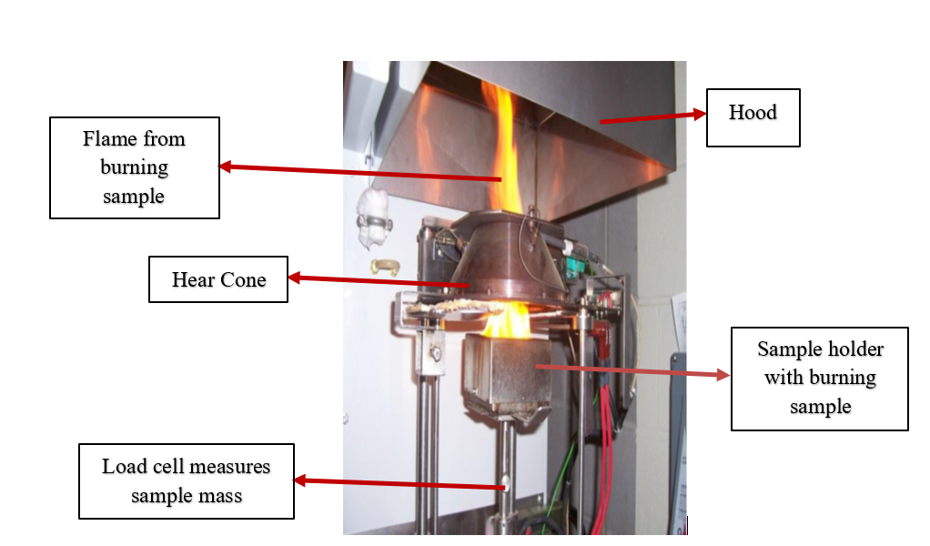
Figure 1: Section of the Cone Calorimeter showing a burning sample

Results
The heat release and the smoke production rates of the samples irradiated with external heat flux of 35 kW/m² are shown in Figure 2 (a) and (b), respectively.
The effect of the two external heat fluxes, 35 and 50 kW/m², on a sample is shown in Figure 3 (a) the Neat Ampreg21 and (b) Ampreg-0.46 wt% Bi binary composite samples. Other samples were measured in similar way.
The overall results of the thermal performance of the samples are displayed in Tables 1 and 2, for external heat flux irradiations of 35 and 50 kW/m², respectively.

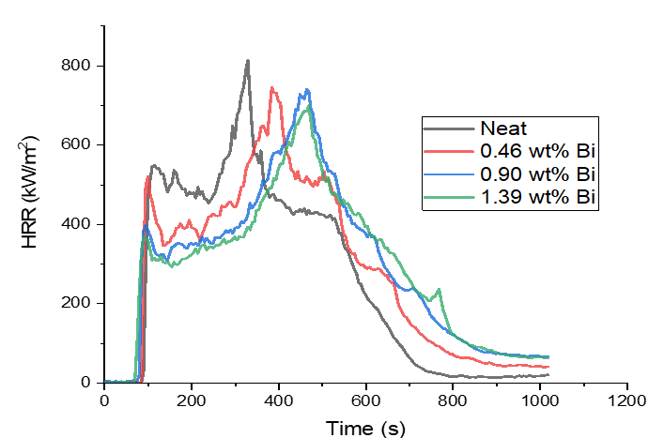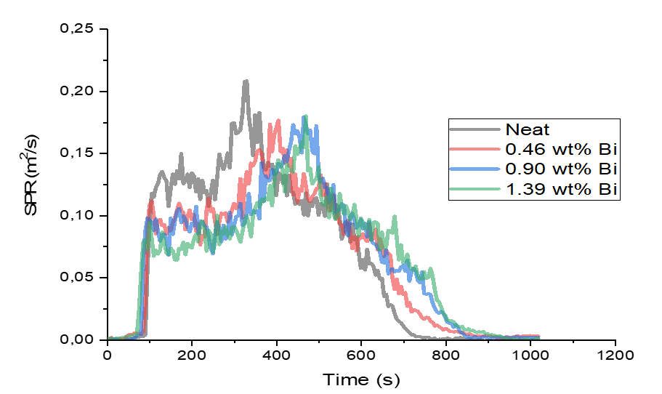
(b)
(a)
Figure 2: (a) HRR and (b) SPR profiles of samples irradiated at 35 kW/m²

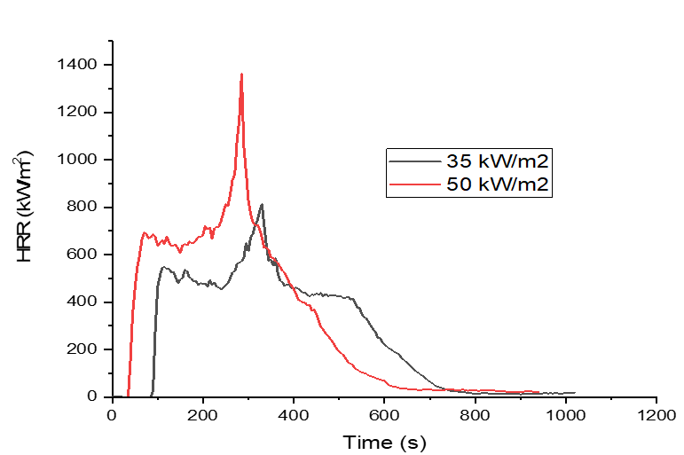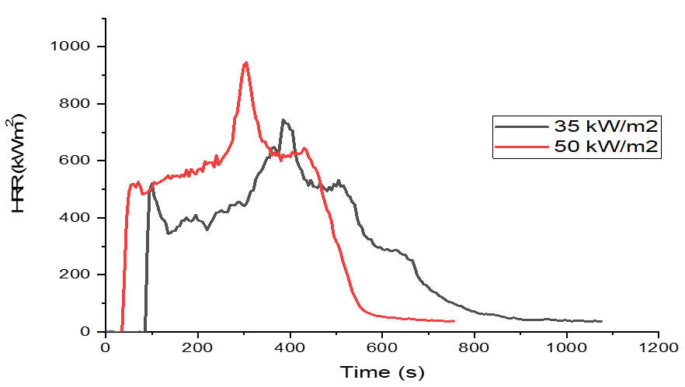
(b)
(a)
Figure 3: (a)Ampreg21neat and (b) Ampreg-0.46 wt% Bi binary composite samples irradiated at 35 and 50 kW/m²
Sample 35 (kW/m²) | Time to ignition (s) | Peak HRR (kw/m²) | FIGRA (W/s) | Peak SPR (m²/s) | SMOGRA (m²/s²) | MARHE (kW/m²)
Neat | 89 | 819.0 | 2.48 | 0.183 | 5.08 | 416.6
0.46% Bi | 89 | 745.1 | 1.94 | 0.177 | 4.37 | 408.2
0.90% Bi | 81 | 740.2 | 1.59 | 0.173 | 3.93 | 393.7
1.39% Bi | 70 | 698.9 | 1.49 | 1.180 | 3.83 | 374.0
Table 1: Thermal performance results from 35 kW/m² external flux irradiation

Sample 50 (kW/m²) | Time to ignition (s) | Peak HRR (kw/m²) | FIGRA (W/s) | Peak SPR (m²/s) | SMOGRA (m²/s²) | MARHE (kW/m²)
Neat | 89 | 819.0 | 2.48 | 0.183 | 5.08 | 416.6
0.46% Bi | 89 | 745.1 | 1.94 | 0.177 | 4.37 | 408.2
0.90% Bi | 81 | 740.2 | 1.59 | 0.173 | 3.93 | 393.7
1.39% Bi | 70 | 698.9 | 1.49 | 1.180 | 3.83 | 374.0
Table 2: Thermal performance results from 50 kW/m² external flux irradiation

Discussions
The heat release rate (HRR), Maximum Average Rate of Heat Emission (MARHE), Fire Spread Index (FIGRA) and Smoke Spread Index (SMOGRA) values determine heat safety hazard of a material.⁵ The lower the values the better the fire safety hazard. Ignition controls the flame spread and fire growth, whereas the pHRR controls the flame spread.⁶
In Figure 2 (a) and (b), the peaks of HRR and SPR decrease with increasing time for increasing Bi content in the composite. Also, the two peaks shift to the right for increasing Bi content. These are attributed to the better thermal conductivity of Bi in the matrix which allows received heat to spread inside the composite. Besides, Bi imparts stronger char-forming ability to the matrix.⁷ In addition, time to ignition, seems to decrease with increasing Bi content which further suggest the synergy of Bi in promoting aromatization structures in the condensed phase of the epoxy. Furthermore, the area under each HRR vs time profile indicates the total heat release (THR). In Figure 2(a), the neat Ampreg21 epoxy sample have the highest THR. Just like peak HRR, THR values decrease with increasing Bi additives.
Figure 3 (a) -Ampreg21 neat and (b) – Ampreg21-0.46 wt% Bi binary composite, show the role of external heat fluxes on the burning behaviour of the samples. The HRR profiles shift to the left for higher external heat flux with the corresponding shorter time-to-ignition. Also, the peak HRR decrease for smaller external heat flux. Thus, for the epoxy neat sample, Figure 3(a), irradiated by 50 kW/m², time to ignition is 38 s as compared to 89 s from the 35 kW/m² irradiation.
Just like THR, the increasing presence of Bi additives in the composites, decrease MARHE and FIGRA values of the samples.⁷ See Tables 1 and 2.
Smoke production rate (SPR) is one of the fire safety parameters in thermal investigations of a material. SPR is related to Smoke Growth Rate Index (SMOGRA) and the Total Smoke Release (TSR) of a burning sample. In the case of toxicity, for all samples irradiated by either 35 or 50 kW/m² external heat fluxes, the smoke spread, SMOGRA values decrease with increasing Bi content. One such example is shown in Figure 2(b).
Tables 1 and 2 show all the summary of the thermal performance parametric properties of the Ampreg21 neat and with Bi additives binary samples that were subjected to the two external heat fluxes of 35 and 50 kW/m². All parametric values decrease with increasing Bi content. Similar study by Xu et al.⁷ confrims the flame retardant behaviour of Bi in epoxy matrix.

Conclusions
The fire performance of the Ampreg21 epoxy-Bi composite samples have been investigated. All the fire performance parameters, namely: peak HRR, peak SPR, MARHE, FIGRA and SMOGRA, obtained from the Cone Calorimeter measurements, decrease with increasing addition of Bi nano-powder in the epoxy (from 0.46, 0.9 and 1.38 wt%). The reason being the peculiar nature of Bi: better thermal conductivity in dispersion heat received and its ability in imparting stronger char formation in the composite; thereby, serving as flame retardant in the organic Ampreg21 epoxy.

References
[1] K. Korniejenko, B. Tyliszczak, M. Łach, J. Mikuła, M. Hebdowska-Krupa and D. Mierzwiński, “Organic Polymers Reinforced Inorganic Polymers - An Overview,” IOP Conf. Ser.: Mater. Sci. Eng. doi:10.1088/1757-899X/416/1/012090, 2018.
[2] L. Guo, W. Yuan, Z. Lu, C.M. Li, “Polymer/nanosilver composite coatings for antibacterial applications,” Collision & Surface Analysis: Physicochem. Eng, Aspects, vol. 439, pp. 69-83, 2013.
[3] B. Schartel and TR Hull, "Development of fire‐retarded materials—Interpretation of cone calorimeter data," Fire and Materials, vo. 31, pp. 327-354, 2007.
[4] Q.T. Nguyen, P. Tran, T.D. Ngo and P. Mendis, "Experimental and computational investigations on fire resistance of GFRP composite for building façade," Science Direct, Composite Part B: Engineering, vol. 62, pp. 218-229, 2014.
[5] L.M. Kekana, J.K.O. Asante and B Mwakikunga, “The effect of repeated washings on thermal protective performances of one most used structural firefighting turnout gear in the Gauteng Province in South Africa,” Journal of Fire Sciences, vol. 43, no. 1, pp. 1-8, https://doi.org/10.1177/07349041241249635, 2024.
[6] T.R. Hull, “Challenges in fire testing: reaction to fire tests and assessment of fire toxicity.” In: Horrocks AR and Price D (eds) Advances in Fire Retardant Materials. Woodhead Publishing, , pp.255-290, 2008.
[7] Z.S. Xu, H.Y. Jia, L. Yan, “Synergistic effect of bismuth oxide and mono-component intumescent flame retardant on the flammability and smoke suppression properties of epoxy resins,” Polym Adv Technol vol. 31, pp. 25–35, https://doi.org/10.1002/pat.4744. 2020.

