Preliminary Investigation of the Mechanical Properties of Tissue Biopsies
Kayode Dada¹ and Risimati Mavunda¹
¹Department of Mechanical Engineering Science, University of Johannesburg, Johannesburg, South Africa

E-mail: kdada@uj.ac.za
Abstract. Cancer induction and progression have been significant challenges faced by humanity. Several procedures and methods have been used to detect the different stages within the clinical setting. However, many of these clinical tests are geared towards biochemical cues. We investigated the resected tissues from three patients (one colorectal and two breast tissues) retrieved from a biobank. A slice from each sample was cut out, attached to a disc, and placed inside a Cypher VRS atomic force microscope. The cut-out tissue was then hydrated with phosphate buffer saline. The indentation curves of the samples were then acquired and fit into the Derjaguin-Muller-Toporov model to extract the mechanical properties needed. The mean Young’s modulus obtained for the colorectal normal biopsy was 3.31±5.32 MPa, while the corresponding value for the cancer cut-out was 2.94±2.87 kPa. However, the mean values for the two breast tissues were 180.25±113.32 and 469.28±480.31 kPa. The corresponding average values of the Young’s moduli distribution of the cancer section of the breast tissues were 48.61±87.06 and 32.22±12.01 kPa, respectively. This preliminary investigation shows differences in the indentation measurements between cancer and non-cancer tissue sections, and these differences also vary with indentation spots in the tissues.

Introduction
Cancer is generally defined as a disease that results from the uncontrolled growth of cells [1]. This arises when there is a significant deficiency in or damage to the cells' deoxyribonucleic acid (DNA). The abnormal cells can either continue to grow at the primary site, invade neighbouring sites or spread to distant sites in the body [2]. Cancer is usually characterised based on the primary affected tissue or organ (such as the brain, breast, colon, cervix, skin, etc.) [2]. The induction and progression in the body have been significant challenges facing humanity over the decades. The different cancer cases have resulted in many fatalities, and the incidences around the world are still very high. A recent global observatory report, shown in Figure 1, estimates that mortalities and incidences of cancer will continue to rise. Other reports say at least one in every four or five people will develop cancer in a lifetime [3]. However, several procedures and methods are being used to detect the stages of cancer presented within a clinical setting. These include physical examination, biochemical assays, conventional X-rays, computed tomography, magnetic resonance imaging and diagnostic nuclear imaging [4, 5, 6]. Although these methods provide clinical notes on the nature of the tumour or cancer, the inherent information on the metastatic potential of the cells of the tissue is minimal. This is a challenge for physicians who only focus on eradicating the solid tumour and clearing any microscopic cells that may remain after surgery. Thus, seeking techniques that can augment the current diagnostic techniques used in a clinical environment is essential.
Biomechanics is an important technique proven to assist in understanding other diseases [7]. This has been applied to biological species at the cellular, tissue and organ levels [7, 8]. At the cellular level, different tools and techniques have been used to retrieve the vital information on the mechanical properties of the cells. These techniques include optical tweezing, micro pipetting, laser tweezing, micro particle tracking, force indentation, magnetic twisting and substrate stretching. The mechanical properties of the cells acquired include elasticity, adhesion, viscoelasticity, mechanosensing, and mechanotransduction [9]. Other reports that investigate cancer cells show that the mechanics of the cells are relevant in describing the development, progression, and metastatic nature of cancer [10, 11]. However, basic biomechanical information about the biopsy of cancer tissues is minimal.
In this study, we investigated the distribution of the mechanical properties of tissue biopsies in their native state. The biopsies were studied using an indentation tool in a liquid medium without conventional tissue processing (such as fixation, staining, and embedding). To achieve this, we used an atomic force microscope (AFM), indicated in Figure 2 (right), operated under a contact mode.
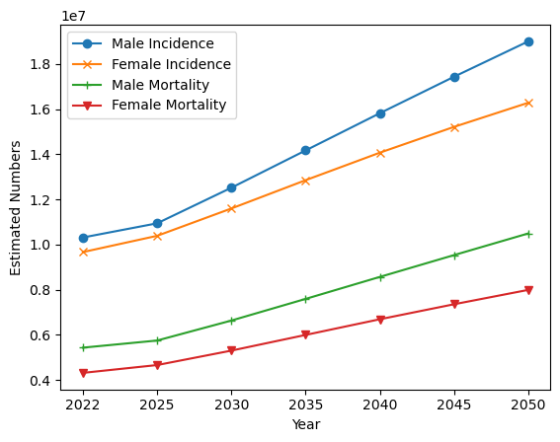
Figure 1: Estimated cancer cases between 2022 and 2050. It indicates that the incidence and mortality for both sexes will continue to increase.[12]

Materials and Methods

Materials
The tissues, shown in Figure 2 (left), used in this study were obtained from the biobank at the Obafemi Awolowo University Teaching Hospital, Nigeria. An approval to access the biopsies was granted by the ethics and research committee of the institution under the protocol number ERC/2022/01/03. In this presentation, samples from three patients (two breast and one colorectal biopsies) were analysed. It should be noted that each biopsy sample was separated into normal and cancer sections based on the pathologist's clinical judgement before being stored in the tissue bank. An Asylum Cypher High Resolution AFM and a cantilever with a spherical probe make up the setup of the indentation tool. Phosphate buffer saline (PBS) was used to create a liquid medium during indentation measurement, and formaldehyde was used to preserve the tissue after retrieval from the tissue bank until the measurement day.
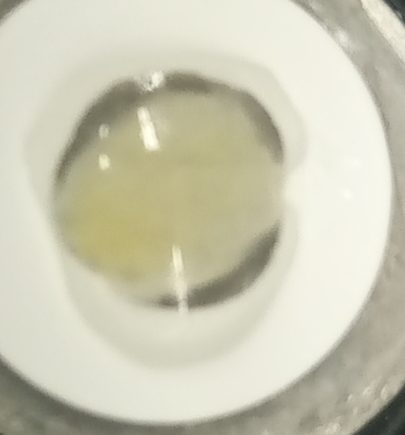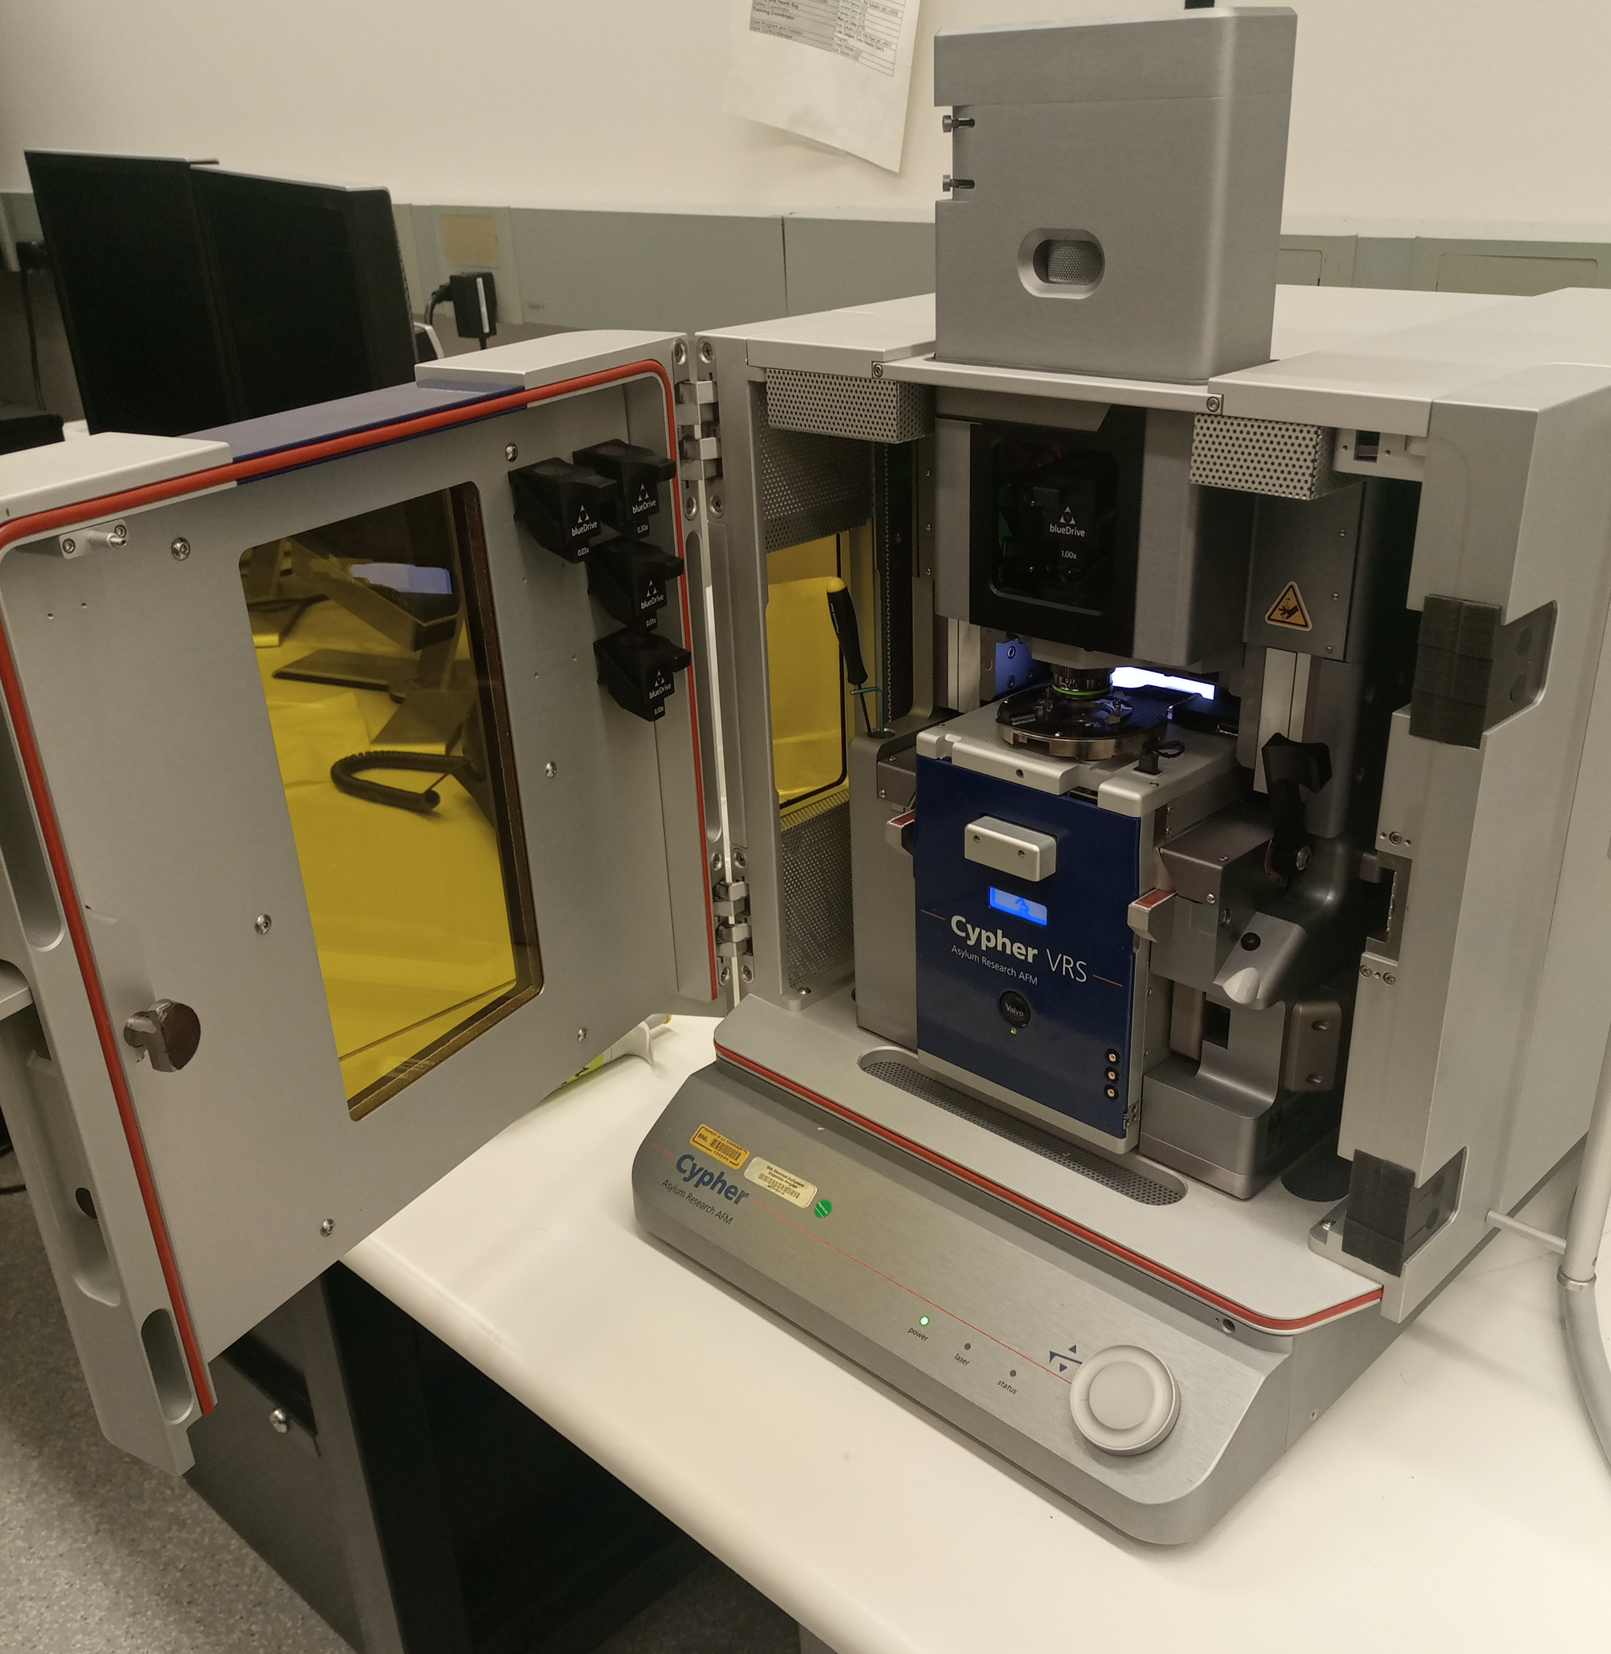
Figure 2: (left) A hydrophobic barrier was created around the tissues. (right) An Asylum Cypher AFM

Methods
The summarised workflow for the acquisition of indentation curves is subsequently shown here.
- The cantilever of the AFM was calibrated before measurement using the thermal noise method.
- The tissues obtained from the bank have already been sectioned into normal and cancer biopsies by the physicians before retrieval from the tissue bank.
- Approximately 1 mm of each resected tissue was cut out and glued to the AFM metal disc.
- About 50 µl of PBS was added to the tissue and placed on the AFM stage.
- The cantilever was carefully fitted into the holder, and then 20 µl of PBS was added to the AFM cantilever tip.
- The holder was then placed in the AFM stage. The holder was gently lowered to create a water column with the liquid on the tissue sample.
- The following basic parameters were used to scan the samples in contact mode.
  - Cantilever probe tips used: Shape (Sphere); radius (500 nm)
  - Scan size: 5 – 20 µm
  - Scan rate: 1 – 2.44 Hz
  - Setpoint: 1 V
- Due to the nature of the samples, each indentation curve was assessed before processing. Deflection-distance curves that do not indicate any possible sample indentation were excluded from further processing. The rejected cases sometimes result when the cantilever picks up some tissue samples during withdrawal.
- The indentation curves were obtained as deflection-distance curves. The curves were then processed, with AtomicJ [13], using the Derjaguin-Muller-Toporov (DMT) model [13], defined as
$P= \frac{4E√R}{3(1-ν^{2})}δ^{3/2}-2πγR$ (1)
Where E is the Young’s modulus; R is the radius of the cantilever probe; ν is the Poisson ratio, taken generally as 0.5 because of the incompressible nature of biological materials; δ is the indentation depth; and γ is the surface energy. The last term $2πγR$, represents the adhesion force.

Results and Discussion
This study examined the preliminary mechanical characteristics of three tissues resected from cancer patients. The tissues were stored in a biobank after clinical separation of the normal and cancer sections. The complete distributions of the Young’s modulus (blue colour), adhesion work (green colour) and the deformation (yellow colour) are presented in Figures 3-5.
The Young’s modulus was assessed to understand the stiffness of the tissues using a nano-indentation tool. These preliminary results show that the cancer biopsies have lower stiffness than the normal tissues. This is in tandem with previous results reported for single-cell analysis [14]. However, the distributions in Figures 3A, 4A, and 5A show that some indented spots in the normal tissues still have values that fall within the range of the distribution noted from the cancer tissues (Figures 3D, 4D and 5D). These findings imply that the stiffness at the nano-scale level for tissues obtained from cancer patients can be heterogeneous, and further analysis should be carried out to understand the extent of these overlaps. This can also mean that the mechanical signature affected by point-to-point measurement is cellular dependent rather than the whole tissue.

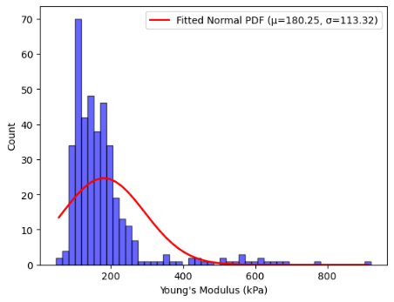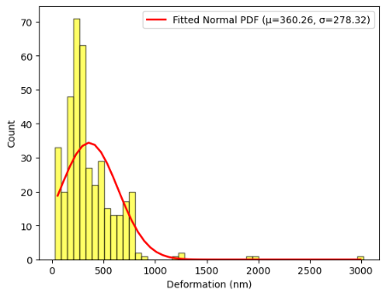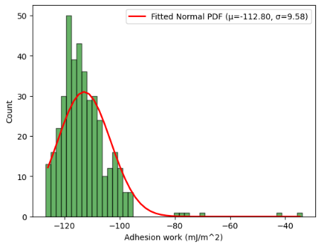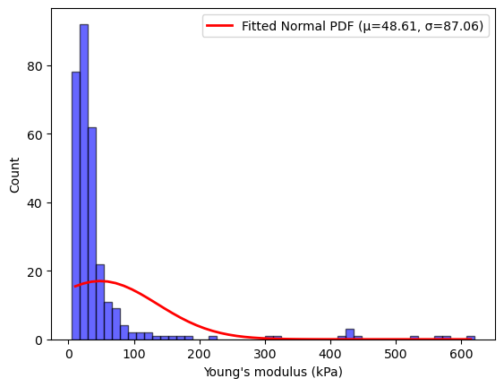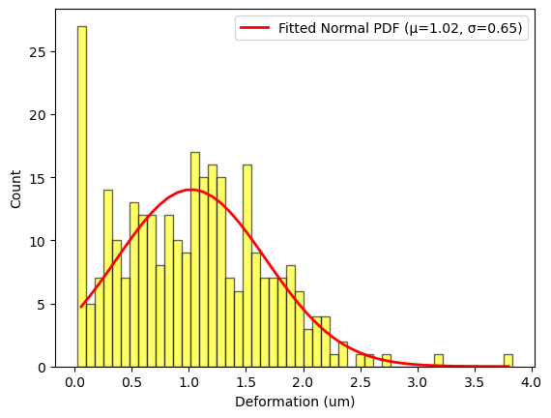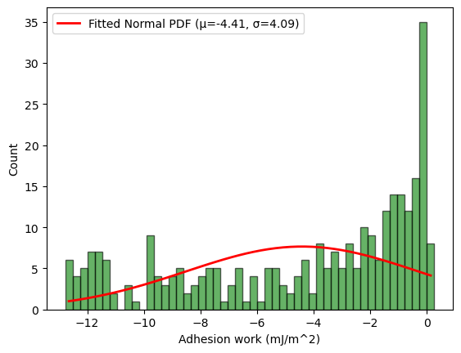
C
F
E
D
B
A
Figure 3: Distribution of the mechanical properties of breast biopsy (BP1) from a patient. (top) Histograms represent a normal tissue biopsy. (bottom): Cancer tissue biopsy
Another property examined is the extent of deformation of the samples under indentation stress. This deformation can affect cell-to-cell interaction or when a cell tries to manoeuvre through channels (e.g. vessels) with a narrower dimension. A comparison in Figure 3 (B and E) shows that the extent of deformation is well distributed for the breast cancer tissue compared to the normal tissue. Also, the mean deformation value was higher in the cancer tissues. A similar trend was observed in the colorectal tissues, as shown in Figure 5 (B and E). This may be due to the ability of the constituent cells that make up the tissue to deform under stress. This can allow the cells to disintegrate and migrate to a new site. This process is usually the hallmark of metastasis. An exception was noted with the breast biopsy measurements in Figures 4 (B and E). A previous report indicated that this may result from the alteration in the cytoskeletal architecture of the cells that form the tissue under study [14, 15]. Thus, further details of the roles of the cytoskeleton in cells extracted from such tissues are imperative.
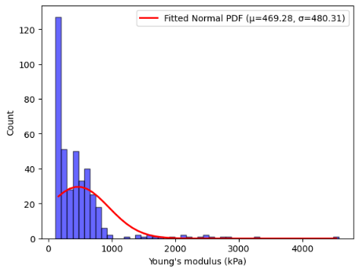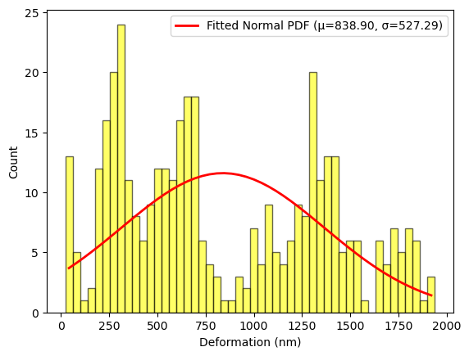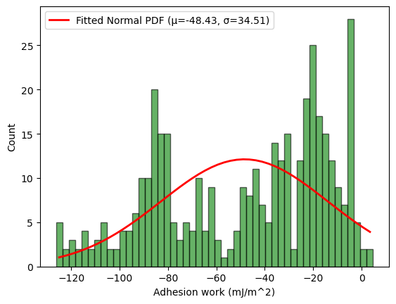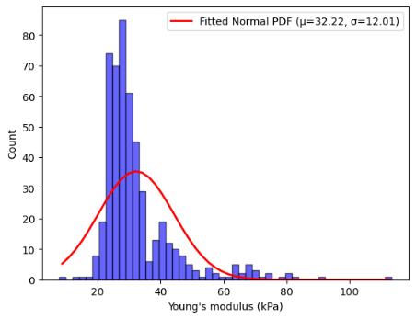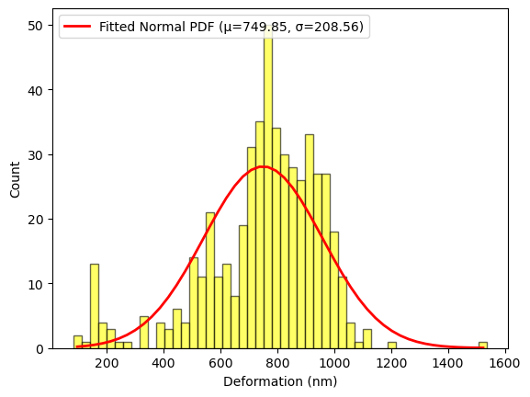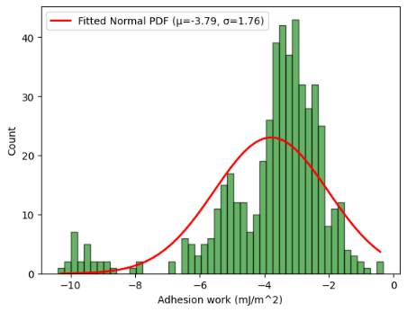
D
E
F
C
B
A
Figure 4: Distribution of the mechanical properties from breast tissue biopsy (BP2) resected from another patient. The upper part indicates the distribution for the normal biopsy, and the lower figures represent the cancer biopsy

In Figures indicated with C and F, we presented the mechanical properties that show the adhesive capacity of the samples. It represents the energy per unit area required to separate two adhering surfaces. Comparing the biopsy measurements, it was observed that the values of the work of adhesion of cancer samples are higher than those of normal tissues. This implies that the cellular components of the cancer tissues are likely to be more adhesive than their normal counterparts. Although there are some overlaps at some indented points, as shown in Figures 4 (C, F) and 5 (C, F). These overlaps also indicate that the mechanical properties of tissues are heterogeneous in nature

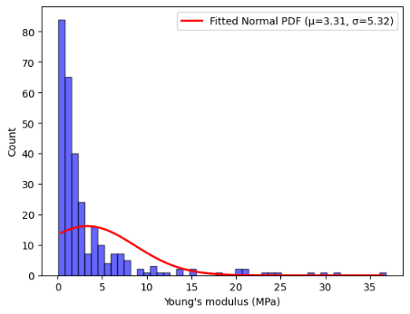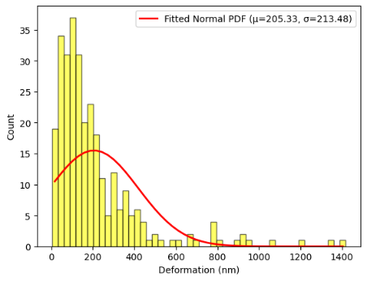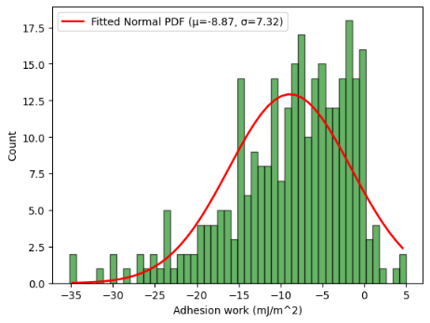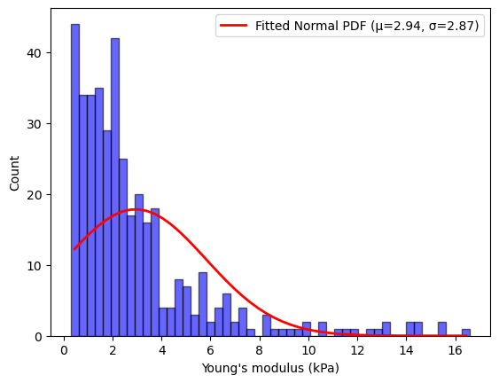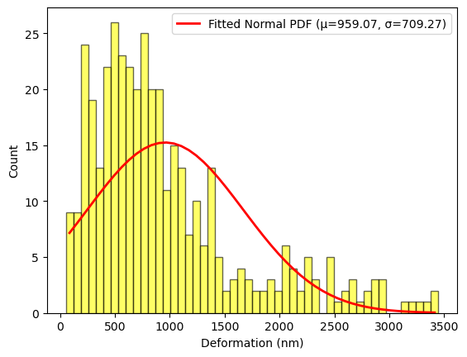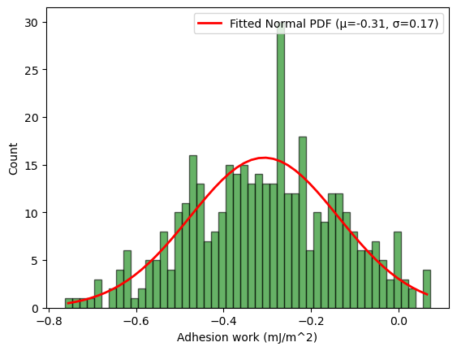
D
E
F
C
B
A
Figure 5: Distribution of the mechanical properties from a biopsy from the colorectal tissue (CRT) bank. Upper figures represent normal tissue, and the lower figures are distributions for cancer sections

Conclusion
In this paper, we have shown that the distribution of the measured mechanical parameters of tissue biopsy is essential for improved understanding of the average values of the mechanical parameters usually reported. Also, the obtained parameters depend on the type of tissue under investigation. Thus, it is crucial to understand these distributions for improved classification of cut-outs from resected tissues in clinical diagnosis.

Limitations
In this study, we could not measure the samples' topography in their native state. This limitation was experienced as the cantilever continuously gets stuck during imaging.

Acknowledgement
The authors would like to appreciate the following for their contribution to the success of this study: the Obafemi Awolowo University Teaching Hospital, Ile-Ife, Nigeria; Sentech SOC Ltd, University of Johannesburg; Nuclear Medicine Department, University of Witwatersrand; and Brookhaven National Laboratory, United States of America.

References
[1] M.-A. Majérus, “The cause of cancer: The unifying theory,” Advances in Cancer Biology - Metastasis, vol. 4, p. 100034, Jul. 2022, doi: 10.1016/j.adcanc.2022.100034.
[2] S. Gerstberger, Q. Jiang, and K. Ganesh, “Metastasis,” Cell, vol. 186, no. 8, pp. 1564–1579, Apr. 2023, doi: 10.1016/j.cell.2023.03.003.
[3] R. Zheng et al., “Global, regional, and national lifetime probabilities of developing cancer in 2020,” Sci Bull (Beijing), vol. 68, no. 21, pp. 2620–2628, Nov. 2023, doi: 10.1016/j.scib.2023.09.041.
[4] P. Gromek et al., “Revisiting the standards of cancer detection and therapy alongside their comparison to modern methods,” World J Methodol, vol. 14, no. 2, Jun. 2024, doi: 10.5662/wjm.v14.i2.92982.
[5] B. K. Prasanth, S. Alkhowaiter, G. Sawarkar, B. D. Dharshini, and A. R. Baskaran, “Unlocking Early Cancer Detection: Exploring Biomarkers, Circulating DNA, and Innovative Technological Approaches,” Cureus, Dec. 2023, doi: 10.7759/cureus.51090.
[6] T. Penzkofer and C. M. Tempany‐Afdhal, “Prostate cancer detection and diagnosis: the role of MR and its comparison with other diagnostic modalities – a radiologist’s perspective,” NMR Biomed, vol. 27, no. 1, pp. 3–15, Jan. 2014, doi: 10.1002/nbm.3002.
[7] Y. Nematbakhsh and C. T. Lim, “Cell biomechanics and its applications in human disease diagnosis,” Acta Mechanica Sinica, vol. 31, no. 2, pp. 268–273, Apr. 2015, doi: 10.1007/s10409-015-0412-y.
[8] T. Lu and C. Chang, “Biomechanics of human movement and its clinical applications,” Kaohsiung J Med Sci, vol. 28, no. 2S, Feb. 2012, doi: 10.1016/j.kjms.2011.08.004.
[9] T. P. Lele et al., “Tools to Study Cell Mechanics and Mechanotransduction,” 2007, pp. 441–472. doi: 10.1016/S0091-679X(07)83019-6.
[10] W. Yu et al., “Cancer cell mechanobiology: a new frontier for cancer research,” Journal of the National Cancer Center, vol. 2, no. 1, pp. 10–17, Mar. 2022, doi: 10.1016/j.jncc.2021.11.007.
[11] S. C. Schwager, P. V. Taufalele, and C. A. Reinhart-King, “Cell–Cell Mechanical Communication in Cancer,” Cell Mol Bioeng, vol. 12, no. 1, pp. 1–14, Feb. 2019, doi: 10.1007/s12195-018-00564-x.
[12] IARC, “Estimated numbers from 2022 to 2050, Males and Females, age [0-85+],” Available: https://gco.iarc.fr/tomorrow/en/dataviz/trends?multiple_populations=1.
[13] P. Hermanowicz, M. Sarna, K. Burda, and H. Gabryś, “AtomicJ: An open source software for analysis of force curves,” Review of Scientific Instruments, vol. 85, no. 6, Jun. 2014, doi: 10.1063/1.4881683.
[14] S. Kwon, W. Yang, D. Moon, and K. S. Kim, “Comparison of Cancer Cell Elasticity by Cell Type,” J Cancer, vol. 11, no. 18, pp. 5403–5412, 2020, doi: 10.7150/jca.45897.
[15] E. Gasser et al., “Deformation under flow and morphological recovery of cancer cells,” Lab Chip, vol. 24, no. 16, pp. 3930–3944, 2024, doi: 10.1039/D4LC00246F.
[16] T.-H. Kim et al., “Cancer cells become less deformable and more invasive with activation of β-adrenergic signaling,” J Cell Sci, vol. 129, no. 24, pp. 4563–4575, Dec. 2016, doi: 10.1242/jcs.194803.

