Electronic and elastic properties of hexagonal molybdenum disulphide
Magopa Kekana^{1*, 2}, Mokete Mahladisa¹, Malili Matshaba¹, Lucky Sikhwivhilu^{2, 3}, Bulelwa Ntsendwana², Thuto Mosuang¹

¹Department of Physics, University of Limpopo, Polokwane, South Africa
²Advanced Materials Division/Mintek, Randburg, South Africa
²Department of Chemistry, University of Venda, Thohoyandou, South Africa

E-mail: tshephomcdonald@gmail.com
Abstract. Electronic and elastic properties of hexagonal molybdenum disulphide (MoS₂) are investigated using the full-potential all electrons linearised augmented plane waves method. PBE_sol generalized gradient approximation (GGA) functional was chosen when calculating the electronic structure and elastic properties. Electronic band structure and density of states suggest a semiconductor material with an indirect narrow energy band gap of 1.45 eV pinned at the Fermi level. The GGA_PBE_Sol approach was used to compute elastic constants C₁₁, C₁₂, C₁₃, C₃₃, and C₄₄, bulk modulus (B_{o}), shear modulus (G), Young’s modulus (Y), and B_{o}/G ratio. Deviation of some parameters from related literature results has been addressed.

Introduction
Two-dimensional (2D) molybdenum disulphide (MoS₂) a family of transition metal dichalcogenides (TMDs) has attracted tremendous interest in materials technology due to its unique fascinating physical and chemical properties [1], [2]. Such interest lies in its capability to fulfil future demands in the nano-electronic industry on flexibility, adaptability, and multi-device functionality [2]. As an analogue of graphene, MoS₂ is part of a family of more than forty (40) kinds of TMDs materials with a MX₂ formula where M stands for transition metals (Mo, W) and X for chalcogens (S, Se) [2]. It is a layered structured sandwich material, where each layer consists of covalently bound S-M-S slaps, held together by weak van der Waals (vdW) forces. Shin et al. [1] and Larentis et al. [3], highlight 2D molybdenum disulphide through electronic, optical, and mechanical properties as one of the most studied TMDs with potential interest in various modern technological applications. Expanding on this material of interest, MoS₂ has excellent semiconducting (n-type) properties, with tunable energy band gaps, where bulk MoS₂ exhibits an indirect band gap of 1.29 eV [3], while turning from bulk to single layer portrays a direct band gap of 1.8 eV [4]. Furthermore, prospective applications of MoS₂ which include ﬁeld eﬀect transistors (FETs) with a large on-oﬀ ratio, applications of strong photoluminescence, and controllable valley and spin polarisation [5], all of which have being studied both theoretically and experimentally. As a member of transition metal disulphides, MoS₂ has emerged as an excellent candidate for the study of fundamental physics in 2D materials [4], [6], [7]. Various studies have been conducted on modiﬁcation of electronic and mechanical properties of MoS₂ and the related group VI TMDs [8], [9], [10]. Lu et al. [11] investigated the strain-dependent electronic and magnetic properties of 2D monolayer and bilayer MoS₂ by using first-principles calculations. Zhou et al. [10] investigated the MoS₂ based nanostructures including atomic defects, nanoholes, nanodots, and antidots with spin-polarized density functional theory. Additionally, Muratore et al. [12] reported on the thermal transport properties of MoS₂ thin films. While recently, Yuan et al. [13] investigated the phonon vibrations and thermal properties of MoS₂. The study revealed that no imaginary phonon frequency is observed in the whole Brillouin zone (BZ), indicating that the bulk MoS₂ is dynamically stable. Furthermore, the geometric and electronic structures of graphene adsorption on MoS₂ monolayer have also been studied by density functional theory [9]. However, many properties of bulk MoS₂, such as electronic and elastic properties, still lacks in-depth investigation. With the increasing interest in the advanced applications of 2D related materials such as MoS₂ especially at the nanoscale, the electronic and mechanical properties of these material become an important part in the overall evaluation of the quality and suitability of a particular application. Various 2D related materials exhibits different microstructural dynamics and defects, which make it quite challenging to examine both their electronic and elastic properties. As a result of increased complexity, novel multicomponent materials and difficulty in obtaining pure crystals of sufficient sizes, make experimental determination of electronic and mechanical properties quite a challenging task [14]. Lately, with increased computational power and much improved methodologies, density functional theory (DFT) calculations on electronic and mechanical properties of MoS₂ has reached a level of accuracy such that the calculated parameters are adequately close to measured values [15], [16]. Within all these investigations, calculation of elastic constants is out-most important due to that, many other parameters in relation to the mechanical properties can be extracted from such parameters. They are the fundamental parameters in understanding the interatomic interaction, mechanical stability, phase transitions, materials strength, and the internal structure of the materials, and much more [1], [2]. It is expected that the present study will greatly help to give in-depth analysis of this material and can be a guide for its practical applications. Furthermore, the consistent implementation of DFT calculations on 2D MoS₂ which can also be extended to other available 2D TMDs materials, will further assists the experimentalists to better asses the reliability of their data where there is unavailability of the experimental data or where there is conflicting data.

Computational details
Electronic and elastic properties calculations of hexagonal MoS₂ are based on density functional theory (DFT) employing the full potential all electrons linearized augmented plane waves method as implemented in the exciting code [17]. The Perdew-Burke-Ernzerhof for solids (PBE_sol) version of the generalized gradient approximation (GGA) [16] was used to describe the exchange correlation functional. A convincing k-points mesh of 4 x 4 x 3 having expanded the periodic basis wave-functions in the Brillouin zone produced ground state total energy of -2.63 x 10⁵ eV for GGA. A hexagonal space group P63/mmc (no: 194) symmetry crystal lattice, with the Wyckoff atomic positions occupation: Mo⁴⁺ occupying 2d⁻ (0.667 0.333 0.250); S²⁻ occupying 4f⁻ (0.667 0.333 0.633) so that a unit cell consisting of two molybdenum and four sulphur ions in 4⁺ and 2⁻ oxidation states was generated as shown in figure 1. All electron linearized plane waves calculations were performed referenced to the following individual atomic electronic states; Mo (4s² 4p⁶ 4d⁵ 5s¹) and S (3s² 3p⁴). The confirmed geometries were all optimised. Good convergence was achieved with the total energy and the number of k-points we used for the methods considered. For each intended calculation, the atomistic positions were fully relaxed according to the Hellmann– Feynman forces until the maximum atomic force was less than 0.03 eV/Å and the total energy difference was less than 1 × 10⁻³ eV/atom.
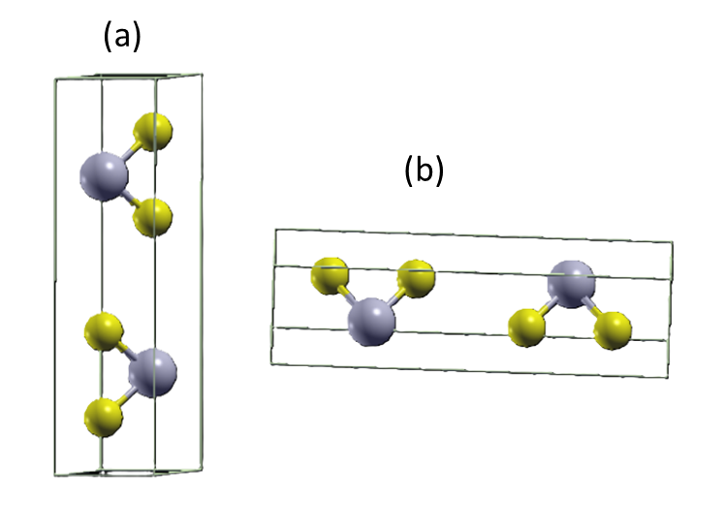
Figure 1: Visualisation of hexagonal MoS₂ were grey balls represent (Mo) and yellow balls represent (S). (a) Vertical alignment (b) horizontal alignment.

Results and discussion

Crystal structure
The structural properties of hexagonal MoS₂ crystal model were calculated based on the symmetry outlined in the methodology section. Table 1 present the calculated equilibrium lattice constants, minimum energy (E_{o}), and bulk modulus (B_{o}). The calculated lattice parameters as depicted in table 1 together will available theoretical and experimental data for comparison, clearly shows excellent agreement on hexagonal MoS₂ with the experimental [18] and theoretical [19] disclosed data, together with the studies disclosed by Shehu et al. [20]. From the data table 1, it can conclusively be drawn that, the existence of the Van der Waals forces helps in the enhancement and the performance of the calculations, which ultimately replicates the experimental results. Which is also explained by the reproducibility of the crystal symmetry c_{o}/a_{o} in comparison to theoretical and experimental data. Such findings show the consistency and the reliability of the GGA correlation functional in prediction of various properties of hexagonal phased systems.
 | a_{o} [Ă] | b_{o} [Ă] | c_{o} [Ă] | c_{o}/a_{o} | E_{o} [eV] | B_{o} [GPa]
Present calculations | 3.141 | 3.141 | 12.516 | 3.984 | -2.64 x 10⁻⁵ | 82.28
Other calculations [19] | 3.199 | 3.199 | 12.493 | 3.905 | -4.99 x 10³ | 63.36
Experiments [18] | 3.160 | 3.160 | 12.295 | 3.890 | - | -
Table 1: Equilibrium parameters of the hexagonal MoS₂. a, b, and c are lattice parameters. E_{o} and B_{o} are minimum energy and bulk modulus respectively.

Electronic properties
The band structure and density of states (DOSs) play an important role when analysing electronic properties of materials. When investigating the electronic properties, the first notion to consider is the band structure as depicted in figure 2. It can be observed that there is an energy gap between the valence and conduction bands at the Fermi level of about 1.45 eV, which suggest that MoS₂ exhibit a narrow band gap. The results were found to be slightly higher than the reported experimental value of 1.29 eV disclosed by Peelaers and Van de Walle [3], however, that is lower than the gap reported by Xiaofeng F et al. [21] of 1.65 eV, calculated using GGA and experimentally measured energy gap (1.8 eV) [4].
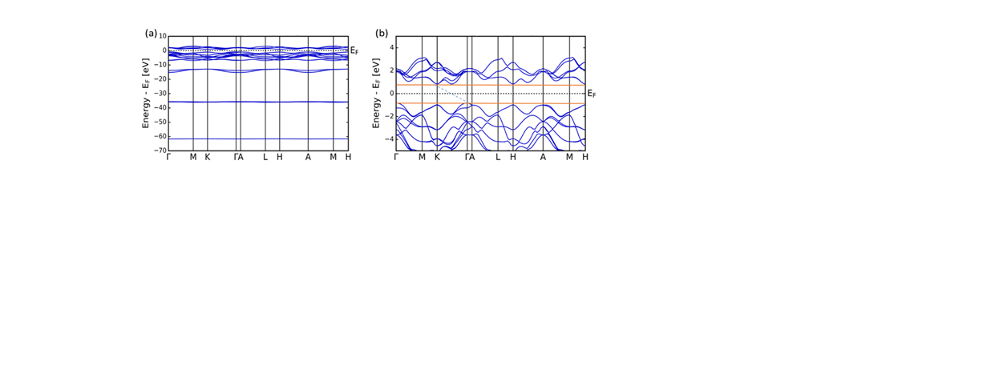
Figure 2: (a) The whole band structure of hexagonal MoS₂ and (b) the zoomed version of band structures of hexagonal MoS₂ around the fermi level under GGA at 0 GPa respectively.
In fact, the underestimation of the band gap is a well-known drawback of GGA calculations [22]. From this figure, it can be observed that the bottom of the conduction band and the top of the valence band are not at the same k-point. Such stature is invoked by the eminent intraband relaxation of electrons or holes in a semiconductor, which is influenced by the increase in the number of layers from mono-, bi-, multi- to bulk-layers [4]. Thus, it results in the alterations or change in the band order between the upper and the lower band which leads to the weakness or non-observant of the luminescence in association with the excitation states, hence the material portrays the indirect band gap semiconducting properties [4]. The DOS are an important tool for understanding the bonding properties and their contribution in the electronic properties of the material. Therefore, the total DOS of hexagonal MoS₂ were also calculated as shown in figure 3. From figure 3 the TDOS of hexagonal` MoS₂ can be divided into three sections. In the valence band, there are two regions; a large band located at: -5.5 to -2.1 eV and a very tiny band: -1.8 to -1.2 eV. In the conduction band, the bands occupy the region 0.9 to 2.9 eV. As evident from the TDOS of hexagonal MoS₂, it can be concluded that a high flux of electrons density is located in the valence band, with core electrons occupying the lowest large band: -5.5 to -2.1 eV. Some of the valence electrons densities occupy the tiny valence band region: -1.8 to -1.2 eV, whilst other can be obtained at the conduction band region: 0.9 to 2.9 eV. The DOS of hexagonal MoS₂ was disclosed by Wei et al. [23], were in their study they reported on five (5) regions of DOS of hexagonal MoS₂ while it is disclosed only on three (3) regions of DOS of hexagonal MoS₂. Consequently, in the present study it was found to compare well with their study only on the three (3) regions (C, D and E) of their study, which shows a great concurrence and good predictions in examining the bonding properties hexagonal MoS₂.
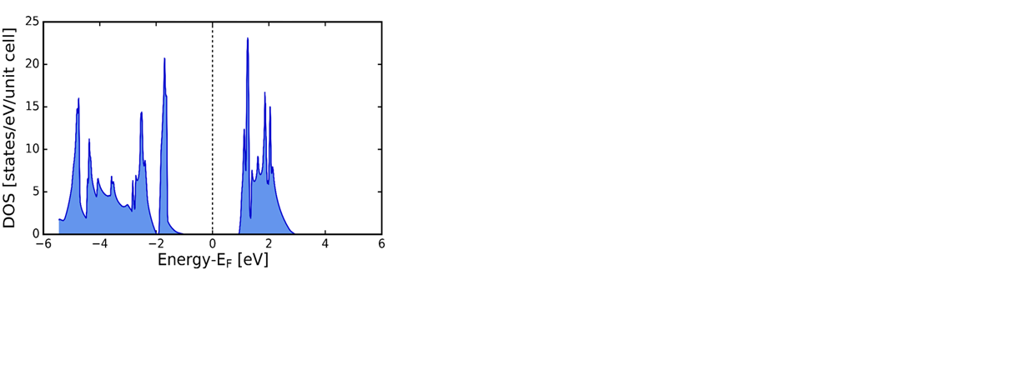
Figure 3: The total density of states (TDOS) of hexagonal MoS₂.

Elastic properties
The elastic constant (C_{ij}) are an important tool for examining the mechanical properties of various materials, especially for 2D hexagonal MoS₂ in relation to its special application conditions such as internal strain and thermo-elastic stress. Elastic stiffness tensor is related to stress tensor and strain tensor by Hooke’s law. The elastic constants C_{ijkl} with respect to the finite strain variables are defined [24] as:
$C_{ijkl} = {\left(\frac{{∂σ}_{ij}\left(x\right)}{{∂e}_{kl}}\right)}_{X}$ (1)
where σ_{ij} and e_{kl} are the applied stress and Eulerian strain tensors, and X and x are the coordinates before and after the deformation, respectively. Elastic tensor C_{ijkl} is known to have 21 independent components. But, taking into account of the crystal symmetry of a material, this number can be reduced. Currently, for the 2D hexagonal structured MoS₂, those independent components are reduced to five components, i.e., C₁₁, C₁₂, C₁₃, C₃₃, and C₄₄. The mechanical stability criteria for hexagonal structured systems are defined by:
$Ĉ_{44}>0, Ĉ_{11}>\left|Ĉ_{12}\right|, Ĉ_{33}\left(Ĉ_{11}+Ĉ_{12}\right)>2Ĉ_{13}^{2}$ (2)
The obtained results of the C_{ij} in the current study were all calculated at 0 GPa as depicted in table 2, together with experimental and theoretical disclosed data [23], [25]. Furthermore, the calculated elastic constants are positive as demonstrated in table 2, indicating that the system is stable and that the material satisfy the Born mechanical stability limitations as outlined by equation (2). Which were then found to be in good accord with the disclosed experimental and theoretical findings. Additionally, the other properties that are known to affect the physical quality of a material are bulk modulus (B_{o}), Young’s modulus (Y) and shear modulus (G). B_{o} is known to be closely related to the cohesive energy, which is used to define the average atomic bond strength of the system [26]. The Y is used to measure the stiffness of a solid as a function of atomic bond strength [27], while the G is assigned to define the hardness of a material [28]. Moreover, Pugh et al. [29] proposed the ratio ${B_{0}}/G$ to describe the ductility and brittleness of a material, as a result of the assumption made of B_{o} to constitute the resistance to fracture deformation while the G outlines the resistance to plastic deformation. The criteria value of the ratio that separates ductile and brittle materials is about 1.75. So, if the ratio ${B_{0}}/G$ > 1.75, the material is set to be ductile, while if ${B_{0}}/G$ <1.75, the material is set to be brittle. In the current work, as outlined in table 2, the ratio ${B_{0}}/G$ (1.44) is less than the criteria value 1.75 which indicate that hexagonal MoS₂ is brittle at 0 GPa. Which was as well found to be in good agreement with the results disclosed by Yuan et al. [30].
 | Present | GGA [31] | LDA [30] | VdW-DF2 [20] | Experimental [25]
C₁₁ | 257.895 | 211.221 | 240.690 | 207.42 | 238
C₁₂ | 63.495 | 49.380 | 53.640 | 60.75 | -54
C₁₃ | 2.465 | 3.078 | 8.500 | 20.49 | 23
C₃₃ | 87.88 | 36.735 | 56.110 | 68.87 | 52
C₄₄ | 5.47 | 30.043 | 26.100 | 28.17 | 19
B_{o} | 82.28 | 63.361 | 50.860 | 65.56 | 47.65 ± 0.3
Y | 139.54 | 199.525 | 107.381 | 111.51 | -
G | 57.311 | 55.111 | 46.76 | 45.84 | -
$${B_{0}}/G$$ | 1.44 | 1.14 | 1.09 | 1.43 | -
Table 2: The calculated elastic constants C_{ij} (GPa)together with elastic bulk modulus (B_{o}) (GPa), Young’s modulus (Y) (GPa), shear modulus (G) (GPa) and ${B_{0}}/G$ of hexagonal MoS₂ at 0 GPa respectively.

Conclusion
The study investigated the structural, electronic and elastic properties of hexagonal MoS₂ using first principles calculations within the GGA correlation functional. The calculated lattice parameters were found to be in good agreement with both theoretical and experimental disclosed data. The calculated band gap energy of hexagonal MoS₂ was obtained to be 1.45 eV portraying indirect n-type semiconductor. However, the correlations have overestimated the band gap in relations to other theoretical and experimental findings. The analysis on the DOS indicates that there is a flux of electrons density located in the valence band. Which is a great property for the enhancement of the material’s atelicity. Lastly, mechanical properties demonstrated that the system is mechanical stable and convey the ductility characteristics which were all found to be in good accord with reported experimental and theoretical disclosed data. The internal analysis of such properties, and their agreement with various studies conveniently convoy the growing interest in atomically thin layers of transition-metal dichalcogenides as well as their potential advantages and challenges, particularly in sensing, energy and optoelectronic devices. Such knowledge, helps the academics and industrialists to precisely asses both experimental and theoretical findings in a viable way to conceive more suitable and sustainable materials for high-tech applications including optoelectronic, sensing and energy. The present study accurately shares a fragment of such knowledge.

References
[1] S. Shin, B., Zhu, Y., Bojarczuk, N.A., Jay Chey, S. and Guha, “No TitleControl of an interfacial MoSe2 layer in Cu2ZnSnSe4 thin film solar cells: 8.9% power conversion efficiency with a TiN diffusion barrier,” Appl. Phys. Lett., vol. 5, no. 101, (2012).
[2] A. . Wilson, J.A. and Yoffe, “The transition metal dichalcogenides discussion and interpretation of the observed optical, electrical and structural properties,” Adv. Phys., vol. 73, no. 18, pp. 193–335, (1969).
[3] H. Peelaers and C. G. Van De Walle, “Effects of strain on band structure and effective masses in MoS2,” Phys. Rev. B - Condens. Matter Mater. Phys., vol. 86, no. 24, p. 241401, (2012).
[4] K. F. Mak, C. Lee, J. Hone, J. Shan, and T. F. Heinz, “Atomically thin MoS2: A new direct-gap semiconductor,” Phys. Rev. Lett., vol. 105, no. 13, p. 136805, (2010).
[5] D. Xiao, G. Bin Liu, W. Feng, X. Xu, and W. Yao, “Coupled spin and valley physics in monolayers of MoS 2 and other group-VI dichalcogenides,” Phys. Rev. Lett., vol. 108, no. 19, p. 196802, (2012).
[6] W. Zheng, X. Liu, J. Xie, G. Lu, and J. Zhang, “Emerging van der Waals junctions based on TMDs materials for advanced gas sensors,” Coordination Chemistry Reviews, vol. 447. p. 214151, (2021).
[7] Y. Ravi Kumar, K. Deshmukh, T. Kovářík, and S. K. Khadheer Pasha, “A systematic review on 2D materials for volatile organic compound sensing,” Coord. Chem. Rev., vol. 461, (2022).
[8] H. Zeng, G. Bin Liu, J. Dai, Y. Yan, B. Zhu, R. He, L. Xie, S. Xu, X. Chen, W. Yao, et al., “Optical signature of symmetry variations and spin-valley coupling in atomically thin tungsten dichalcogenides,” Sci. Rep., vol. 3, no. 1, p. 1608, (2013).
[9] Y. Ma, Y. Dai, M. Guo, C. Niu, and B. Huang, “Graphene adhesion on MoS2 monolayer: An ab initio study,” Nanoscale, vol. 3, no. 9, pp. 3883–3887, (2011).
[10] Y. Zhou, P. Yang, H. Zu, F. Gao, and X. Zu, “Electronic structures and magnetic properties of MoS2 nanostructures: Atomic defects, nanoholes, nanodots and antidots,” Phys. Chem. Chem. Phys., vol. 15, no. 25, pp. 10385–10394, (2013).
[11] P. Lu, X. Wu, W. Guo, and X. C. Zeng, “Strain-dependent electronic and magnetic properties of MoS 2 monolayer, bilayer, nanoribbons and nanotubes,” Phys. Chem. Chem. Phys., vol. 14, no. 37, pp. 13035–13040, (2012).
[12] C. Muratore, V. Varshney, J. J. Gengler, J. Hu, J. E. Bultman, A. K. Roy, B. L. Farmer, and A. A. Voevodin, “Thermal anisotropy in nano-crystalline MoS2 thin films,” Phys. Chem. Chem. Phys., vol. 16, no. 3, pp. 1008–1014, (2014).
[13] J. Yuan, Z. Lv, Q. Lu, Y. Cheng, X. Chen, and L. Cai, “First-principles study of the phonon vibrational spectra and thermal properties of hexagonal MoS2,” Solid State Sci., vol. 40, pp. 1–6, (2015).
[14] Y. Kawazoe, “Can ab initio simulation really predict properties of materials prior to experimental,” Bull. Mater. Sci., vol. 22, no. 5, pp. 901–904, (1999).
[15] A. D. Becke, “Density-functional exchange-energy approximation with correct asymptotic behavior,” Phys. Rev. A, vol. 38, no. 6, pp. 3098–3100, (1988).
[16] J. P. Perdew, K. Burke, and M. Ernzerhof, “Generalized gradient approximation made simple,” Phys. Rev. Lett., vol. 77, no. 18, pp. 3865–3868, (1996).
[17] C. Vorwerk, B. Aurich, C. Cocchi, and C. Draxl, “Bethe-Salpeter equation for absorption and scattering spectroscopy: Implementation in the exciting code,” Electron. Struct., vol. 1, no. 3, p. 037001, (2019).
[18] J. P. Perdew, A. Ruzsinszky, G. I. Csonka, O. A. Vydrov, G. E. Scuseria, L. A. Constantin, X. Zhou, and K. Burke, “Restoring the density-gradient expansion for exchange in solids and surfaces,” Phys. Rev. Lett., vol. 100, no. 13, p. 136406, (2008).
[19] C. Ataca, H. Şahin, E. Aktuörk, and S. Ciraci, “Mechanical and electronic properties of MoS2 nanoribbons and their defects,” J. Phys. Chem. C, vol. 115, no. 10, pp. 3934–3941, (2011).
[20] S. A. Yamusa, A. Shaari, N. A. M. Alsaif, I. M. Alsalamah, I. Isah, and N. Rekik, “Elucidating the Structural, Electronic, Elastic, and Optical Properties of Bulk and Monolayer MoS2Transition-Metal Dichalcogenides: A DFT Approach,” ACS Omega, vol. 7, no. 49, pp. 45719–45731, (2022).
[21] X. Fan, C. H. Chang, W. T. Zheng, J. L. Kuo, and D. J. Singh, “The electronic properties of single-layer and multilayer MoS2 under high pressure,” J. Phys. Chem. C, vol. 119, no. 19, pp. 10189–10196, (2015).
[22] M. Orio, D. A. Pantazis, and F. Neese, “Density functional theory,” Springer, vol. 102, no. 2, pp. 443–453, (2009).
[23] W. Wei, L., Jun-fang, C., Qinyu, H. and Teng, “Electronic and elastic properties of MoS2,” Phys. B Condens. Matter, vol. 405, no. 10, pp. 2498–2502, (2010).
[24] D. C. Wallace and H. Callen, “Thermodynamics of Crystals,” Am. J. Phys., vol. 40, no. 11, pp. 1718–1719, (1972).
[25] J. L. Feldman, “Elastic constants of 2H-MoS2 and 2H-NbSe2 extracted from measured dispersion curves and linear compressibilities,” J. Phys. Chem. Solids, vol. 37, no. 12, pp. 1141–1144, (1976).
[26] K. A. Gschneidner, “Physical Properties and Interrelationships of Metallic and Semimetallic Elements,” Solid State Phys. - Adv. Res. Appl., vol. 16, no. C, pp. 275–426, (1964).
[27] A. Q. Morrison, E. D. Case, F. Ren, A. J. Baumann, D. C. Kleinow, J. E. Ni, T. P. Hogan, J. D’Angelo, N. A. Matchanov, T. J. Hendricks, et al., “Elastic modulus, biaxial fracture strength, electrical and thermal transport properties of thermally fatigued hot pressed LAST and LASTT thermoelectric materials,” Mater. Chem. Phys., vol. 134, no. 2–3, pp. 973–987, (2012).
[28] D. M. Teter, “Computational alchemy: the search for new superhard materials,” MRS Bull., vol. 23, no. 1, pp. 22–27, (1998).
[29] S. F. Pugh, “XCII. Relations between the elastic moduli and the plastic properties of polycrystalline pure metals,” London, Edinburgh, Dublin Philos. Mag. J. Sci., vol. 45, no. 367, pp. 823–843, (1954).
[30] J. N. Yuan, Y. Cheng, X. Q. Zhang, X. R. Chen, and L. C. Cai, “First-principles study of electronic and elastic properties of hexagonal layered crystal MoS2 under pressure,” Zeitschrift fur Naturforsch. - Sect. A J. Phys. Sci., vol. 70, no. 7, pp. 529–538, (2015).
[31] L. Wei, C. Jun-fang, H. Qinyu, W. T.-P. B. C. Matter, and undefined 2010, “Electronic and elastic properties of MoS2,” Elsevier.

Acknowledgements
The authors wish to acknowledge the University of Limpopo (UL) and Mintek for financial support. Centre for High Performance Computing (CHPC) is recognised for research facilities.

