Design of a slotted Invelox-based wind delivery system for domestic low wind speed operation.
Anesu Chitura¹, Ngwarai Shambira¹ and Patrick Mukumba¹
¹Department of Computational Sciences, Faculty of Science & Agriculture, University of Fort Hare, Alice 5700, South Africa
E-mail: 201714884@ufh.ac.za
Abstract. Features such as the omni directional intake, the nozzle-diffuser section as well as the diffuser section of the Increased velocity (Invelox) wind delivery system augment incident air to a cut in wind speed of most small-scale wind turbines systems. Despite these properties, the Invelox delivery systems suffers from adverse pressure gradient leading to flow separation within the throat section. This significantly reduces the suction capacity of the intake thus diminishing aerodynamic performance of the system. Amid other scholars that have researched to improve it, this study modified the original Invelox setup by employing a multi-element diffuser section. The aim is to improve the expansion area and subsequently avoid flow separation on the diffuser wall. The geometry was developed and simulated in an OPEN FOAM environment where the effect to the performance of the Invelox system as well as the augmented velocity is then observed. The results show an improved pressure gradient leading to an improved flow profile within the diffuser. The introduction of a slot was shown to improve the speed up ratio of the throat thus emphasising the potential of the improvement. The 9% improvement in velocity augmentation proved potential and pointed to more optimisation to realise even better augmentation.

Introduction

Residential wind energy conversion is increasingly vital for generating distributed power and reducing reliance on fossil fuels. In the context of global efforts to lower carbon emissions and combat climate change, wind power offers a clean alternative. However, wind applications in residential areas face key challenges, including low wind speeds and high turbulence due to surrounding buildings. At Fort Hare University, the area under study, average wind speeds are typically below 3 m/s as investigated by [1]. Under such low wind conditions, even turbines designed for low-speed performance, such as the Savonius type, fail to start, as the available wind energy is insufficient to overcome their cut-in speed threshold. The wind resource is too weak for off-the-shelf small-scale wind turbines to operate effectively on their own. To address this limitation, an augmentation or interfacing device is necessary to improve the velocity and quality of the incoming wind. A wind delivery system serves this purpose by increasing wind velocity and quality, enabling the turbine housed within to operate more smoothly and reliably.
The concept of using augmentation devices to bridge the gap between slow-moving wind and turbines with higher cut-in speeds has gained attention in residential wind applications. Diffuser-based wind turbine shrouds have been widely studied for this purpose [2]. For example, [2] used the simplex algorithm to optimize the shape of a diffuser, achieving a 1.76-fold increase in incident wind speed. Key geometric parameters such as flange height and angle were identified as critical to performance, with [3] using Design of Experiments and one-factor-at-a-time methods to narrow down the most influential design variables to three, highlighting the importance of interactional effects. In addition to diffusers, concentrators (or nozzles) have been explored as augmentation devices [4,5], and combinations of concentrator-diffuser systems have been examined by [6]. Such systems address the interaction between geometric elements, with [6] analyzing the relationship between augmented throat velocity and six parameters in a concentrator-diffuser configuration, resulting in an increase in wind speed by a factor of 1.953. Efforts have also been made to integrate wind turbines directly into building structures, using the building itself as a shroud to augment wind speeds [7]. Among such systems, the Invelox wind delivery system is considered one of the most promising. It features a raised omnidirectional intake that removes the need for yaw mechanisms, channels wind through a funnel, bends toward a nozzle and throat (where the turbine is placed), and exhausts the used wind through a gradually expanding diffuser [8]. Although effective, the system faces challenges such as escaping air, recirculation, and flow separation [9].
This study aims to enhance wind augmentation in the throat region by modifying the Invelox system with a multi-slot diffuser. By incorporating a multi-slot diffuser into the conical section, this design addresses these issues by directing energetic air streams to control the boundary layer along the diffuser walls, thereby delaying or preventing flow separation. The aerodynamic performance is analysed using an empty wind delivery system, without a turbine, to isolate the effect of the diffuser modification.

Mathematical framework
As a fluid, free-stream moving air possesses kinetic energy. This total energy ($e$) is represented by Equation 1.

$$e=\frac{p}{ρ}+\frac{|v|^{2}}{2}=\frac{P_{0}}{ρ}$$ | (1)

After air is collected by the omnidirectional intake of the INVELOX system, it is directed toward the nozzle-diffuser section. In the throat section, work is done by the air on the turbine blades, converting its energy into mechanical energy. Before reaching the turbine blades, the airflow experiences shear losses, which can be neglected for simplicity. Thus, the power in the wind passing through the INVELOX system can be expressed as in Equation 2.
$$Power=η\dot{Q}\left[P_{atm}-P_{out}\right]+ρ\frac{V_{in}^{2}}{2}-ρ\frac{V_{out}^{2}}{2}$$ | (2)

Equation 2 above highlights the two main mechanisms through which the INVELOX system extracts power from incident wind. These are: (1) the increase in kinetic energy, represented by the term $ρ\frac{V_{in}^{2}}{2}-ρ\frac{V_{out}^{2}}{2}$, and (2) the change in potential energy as the wind flows from the inlet to the outlet. These two effects enable INVELOX turbines to harness more power than conventional bare wind turbines.

Materials and Methods

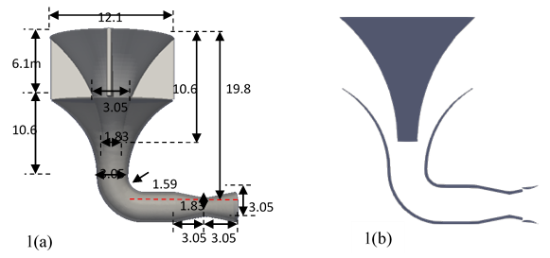
The geometry of the Increased Velocity (INVELOX) wind delivery system was developed using Shaper within the Salome platform. This original geometry served as the basis for constructing a modified version of the system, incorporating structural enhancements to improve wind augmentation. To validate the simulation approach and software configuration, a replica of the original INVELOX design was created, meshed, and used to conduct a grid independence study following standard practices [10].
Figure 1. Dimensions and design of the original Invelox system as adapted from [8]

The improved version features a slot at the throat section of the INVELOX system, as shown in Figure 1(b), along with an E432 airfoil-shaped diffuser. This configuration helps avoid a sudden pressure change at the throat section and subsequently prevents choking of the delivery system. This modification is expected to enhance flow within the system, thereby improving the augmentation of incident wind.

  - Mesh Development, grid independence check, and validation
The goal of the mesh independence study was to establish a mesh that meets all quality requirements while eliminating mesh sensitivity and minimizing computational cost in terms of time and resources. The mesh size was varied from 670294 to 1848672 cells, up to the point where less than 1% change was observed in the results.
A mesh consisting of 1542645 cells was selected, with a non-orthogonality of 63 and a skewness of 3.04, values considered very good for high-quality meshing in Openfoam. A length scale of 1 m was adopted for the geometrical setup, and an upstream wind speed of 6.7 m/s was used, in line with values reported in the literature [11]. Prism layers were applied along wall boundaries to maintain an operational y⁺ value of 35, which falls within the logarithmic region of the boundary layer. The k–ε turbulence model was chosen for the simulations due to its suitability for high Reynolds number flows. Figure 2 presents the mesh independence results for the 12 cases studied, with the selected mesh indicated by a star marker. The figure also compares the current results with those from previous research by other scholars.
Figure 2. Mesh independence testing.

CFD simulation set up
Computational Fluid Dynamics (CFD) was used to analyse the influence of geometric parameters on wind speed augmentation at the INVELOX throat section. This method utilises statistical decomposition, wherein the local value of a flow variable is expressed as the sum of a mean and its fluctuating component. Applying this decomposition to the Navier–Stokes equations leads to the Reynolds-Averaged Navier–Stokes (RANS) formulation:

Continuity Equation:

$$∇.\overline{\text{U}}=0$$ | (3)
Momentum Equation:

$$\frac{∂\overline{U}}{∂t}+∇_{∙}\left(\overline{U\overline{U}}\right)=g-∇\overline{p}+∇_{∙}\left(ν∇\overline{U}\right)+\overline{{\text{U}}^{\text{'}}{\text{U}}^{\text{'}}}.$$ | (4)

The term $\overline{{\text{U}}^{\text{'}}{\text{U}}^{\text{'}}}$represents the Reynolds stress tensor, which accounts for turbulent fluctuations.
Numerical simulations were performed using the SimpleFoam solver in Openfoam under steady-state conditions. The flow medium was limited to air, with a velocity inlet of 6.7 m/s, a pressure outlet of zero-gauge pressure, and no-slip wall conditions applied to all solid surfaces. A realisable k–ε turbulence model was used to better accurately simulate recirculating and separated flows. The SIMPLE algorithm was applied for pressure–velocity coupling along with moderate under-relaxation factors to ensure stability and convergence. For numerical discretisation, the Least Squares Cell-Based method was used for gradient calculations, while second-order discretisation schemes were employed for pressure, momentum, and turbulence equations to enhance solution fidelity. A bounded Gauss linear upwind scheme was used for divergence terms, Gauss linear for gradient terms, and Gauss linear corrected for Laplacian terms to account for mesh non-orthogonality and improve numerical accuracy.

Results and Discussion

The chosen mesh as outlined in the previous section was simulated and part of the results are shown in Figure 3 below. I Figure 3 (a), streamlines present how air escapes the intake and only a fraction of the air is drawn into the system. Some of the air steams that do enter the omnidirectional intake gets misdirected and develop recirculation areas as shown in figure 3 (b). The vector plots in Figure 3 (b) highlight the density of streamlines as well as the direction in which the travel as they move through the INVELOX setup. Dense vectors can be seen around the shoulders of the bottom funnel as well as in the diffuser sections which is consistent with what other scholars observe.
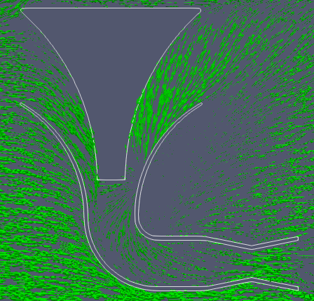
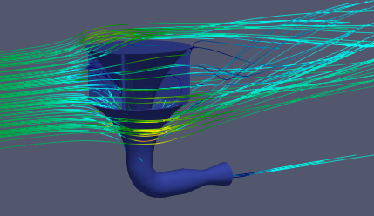
3(a)
3(b)

Figure 3. Simulation of the chosen solution.

The chosen solution was simulated using the same settings as the original setup, with the only modification being reducing the upstream wind speed to 3 m/s to mimic flow rates found in residential areas, which better suited our study area. Figures 4 (a) – 4 (d) compare the throat section of the original configuration with the modified one. The pressure plots (Figures 4 (a) and 4 (b) show a greater reduction in pressure as the flow constricts at the throat, indicating an improvement in flow velocity in accordance with Bernoulli's principle. The lighter colour scheme in the modified version illustrates the extended region of pressure reduction compared to the original. Similarly, the velocity profiles (Figures 4 (c) and 4 (d) display a more pronounced darker colour, suggesting a slight increase in velocity at the throat section due to the addition of a slot in the nozzle-diffuser section of the INVELOX system. To validate this observation, a horizontal line was drawn across the pressure field and a 100-point plot over this line is presented in Figure 5. Likewise, a vertical line was drawn at the throat section of both the original and improved setups. Figure 5 compares the pressure and velocity distributions along a horizontal line through the centre of the venturi section. The slotted version shows an increase in peak velocity from 3.19 m/s to 3.48 m/s and a deeper pressure drop from −4.86 Pa to −5.56 Pa. Notably, the slotted version exhibits improved pressure recovery, returning to values similar to the original INVELOX setup despite the greater initial drop. This suggests the potential for using a shorter diffuser, which would be advantageous in spatially constrained installations [12].
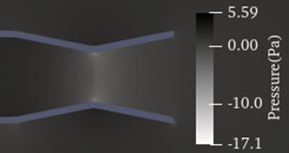
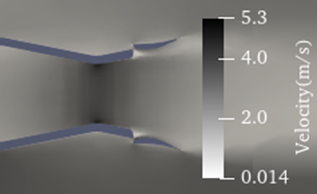
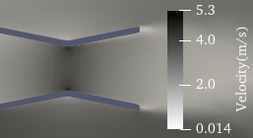
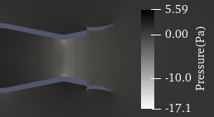
Figure 4.Throat section comparisons between the slotted and non-slotted Invelox setup.
4(b)
4(d)
4(c)
4(a)

Figure 5: Pressure-Velocity for slotted and non-slotted INVELOX.

Figure 6 displays the velocity along a vertical line that runs through the throat section of Invelox. The graph is not horizontal showing that the velocity peaks towards the walls of the throat and reduced towards the central part of the throat. This is not desirable for the application of a wind turbine since it reduces the blade tip speed of the operating turbine [13]. Such diminished uniformity of the flow profile increases blade vibration leading to a noisy setup.

Figure 6: Velocity for slotted and non-slotted INVELOX along vertical throat line.

Conclusions and Recommendations

The slotted INVELOX setup demonstrated consistent improvements over the original configuration across all points along the centreline. The original setup peaked at 3.9 m/s with an average velocity of 3.3 m/s, while the slotted configuration achieved a higher peak of 4.3 m/s and averaged 3.6 m/s. In terms of the speed ratio, the original recorded 1.1, whereas the slotted version reached 1.2 an approximate 9% improvement. Although seemingly modest, this gain is encouraging, especially considering that no geometric optimization has yet been applied. The next phase of the study will focus on optimizing the geometric parameters to achieve the most effective configuration of the slotted INVELOX design. The current results show that the slotted version has potential for application in low-speed, turbulent wind conditions that are typically underutilized. Post-optimization, further validation using alternative optimization techniques will be conducted to ensure robustness. The anticipated outcomes include improved speed ratios, more uniform flow through the throat section, and enhanced augmentation levels, all of which strengthen the case for deploying such technology in residential areas across South Africa. Development of a prototype and subsequent field testing under varied flow conditions will follow to confirm practical feasibility and performance.

References

1. Shambira, N.; Mukumba, P.; Makaka, G. Assessing the Wind Energy Potential : A Case Study in Fort Hare , South Africa , Using Six Statistical Distribution Models. Applied Sciences 2025, 15, 2778.
2. Elsayed, A.M. Design Optimization of Diffuser Augmented Wind Turbine. CFD Letters 2021, 13, 45–59.
3. Gujar, S.; Auti, A.; Kale, S. Advancements in Wind Energy: Exploring the Potential of Diffuser Augmented Wind Turbines (DAWTs). SSRG International Journal of Mechanical Engineering 2025, 12, 12–23, doi:10.14445/23488360/IJME-V12I1P102.
4. Shonhiwa, C.; Makaka, G.; Mukumba, P.; Shambira, N. Determination of Optimal Geometry for an Empty Concentrator Augmented Wind Turbine. Physical Science International Journal 2023, 27, 75–90, doi:10.9734/psij/2023/v27i6815.
5. Shambira, N.; Makaka, G.; Mukumba, P. Analytical Models for Concentrator and Diffuser Augmented Wind Turbines: A Review. International Journal of Smart Grid and Clean Energy 2021, 10, 123–132.
6. Shambira, N.; Makaka, G.; Mukumba, P. Velocity Augmentation Model for an Empty Concentrator-Diffuser-Augmented Wind Turbine and Optimisation of Geometrical Parameters Using Surface Response Methodology. Sustainability (Switzerland) 2024, 16, doi:10.3390/su16041707.
7. Bošnjaković, M.; Veljić, N.; Hradovi, I. Perspectives of Building-Integrated Wind Turbines (BIWTs). Smart Cities 2025, 8, 1–27, doi:10.3390/smartcities8020055.
8. Allaei, D.; Tarnowski, D.; Andreopoulos, Y. INVELOX with Multiple Wind Turbine Generator Systems. Energy 2015, 93, 1030–1040, doi:10.1016/j.energy.2015.09.076.
9. Ghorani, M.M.; Karimi, B.; Mirghavami, S.M.; Saboohi, Z. A Numerical Study on the Feasibility of Electricity Production Using an Optimized Wind Delivery System (Invelox) Integrated with a Horizontal Axis Wind Turbine (HAWT). Energy 2023, 268, 126643, doi:10.1016/j.energy.2023.126643.
10. Ghorani, M.M.; Karimi, B.; Mirghavami, S.M.; Saboohi, Z. A Numerical Study on the Feasibility of Electricity Production Using an Optimized Wind Delivery System ( Invelox) Integrated with a Horizontal Axis Wind Turbine (HAWT). Energy 2023, 268, 126643.
11. Hosseini, S.R.; Ganji, D.D. A Novel Design of Nozzle-Diffuser to Enhance Performance of INVELOX Wind Turbine. Energy 2020, 198, 117082, doi:10.1016/j.energy.2020.117082.
12. García Auyanet, A.; Verdin, P.G. Numerical Study of the Effect of Flap Geometry in a Multi-Slot Ducted Wind Turbine. Sustainability 2022, 14, 12032, doi:10.3390/su141912032.
13. Dighe, V.; Suri, D.; Avallone, F.; Van Bussel, G. Ducted Wind Turbines in Yawed Flow: A Numerical Study. Wind Energ. Sci. 2021, 6, 1263–1275, doi:10.5194/wes-6-1263-2021.

Acknowledgments: Special acknowledgement to the Postgraduate Studies and Postdoctoral Fellowships Unit, National Research Foundation (NRF), the Department of Research, Partnership and Innovation (DRPI) at the University of Fort Hare, Research Niche Area (RNA), Renewable Energy—Wind, for their financial support.

