Enhancing the Efficacy of Photodynamic Therapy: The Role of Hypocrellin B, Quercetin, and their combinations in a Human Breast Cancer Cell Line
Sheeja S. Rajan^{1*} and Heidi Abrahamse¹
¹Laser Research Centre, Faculty of Health Sciences, University of Johannesburg, Johannesburg, South Africa
E-mail: srajan@uj.ac.za
Abstract. Photodynamic therapy (PDT) is an emerging treatment modality that utilizes photosensitizers and light to induce cytotoxic effects in cancer cells. This study investigates the combined therapeutic potential of hypocrellin B (HB) and quercetin (Quer) in PDT against human breast cancer cell lines. The primary objective was to evaluate the effects of PDT with HB, Quer, and their combination on cell viability, oxidative stress, mitochondrial integrity, and apoptosis in vitro. We utilized the MTT assay to assess cell viability post-PDT treatment, followed by the LDH assay to measure cellular membrane integrity. The ATP assay was employed to evaluate the energy status of cells after PDT, while reactive oxygen species (ROS) production was measured using a ROS assay to assess oxidative stress. Mitochondrial membrane potential was monitored to determine the effects on mitochondrial health. Finally, apoptosis was assessed using annexin V/PI staining and flow cytometry, which allowed for the detection of early and late apoptotic cells. The results revealed that combination therapy with HB and Quer significantly enhanced cytotoxicity compared to individual treatments, as evidenced by a marked decrease in cell viability, elevated ROS production, and loss of mitochondrial membrane potential. Furthermore, combined treatment induced a higher percentage of apoptosis, suggesting a synergistic effect between HB and Quer in enhancing PDT efficacy. These findings highlight the potential of HB and Quer as effective PDT agents for breast cancer therapy, supporting further exploration of their combination in clinical applications.

1 Introduction
In 2020, the estimated number of breast cancer cases in Africa was around 187,000, with projections indicating it could rise to 347,000 by 2040. At the same time, an estimate was made of the mortality rate to be 85,800 in 2020, with projections indicating an increase to 162,000 by 2040 [1]. The increase in both the rates of occurrence and death from breast cancer might be linked with range of risk factor, including alcohol intake, age progression, hormonal effects, genetic vulnerabilities, and harmful lifestyle choices [2]. Conventional cancer treatment modalities include surgery, radiation, chemotherapy, immunotherapy, endocrine therapy, and targeted therapy [3]. Unfortunately, these treatments come with significant disadvantages, such as harmful side effects and toxicities, which limit the administration of dosages [4]. PDT has recently attracted interest as an alternative to standard cancer treatments. PDT effectively destroys cancer cells by using targeted photochemical and/or photothermal mechanisms [5,6].
Photosensitizers obtained from entirely natural sources have garnered significant interest in the medical field due to their distinctive biological effects, diverse molecular compositions, and minimal toxicity risk [7]. HB is a naturally occurring pigment derived from perylquinone compounds found in the traditional Chinese herb Hypocrella bambuase [8]. HB-mediated PDT is a sanctioned and efficacious therapy for cancers such as esophageal, nasopharyngeal, breast, lung, and ovarian. It enhances the sensitivity of human cells to chemicals and radiation due to hypocrellin's role in cell phototoxicity [9]. Quer is a bioflavonoid that is pharmacologically active and safe, found in abundance in onions, apples, broccoli, tomatoes, and citrus fruits [10]. Quer exhibits various therapeutic effects, including antioxidant, anti-inflammatory, antimicrobial, and anticancer properties [11]. Quer is found in nature as either a glycoside or an aglycone, and both forms are biologically active [12]. Its clinical use is restricted, however, due to academics solubility and bioavailability [13]. This study aimed to explore the potential of HB, Quer, their combination, and PDT-mediated treatment to induce apoptosis in MCF-7 cells.

2 Materials and methods

2.1 Materials
‘Fetal bovine serum (FBS), Dulbecco's Modified Eagle Medium (DMEM) medium, Quer, 2–7' dichlorodihydrofluorescein diacetate (H2-DCFDA), rhodamine 123 (Rh 123), Annexin V (AV), propidium iodide (PI), 3-(4,5-dimethylthiazol-2-yl)-2,5-diphenyl tetrazolium bromide (MTT), and penicillin-streptomycin were sourced from Merck Chemicals Co. in South Africa. HB was obtained from Cayman Chemicals (Biocom Africa, Johannesburg, South Africa).’

2.2 Cell lines and culturing
The research made use of the MCF7 ‘breast cancer cell line obtained from the American Type Culture Collection (ATCC; HTB22), located in Manassas, VA, USA.’ This was authorized by the Research Ethical Committee (REC-2223-2023) at the University of Johannesburg. The cells were cultured as monolayers in DMEM media, enriched ‘with 10% FBS and 100 μg/mL penicillin-streptomycin, and maintained at 37°C in a 5% CO₂ incubator.’ Three biological replicates were used with a seeding concentration of 1 × 10^4 cells/well between passage numbers 5 and 10. Before treatment, the cells were cultured for 24 hours to achieve 70–80% confluency.

2.3 Irradiation by laser light
After incubation, washed HB-PDT treated cells and exposed them to 470 nm laser (97 mW) for 62 seconds at 5 J/cm² and washed Quer-PDT treated cells and exposed them to 405 nm laser (97 mW) for 93 seconds at 5 J/cm². Subsequently, the medium was replace with 2 mL of DMEM medium for further treatment.

2.4 Drug treatment and dosage determination study
MCF7 cells were treated with varying concentration of HB ‘(10, 20, 40, 80, and 100 ng/ml)’ and Quer (25, 50, 100, 250, and 500 μM). Initial experiments involving laser irradiation were conducted to determine the non-toxic dose of HB, Quer, combinations, and their-PDT for evaluating its effects. The cells were then cultured for 24 hours in a 5% CO₂ environment. Cell viability was estimated by using MTT assay, with measurements obtained using a PerkinElmer VICTOR NivoTM plate reader [14]. Subsequently, IC50 values were determined, and the most effective doses were selected for subsequent investigations.

2.5 Lactate dehydrogenase cytotoxicity assay
Lactate dehydrogenase (LDH) efflux from damaged MCF7 cells were used to determine the integrity of the cell membrane in these cells. ‘The CytoTox 96® Non-Radioactive Cytotoxicity test (G1780, Promega)’ was utilized to assess the cytotoxicity of LDH. To summarize, equal amounts of the reconstituted reagent and cell culture media (50 μL each) were put into a 96-well plate, and HB, Quer, combinations, and their-PDT were allowed to incubate for 30 minutes at 37°C. A plate reader manufactured by PerkinElmer VICTOR NivoTM was used to measure the absorbance at 490 nm [15].

2.6 ATP cell proliferation assay
Cell proliferation was assessed through adenosine triphosphate (ATP) levels utilized CellTiter-Glo® 3D luminescence assay (G968, Promega). In brief, for HB, Quer, combinations, and their-PDT, 50 μL of cell suspension and 50 μL of CellTiter-Glo® 3D reagent was added to a 96-well plate, well mixed, and then incubated at 37°C for 10 minutes in the dark. ATP luminescence was assessed with the VICTOR NivoTM plate reader by PerkinElmer [16].

2.7 Intracellular ROS Level Assessment
Intracellular ROS levels in MCF7 cells post-treatment were assessed as per previous methods [17]. Briefly, DCFH-DA dye was used to incubate the cells that is converted to DCFH upon uptake and subsequently oxidized to measurable dichlorofluorescein. Cells were treated with HB, Quer, combinations, and their-PDT for 4 hours, with separate groups serving as controls. Following treatment, DCFH-DA (5 μM final concentration) was added, and after 40 minutes of incubation in darkness, fluorescence degradation were measured at 485 and 535 nms for the excitation and emission wavelengths by using a PerkinElmer VICTOR NivoTM plate reader.

2.8 Mitochondrial Membrane Potential
Studing mitochondria and alterations in mitochondrial membrane potential has emerged as a key area of focus in the analysis of apoptosis. Following the incubation of the cells with HB, Quer, combinations, and their-PDT, fluorescent dye Rh-123 (5 μM final concentration) was added to the cells. The cells were then kept in the incubator for 30 minutes [18]. The cells were subsequently washed with PBS and examined under a fluorescent microscope with a blue filter. The fluorescence intensity were recorded at the excitation and emission wavelengths of 510 and 535 nms by using a PerkinElmer VICTOR NivoTM plate reader.

2.9 Cell Death Mechanisms
‘Flow cytometry analysis with AV/PI (BD Pharmingen™) (556570) was employed to identify the mechanisms of cell death in both control and experimental groups. The Annexin V-PI kit was used according to the manufacturer’s instructions to identify and quantify the number of cells undergoing apoptosis or necrosis. In short, cells were detached using Tryple™ Select from the 3.5 cm² culture dishes and subsequently washed three times with ice-cold 1X PBS. Subsequently, the cells were resuspended in 200 μL of 1X binding buffer. 5 µL of AV solution and 5 µL of Reconstituted PI Staining Solution were added to each cell suspension after dispensing a total of 100 µL of each cellular suspension into flow cytometry tubes. The tubes used for flow cytometry, along with their contents, were softly vortexed and kept in the dark at room temperature for 15 minutes.’ After that, all of the flow cytometry tubes were supplemented with 400 µL of Binding Buffer (1x, v/v) that had been chilled to ice temperature. The cell preparations were then examined and evaluated with the BD AccuriTM C6 flow cytometer.

2.10 Statistical Analysis
The studies were carried out in biological triplicate (n = 3) on three different occasions. ‘Data analysis was performed using the GraphPad Prism 5 program (GraphPad program Inc., San Diego, CA, USA), which included a one-way analysis of variance (ANOVA) with Tukey's post hoc test and a two-tailed Student's t-test. Results are presented as mean ± standard deviation (SD), with significance defined as p ≤ 0.05 for comparisons among experimental groups.’

3 Result and Discussion

MCF-7 cells were treated with different concentration of HB/Quer for 24 hours to evaluate the effectiveness of HB-PDT and Quer-PDT. Following this treatment, the cells were irradiated with laser light at 470/405 nm. The cytotoxic effect, illustrated in Figure 1, was assessed 24 hours after HB, Quer, and their-PDT post-laser irradiation. This assessment reveals a reduction in % cell viability in comparison to the DMSO control. The light-dose response curve demonstrated that the cytotoxicity of HB, Quer, and their-PDT in MCF-7 cells was dose-dependent. Our study demonstrated cell viability of 50% at HB (40 ng/mL) and Quer (50, 100, and 250 μM). For our study we chose 50 μM, which indicates higher potency and reduce the risk of toxicity or adverse effects. Cells were treated with HB (1.25 µM) for 5 hours, after which they were exposed to LED light at a wavelength of 470 nm and different energy densities, according to another study [19]. The study evaluated the viability of keloid fibroblasts using the MTT assay across several treatment groups: control, HB alone, LED alone, and HB-LED treatment. All treatments resulted in reduced cell viability, but the effect was most marked for HB-LED PDT. It is worth mentioning that the greatest decline in cell viability was observed 12 hours after treatment. At this time point, the MTT assay showed that LED treatment alone caused a 16.57% reduction in cell activity, while HB treatment alone resulted in a 25.77% reduction. In contrast, HB-LED PDT resulted in a significant decrease in cell activity of 50.23% compared to the control group [20]. According to another study, the MTT assay revealed a significant reduction in the survival rate of HO-8910 cells after PDT treatment. Neither treatment with HB alone nor light irradiation alone showed a significant impact on cell survival [21]. A further study showed that Quer at concentrations of 50 and 100 μM significantly hindered cell proliferation [22]. A research team characterized the photosensitizing effect of Quer on the PDT of Hep-2 cancer cells in 2014. Quer's absorption wavelength is 557 nm. At a concentration of 50 µM, Quer improved the therapeutic effects of aluminium phthalocyanine tetrasulfonate (10 M), mediated PDT-induced cytotoxicity, and caused changes in the mitochondrial membrane potential (MMP) and apoptosis in cancer cells [23].

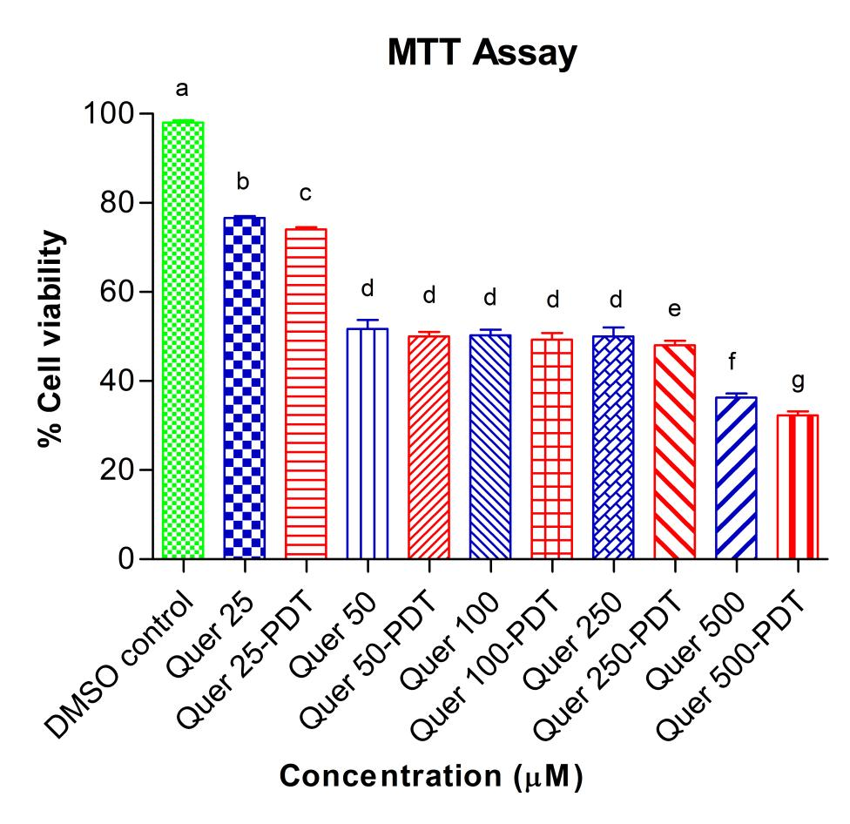
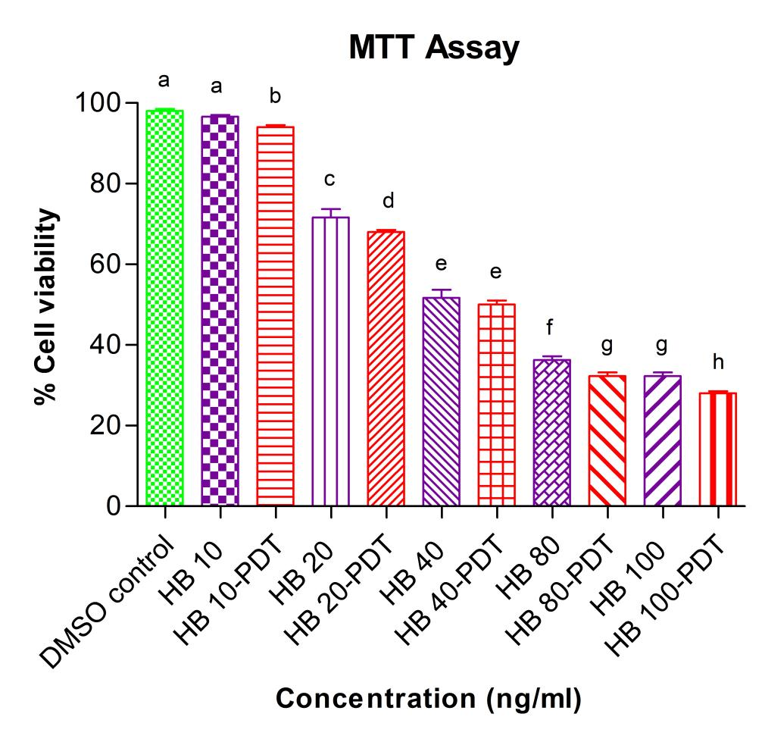

Figure 1: Cell viability of breast cancer cells (MCF7) 24 h of HB, Quer, and their PDT treatment. The experimental results represent the mean ± standard deviation of three separate experiments conducted in triplicate. Statistical analysis was carried out using one-way analysis of variance (ANOVA) with Tukey's pairwise comparison. The letters represent statistical differentiation, while if means are indicated by the same letter, they are not significantly different at a significance level of p ≤ 0.05.

As determined by the quantification of LDH release, the effects on apoptosis and cell viability were found to be independent of cytotoxicity [24]. As shown in Figure 2, HB, Quer, and their-PDT exhibited a higher degree of cytotoxicity compared to the DMSO control. According to the research findings, suppressing LDH can reduce cell viability in MCF-7 cells by triggering the intrinsic apoptotic pathway, which is marked by increased VDAC protein levels and Bcl2 inhibition, as well as by activating the extrinsic apoptotic pathway through caspase-8 activation [25]. MCF-7 cell lines exhibited comparable localization patterns for Zn(II) Pz, leading to differences in significant LDH release, according to another study [26]. Quer exposure in human HaCaT keratinocytes and Hs68 human skin fibroblasts shows no cytotoxic effects at concentrations that are otherwise toxic to B16F10 and A375 melanoma cells [27].

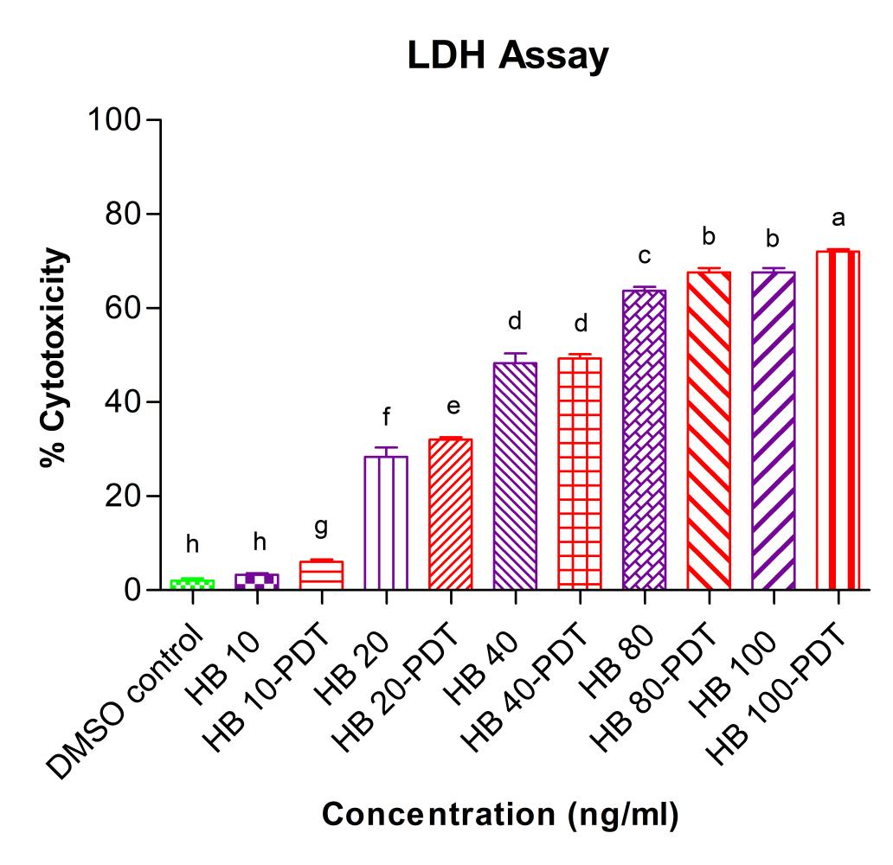
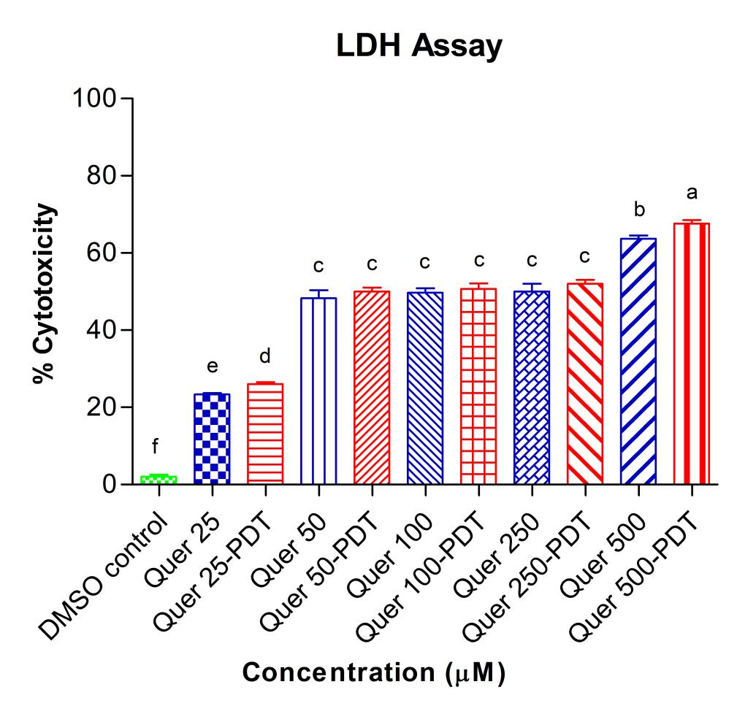

Figure 2: Cytotoxicity of breast cancer cells (MCF7) 24 h of HB, Quer, and their PDT treatment. The experimental results represent the mean ± standard deviation of three separate experiments conducted in triplicate. Statistical analysis was carried out using one-way analysis of variance (ANOVA) with Tukey's pairwise comparison. The letters represent statistical differentiation.

Cell proliferation, which involves the highly regulated and complex process of increasing flooding through division, is pallid for understandingg embryogenesis, tissue repair, liminal development, and other medical fields, particularly in light of the pathological consequences Mountains this system fails [16]. Figure 3 illustrates a decrease in cell proliferation noted in HB, Quer, and their-PDT treatments when compared to the DMSO control. Recent studies showed that when exposed to LED light, the PDT effect of HB significantly decreased cell proliferation and caused damage to the morphology and function of mitochondria in ovarian cancer cells [21]. According to the study, using low concentrations of hypocrellin A (HA) in conjunction with red light irradiation could possibly impede cell proliferation by causing cell cycle arrest [28]. ‘At the molecular level, the apoptosis induced by Quer can be influenced by Akt-mTOR signaling and hypoxia-induced factor 1α (HIF-1α) signaling. Quer hampers cell proliferation and triggers autophagy in U87 and U251 glioma cells [29].’
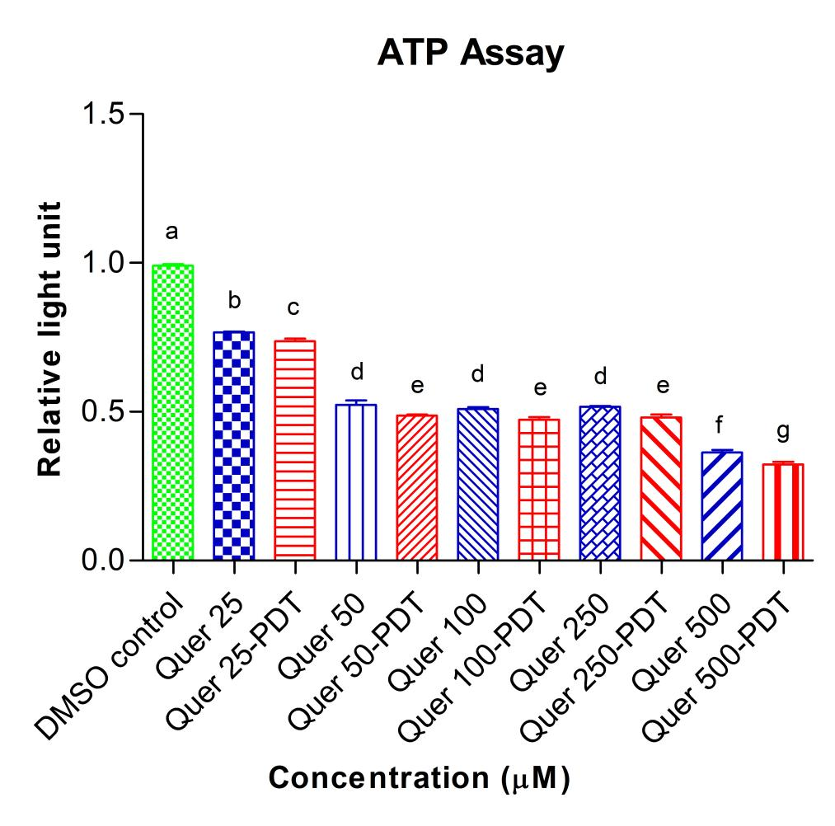
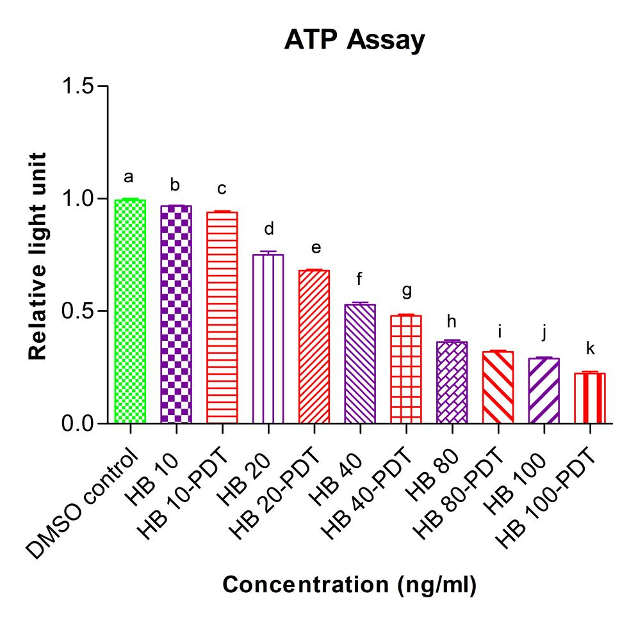
Figure 3: Proliferation of breast cancer cells (MCF7) 24 h of HB, Quer, and their PDT treatment. The experimental results represent the mean ± standard deviation of three separate experiments conducted in triplicate. Statistical analysis was carried out using one-way analysis of variance (ANOVA) with Tukey's pairwise comparison. The letters represent statistical differentiation.

Recent evidence suggests more and more that ROS may be crucial in cancer treatment, especially in inducing apoptosis [30]. The impact of HB, Quer, combination, and their-PDT on reducing intracellular ROS levels in MCF-7 cells was examined using different concentrations of these substances (illustrated in Figure 4). The application of HB, Quer, combination, and their-PDT treatments in MCF-7 cells led to a statistically significant increase (p ≤ 0.05) and a two-fold rise in overall ROS levels compared to the control group, particularly when compared to PDT alone. Another research demonstrated that the intracellular ROS levels in E. coli were assessed via flow cytometry with DCFH-DA staining. The outcomes, signified by a rightward shift in fluorescence curves after light activation of HB, demonstrated a considerable increase in ROS levels within the E. coli cells [31]. The research showed that combining HA with red light exposure significantly induces ROS-mediated cell death, resulting in inhibited cell proliferation, increased apoptosis, and autophagy induction in A431 cells [28].

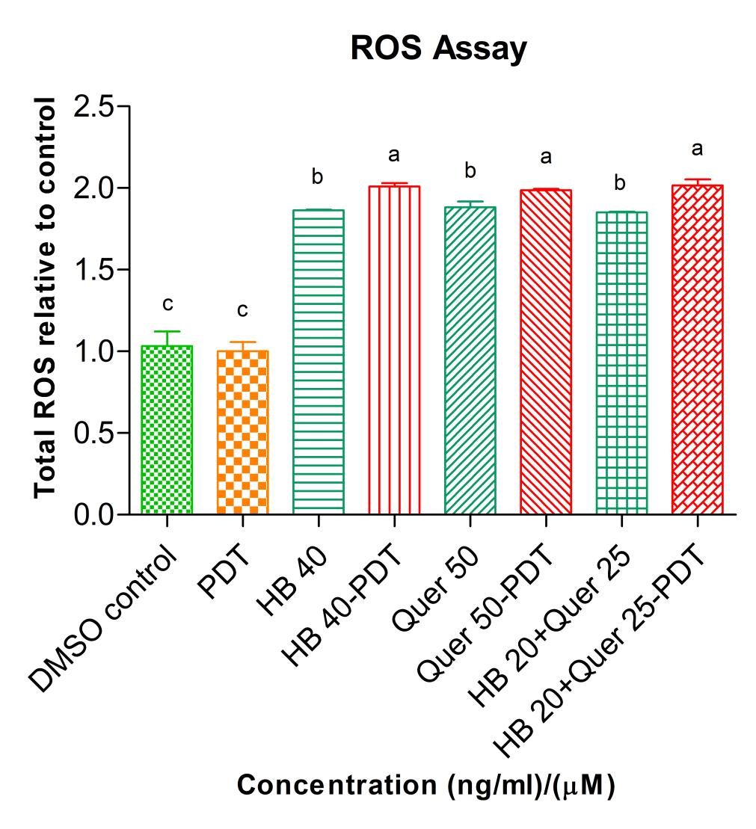

Figure 4: ROS generation of breast cancer cells (MCF7) of HB, Quer, combination and their PDT treatment. The experimental results represent the mean ± standard deviation of three separate experiments conducted in triplicate. Statistical analysis was carried out using one-way analysis of variance (ANOVA) with Tukey's pairwise comparison. The letters represent statistical differentiation.

The MMP changes in HB, Quer, combination, and their-PDT treated cells were illustrated in Figure 5. Compared to the DMSO control and PDT treatment alone, MMP was significantly reduced in cells treated with HB, Quer, the combination, and their-PDT. Anther research suggested that with Rh123 staining, the MMP of MDA-MB-231 cells was assessed. The outcome showed that the percentages of cells with MMP collapse when treated with HB [32]. Another study demonstrated that the MMP in MCF-7 cells treated with 10 µM of quercetin rose by a factor of 1.43 [33]. Another study indicated that Quer combined with PDT led to a reduction in MMP and features of late apoptosis and/or the beginning stages of necrosis [23].

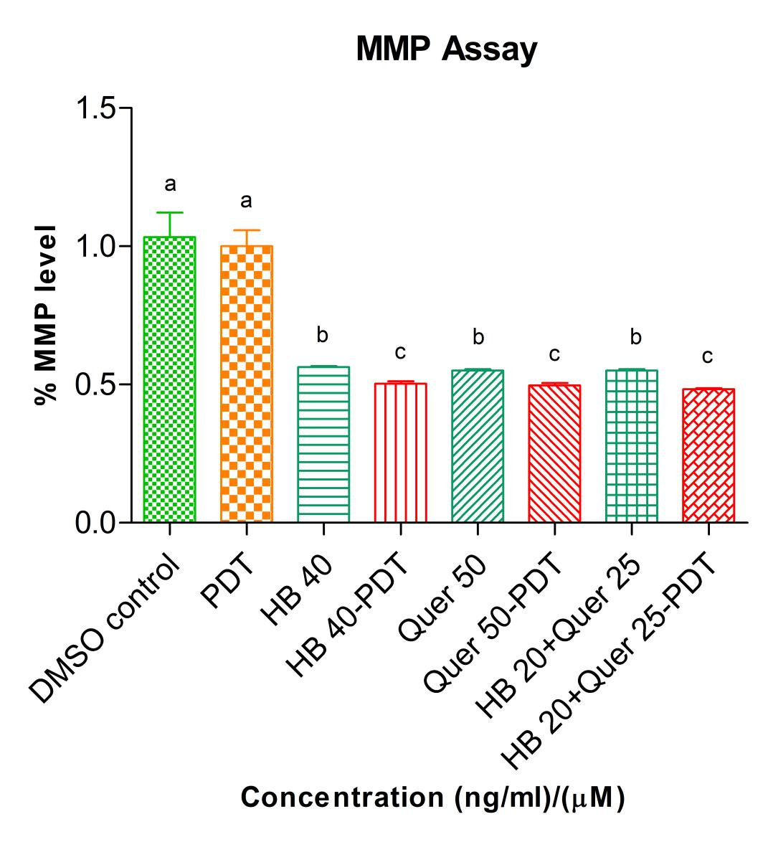

Figure 5: MMP levels of breast cancer cells (MCF7) of HB, Quer, combination and their PDT treatment. The experimental results represent the mean ± standard deviation of three separate experiments conducted in triplicate. Statistical analysis was carried out using one-way analysis of variance (ANOVA) with Tukey's pairwise comparison. The letters represent statistical differentiation.

We subsequently assessed the apoptotic rates of HB, Quer, and PDT treatment in MCF7 cell lines. The results showed that HB, Quer, and their-PDT initiated apoptosis in these cells in a dose-dependent manner (Figure 6). Another study showed that flow cytometry using annexin V/PI staining revealed a significant increase in early apoptotic and late apoptotic (necrotic) rates after photodynamic therapy with HB and HB-PDT treatment [34]. Other study showed that flow cytometry indicated an increased rate of early and late apoptosis in MDA-MB-231 cells following treatment with LED-activated HB [19]. Another study indicated that the impact of Quer at 120 µM on the apoptotic rate of the CT-26, LNCaP, MOLT-4, and Raji cell lines [35]. A further investigation showed that Quer prevents cell proliferation linked to the triggering of cell apoptosis and evaluated the apoptosis of MDA-MB-231 cells through flow cytometry [22].
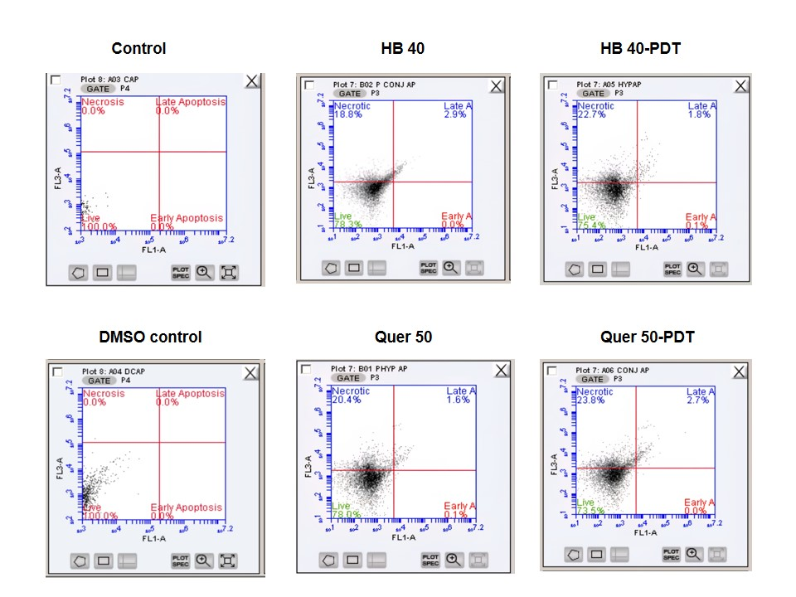

Figure 6: Apoptosis mechanism of breast cancer cells (MCF7) of HB, Quer, and their PDT treatment.

4 Conclusion

To conclude, our research highlights the promise of HB and Quer as a powerful enhancer of PDT for treating human breast cancer. A series of biochemical assays, including MTT, LDH, cell proliferation, intracellular ROS measurements, MMP, and apoptosis mechanism, demonstrate that the synergistic effect of HB, Quer, combination, and their-PDT significantly enhances cytotoxicity against breast cancer cells. This synergism seems to be driven by the induction of intracellular ROS accumulation, which enhances anticancer activity. These findings underscore the therapeutic potential of HB-PDT combinations and advocate for additional in vivo studies to investigate their clinical applicability and safety profiles in breast cancer management.

Acknowledgements

The authors extend their gratitude to ‘the University of Johannesburg and the Laser Research Centre for their valuable contributions to this review. They also acknowledge the support received from the South African Research Chairs Initiative of the Department of Science and Technology and the National Research Foundation of South Africa (SARChI/NRF-DST) under Grant No. 98337.’

References
[1] World Health Organization. Cancer Tommorow, Https://GcoIarcFr/Tomorrow/En 2020.
[2] Y-S. Sun, Z. Zhao, Z-N. Yang, F. Xu, H-J. Lu, Z-Y. Zhu, et al., "Risk Factors and Preventions of Breast Cancer," International Journal of Biological Science, vol. 13, pp. 1387–1397, 2017,. doi: https://doi.org/10.7150/ijbs.21635
[3] J. P. J. Merlin, S. Mathavarajah, G. Dellaire, K. P. J. Murphy, and H. P. V. Rupasinghe, "A Dietary Antioxidant Formulation Ameliorates DNA Damage Caused by γ-Irradiation in Normal Human Bronchial Epithelial Cells In Vitro," Antioxidants, vol. 11, no. 1407, 2022, doi: https://doi.org/10.3390/antiox11071407.
[4] T. L. Suraweera, J. P. J. Merlin, G. Dellaire, Z. Xu, and H. P. V. Rupasinghe, "Genistein and Procyanidin B2 Reduce Carcinogen-Induced Reactive Oxygen Species and DNA Damage through the Activation of Nrf2/ARE Cell Signaling in Bronchial Epithelial Cells In Vitro," International Journal of Molecular Science, vol. 24, no. 3676, 2023, doi: https://doi.org/10.3390/ijms24043676
[5] J. P. J. Merlin, A. Crous, and H. Abrahamse, "Nano‐phototherapy: Favorable prospects for cancer treatment," WIREs Nanomedicine and Nanobiotechnology, vol. 16, no. e1930, 2024, doi: https://doi.org/10.1002/wnan.1930
[6] S. S. Rajan, R. Chandran, and H. Abrahamse, "Overcoming challenges in cancer treatment: Nano‐enabled photodynamic therapy as a viable solution," WIREs Nanomedicine and Nanobiotechnology, vol. 16, no. e1942, 2024, doi: https://doi.org/10.1002/wnan.1942
[7] N. Zhao, X. Lin, S-S. Qi, Z. M. Luo, and S-L. Chen, "Yan De Novo Transcriptome Assembly in Shiraia bambusicola to Investigate Putative Genes Involved in the Biosynthesis of Hypocrellin A," International Journal of Molecular Science, vol. 17, no. 311, 2016, doi: https://doi.org/10.3390/ijms17030311.
[8] S. Law, C. Lo, J. Han, A. W. Leung, and C. Xu, "Antimicrobial photodynamic therapy with hypocrellin B against SARS-CoV-2 infection?," Photodiagnosis and Photodynamic Therapy, vol. 34, no. 102297, 2021, doi: https://doi.org/10.1016/j.pdpdt.2021.102297
[9] S. S. Rajan, R. Chandran, H. Abrahamse, "Advancing photodynamic therapy with nano-conjugated Hypocrellin: Mechanisms and clinical applications," International Journal of Nanomedicine, vol. 196, pp. 11023-11038, 2024, doi: https://doi.org/10.2147/IJN.S486014
[10] R. A. Rather and M. Bhagat, "Quercetin as an innovative therapeutic tool for cancer chemoprevention: Molecular mechanisms and implications in human health," Cancer Medicine, vol. 9, no. 24, pp. 9181–9192, 2020, doi: https://doi.org/10..1002/cam4.1411
[11] A. A. Rafiq, A. Quadri, L. A. Nazir, K.. Peerzada, B. A. Ganai, and S. A. Tasduq, "A potent inhibitor of phosphoinositide 3-kinase (PI3K) and mitogen activated protein (MAP) kinase signalling, quercetin (3, 3’, 4’, 5, 7-Pentahydroxyflavone) promotes cell death in ultraviolet (UV)-B-Irradiated B16F10 melanoma cells," PLoS ONE, vol. 10, no. e0131253, 2015, doi: https://doi.org/10.1371/journal.pone.0131253
[12] G. D’Andrea, "Quercetin: A flavonol with multifaceted therapeutic applications?," Fitoterapia, vol. 106, pp. 256–271, 2015, doi: https://doi.org/10.1016/j.fitote.2015.09.018
[13] X. Cai, Z. Fang, J. Dou, A. Yu, and G. Zhai, "Bioavailability of quercetin: problems and promises," Current Medicinal Chemistry, vol. 20, pp. 2572–2582, 2013, doi: https://doi.org/10.2174/09298673113209990120
[14] J. P. J. Merlin, B. Venkadesh, R. Hussain, N. R. Prasad, S. M. A. Shibl, A. V. Raj, and S. S. Rajan, "Paclitaxel loaded poly-d,l-lactide-co-glycolide nanoparticles: Enhanced anticancer effect in non-small cell lung carcinoma cell line," Biomedicine and Preventive Nutrition, vol. 3, pp. 1-9, 2013, doi: https://doi.org/10.1016/j.bionut.2012.10.016
[15] P. Kumar, A. Nagarajan, and P. D. Uchil, "Analysis of Cell Viability by the Lactate Dehydrogenase Assay," Cold Spring Harbor Protocol, vol. 2018, no. pdb.prot095497, 2018, doi: https://doi.org/10.1101/pdb.prot095497
[16] A. Adan, Y. Kiraz, and Y. Baran, "Cell Proliferation and Cytotoxicity Assays," Current Pharmaceutical Biotechnology, vol. 17, pp. 1213–1221, 2016, doi: https://doi.org/10.2174/1389201017666160808160513
[17] F. A. R. dos Santos, J. A. Xavier, F. C. da Silva, J. P. J. Merlin, M. O. F. Goulart, and H. P. V. Rupasinghe, "Antidiabetic, Antiglycation, and Antioxidant Activities of Ethanolic Seed Extract of Passiflora edulis and Piceatannol In Vitro," Molecules, vol. 27, no. 4064, 2022, doi: https://doi.org/10.3390/molecules27134064
[18] J. P. J. Merlin, B. Venkadesh, S. S. Rajan, and P. Subramaniam, “Multidrug Resistance for Cancer Treatment: Delivery of Ursolic Acid and Caffeine by Poly (Lactic-Co-Glycolic Acid) Nanoparticles,” Journal of Cancer Science and Research, vol. 3, no. S2, 2017, doi: https://doi.org/10.4172/2576-1447.1000S2-010
[19] Y. Jiang, X. Xia, A. W. Leung, J. Xiang, and C. Xu, “Apoptosis of breast cancer cells induced by hypocrellin B under light-emitting diode irradiation,” Photodiagnosis and Photodynamic Therapy, vol. 9, pp. 337–343, 2012, doi: https://doi.org/10.1016/j.pdpdt.2012.03.009
[20] Y. Hu, C. Zhang, S. Li, Y. Jiao, T. Qi, G. Wei, et al, “Effects of Photodynamic Therapy Using Yellow LED-light with Concomitant Hypocrellin B on Apoptotic Signaling in Keloid Fibroblasts,” International Journal of Biological Science, vol. 13, pp. 319–326, 2017, doi: https://doi.org/10.7150/ijbs.17920
[21] Y. Jiang, A. W. Leung, J. Xiang,and C. Xu, “LED Light-Activated Hypocrellin B Induces Mitochondrial Damage of Ovarian Cancer Cells,” International Journal of Photoenergy, vol. 2012, pp. 1–5, 2012, doi: https://doi.org/10.1155/2012/186752
[22] R. Wang, L. Yang, S. Li, D. Ye, L. Yang, Q. Liu, et al., “Quercetin inhibits breast cancer stem cells via downregulation of aldehyde dehydrogenase 1A1 (ALDH1A1), chemokine receptor type 4 (CXCR4), mucin 1 (MUC1), and epithelial cell adhesion molecule (EpCAM),” Medical Science Monitor, vol. 24, pp. 421-420, 2018, doi: https://doi.org/10.12659/MSM.908022
[23] R. D. P. Rodrigues, I. R. P. Tini, C. P. Soares, and N. S. da Silva, “Effect of photodynamic therapy supplemented with quercetin in Hep-2 cells,” Cell Biology International, vol. 38, no. 6, pp. 716-722, 2014, doi: https://doi.org/10.1002/cbin.10251
[24] J. Zhu, P. Langer, C. Ulrich, and J. Eberle, “Crucial Role of Reactive Oxygen Species (ROS) for the Proapoptotic Effects of Indirubin Derivatives in Cutaneous SCC Cells,” Antioxidants, vol. 10, no. 1514, 2021, doi: https://doi.org/10.3390/antiox10101514
[25] S. Al-Salam, K. Kandhan, and M. Sudhadevi, “Down regulation of lactate dehydrogenase initiates apoptosis in HeLa and MCF-7 cancer cells through increased voltage-dependent anion channel protein and inhibition of BCL2,” Oncotarget, vol. 12, pp. 923–935, 2021, doi: https://doi.org/10.18632/oncotarget.27950
[26] T. K. Horne and M. J. Cronjé, “Novel carbohydrate-substituted metallo -porphyrazine comparison for cancer tissue-type specificity during PDT,” Journal of Photochemistry and Photobiology B: Biology, no. 173, pp. 412-422, 2017, doi: https://doi.org/10.1016/j.jphotobiol.2017.06.013
[27] R. A. Rafiq, A. Quadri, L. A. Nazir, K. Peerzada, B. A. Ganai, and S. A. Tasduq, “A potent inhibitor of phosphoinositide 3-kinase (PI3K) and mitogen activated protein (MAP) kinase signalling, quercetin (3, 3’, 4’, 5, 7-Pentahydroxyflavone) promotes cell death in ultraviolet (UV)-B-Irradiated B16F10 melanoma cells,” PLoS ONE, vol. 10, no. E0131253, 2015, doi: https://doi.org/10.1371/journal.pone.0131253
[28] T. Niu, Y. Tian, G. Wang, G. Guo, Y. Tong, and Y. Shi, “Inhibition of ROS-NF-κB-dependent autophagy enhances Hypocrellin A united LED red light-induced apoptosis in squamous carcinoma A431 cells,” Cell Signaling, vol. 69, no. 109550, 2020, doi: https://doi.org/10.1016/j.cellsig.2020.109550
[29] Y. Bi, C. Shen, C. Li, Y. Liu, D. Gao, C. Shi, et al., “Inhibition of autophagy induced by quercetin at a late stage enhances cytotoxic effects on glioma cells,” Tumour Biology, no. 37, pp. 3549–3560, 2016, doi: https://doi.org/10.1007/s13277-015-4125-4
[30] J. P. J. Merlin, G. Dellaire, K. Murphy, and H. P. V. Rupasinghe, “Vitamin-containing antioxidant formulation reduces carcinogen-induced dna damage through atr/chk1 signaling in bronchial epithelial cells in vitro,” Biomedicines, vol. 9, no. 1665, 2021, doi: https://doi.org/10.3390/biomedicines9111665
[31] Y. Jiang, W. Leung, Q. Tang, H. Zhang, and C. Xu, “Effect of Light-Activated Hypocrellin B on the Growth and Membrane Permeability of Gram-Negative Escherichia coli Cells,” International Journal of Photoenergy, vol. 2014, pp. 1–6, 2014, doi: https://doi.org/10.1155/2014/521209
[32] Y. Jia, X. Wang, Q. Liu, A. W. Leung , P. Wang, and C. Xu, “SonoUltrasonics,dynamic action of hypocrellin B triggers cell apoptoisis of breast cancer cells involving caspase pathway,” Ultrasonics, vol. 73, pp. 154-161, 2017, doi: http://dx.doi.org/10.1016/j.ultras.2016.09.013
[33] P. S. Ramos, C. Ferreira, C. L. A. Passos, J. L. Silva, and E. Fialho, “Effect of quercetin and chrysin and its association on viability and cell cycle progression in MDA-MB-231 and MCF-7 human breast cancer cells,” Biomedicine & Pharmacotherapy, vol. 179, no. 117276, 2024, doi: https://doi.org/10.1016/j.biopha.2024.117276
[34] Y. Jiang, A. W. Leung, X. Wang, H. Zhang, and C. Xu, “Effect of photodynamic therapy with hypocrellin B on apoptosis, adhesion, and migration of cancer cells,” International Journal of Radiation Biology, vol. 90, no. 7, pp. 575-579, 2014, doi: https://doi.org/10.3109/09553002.2014.906765
[35] M. Hashemzaei, A. D. Far, A. Yari, R. Rezaee, “Anticancer and apoptosis-inducing effects of quercetin in vitro and in vivo,” Oncology Reports, no. 38, no. 2, 2017, doi: http://dx.doi.org/10.3892/or.2017.5766

