Physiochemical, optical, and magnetic properties of nickel-magnesium ferrite nanoparticles for various applications
S.T.M Nxumalo,¹ W.B. Mdlalose,¹ and P. Khoza,¹
¹School of Chemistry and Physics, University of KwaZulu-Natal, P/Bag X54001, Durban 4000, South Africa

E-mail: 223153020@. stu.ukzn.ac.za
Abstract. This study investigates the structural, morphological, optical, and magnetic properties of MgFe₂O₄, Ni_{0.5}Mg_{0.5}Fe₂O₄, and NiFe₂O₄ nanoparticles synthesised via the glycol-thermal method. Characterisation techniques, including X-ray diffraction (XRD), Fourier transmission infrared (FTIR), High-resolution transmission electron microscope (HRTEM), Ultraviolet-visible (UV-Vis) spectroscopy, Mӧssbauer spectroscopy (MS), and vibrating sample magnetometer (VSM), were employed. XRD confirmed single-phase spinel structures with decreasing crystal size from 11.40-8.600 nm and lattice parameters from 8.38-8.33 Å as Ni content increased. FT-IR supported the spinel structure findings. TEM revealed semi-spherical particles with varying degrees of clustering. Optical band gaps decreased from 4.52-4.06 eV with increasing Ni content. Magnetic analysis showed a mix of ferrimagnetic and paramagnetic behaviour, with saturation magnetisation increasing from 45.74-70.39 emu/g alongside Ni concentration. These findings suggest potential applications in medical and electronic fields.
- Introduction
Spinel ferrites with the general formula of MFe₂O₄ (where M could be Mg²⁺, Ni²⁺, etc.) are attracting significant research interest due to their versatile physical properties, making them suitable for applications; this includes sensors, supercapacitors, and magnetic devices [1]. At the nanoscale, these properties can be tuned by altering crystallite size and cation distribution within the spinel structure.
Nickel and magnesium ferrites are soft magnetic materials with high electrical resistance and low coercivity[2]. Magnesium (Mg²⁺) is a non-magnetic ion without an unpaired electron and could prefer any of the tetrahedral (A) and octahedral (B) sites of the ferrite structure. NiFe₂O₄ nanostructures offer excellent stability and electrochemical performance, making them ideal for energy storage, data recording, and biomedical applications [3]. In most new studies, substitution leads to an improvement in the properties of spinel ferrites due to their adjustable properties [4]. The Ni²⁺ in MgFe₂O₄ can change the various properties of magnesium ferrite. This can significantly influence the structural, morphological, optical, and magnetic properties of magnesium ferrite [1]. The main focus of this work is to investigate the effect of nickel-substituted magnesium in concentrations produced using the glycol thermal method (x = 0.0, 0.5, 1.0). The structural, morphological, optical, and magnetic analyses were carried out in detail.
- Methodology
2.1 Synthesis of nickel-magnesium ferrite nanoparticles
Nickel-substituted magnesium ferrite nanoparticles (NPs) with the general formula of Ni_{x}Mg_{1-x}Fe₂O₄ (at x = 0.0, 0.5, and 1.0) were synthesized using the glycothermal method in a Watlow series stirred pressure reactor, model PARR 4843. The ferrite samples were synthesized. Magnesium (II) chloride hexahydrate (MgCl₂6H₂O), nickel (II) chloride hexahydrate (NiCl₂6H₂O), and iron (III) chloride hexahydrate (FeCl₃6H₂O) from Sigma Aldrich were used as high-purity starting raw materials. The materials were weighed according to the chemical formula of MgFe₂O₄, Ni_{0.5}Mg_{0.5}Fe₂O₄, and NiFe₂O₄. For each active ingredient preparation, the weighed mixture was transferred to a beaker containing 40 ml of deionized water and stirred with a magnetic stirrer for about 20 minutes. A 5 M sodium hydroxide (NaOH) solution was added dropwise to the mixture, stirring for the mixed precipitation while monitoring the pH of the mixture to a value of about 9 to 10. The precipitate was then washed several times with deionized water to remove the chlorine ions in the solution. The cleaned precipitate was mixed with ethylene glycol and transferred to the pressure reactor, heated at 200 °C for 6 hours, then cooled to room temperature. The resulting product was washed with deionized water and 200 ml ethanol. The final precipitate was dried overnight in 250 W infrared light and ground homogeneously, using a mortar and an agate pestle as the end product.
2.2 Characterization techniques
The synthesized ferrite NPs were characterized using a range of analytical techniques. The XRD patterns were obtained using Cu Kα radiation (λ = 1.5406 Ǻ) by XRD Diffractometer MiniFlex 600. FTIR: Recorded using a PerkinElmer Spectrum IR (version 10.7.2). HRTEM: Conducted with a JOEL 1400 microscope. UV-vis: Cary-60 absorption instrument. MS: Co-57 sealed in Rh matrix. VSM: Cryogenic Model 3505 Ltd., UK.

- Results and discussions
  - Structural Information

3.1.1 XRD analysis
XRD patterns for MgFe₂O₄, Ni_{0.5}Mg_{0.5}Fe₂O₄, and NiFe₂O₄ are shown in Figure 1(a). Diffraction patterns are consistent with the Fd3m spatial group forming a cubic spinel structure that corresponds to ICDD reference numbers 9003597, 9005842, and 9003776 for MgFe₂O₄, Ni_{0.5}Mg_{0.5}Fe₂O₄, and NiFe₂O₄, respectively. No impurity peaks were observed. The average crystallite size was calculated using the Debye-Scherrer formula, estimated from the highest intensity peak (311). $D$ = $\frac{Kλ}{β cos θ}$ , where $K$is the Scherer constant ($K=$ 0.94),$λ$ is the X-ray wavelength, $β$ is the peak width at half maximum, and $θ$ is the Bragg’s diffraction angle. The other key crystallographic parameters were also calculated; this includes lattice parameter $(a)$, microstrain, x-ray density, and volume of the unit cell. The results are presented in Table 1.
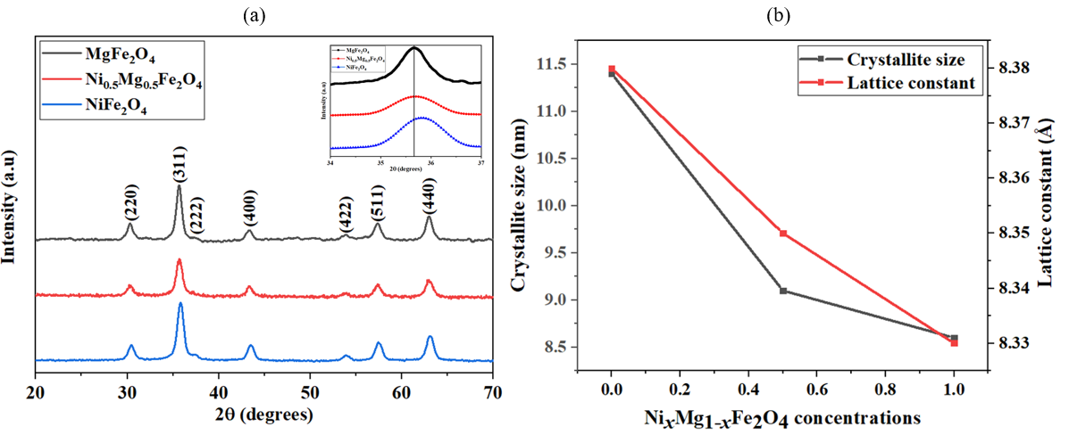

Figure 1: (a) X-ray diffraction pattern of the NPs, the inset is the magnified view of the (311) peak alignment, and (b) behaviour change in crystallite size along with lattice constant.
The results reveal the significant change of Ni²⁺ substitution on the structural characteristics of the ferrite materials. Figure 1(b), the crystallite size decreases with increasing nickel content from 11.40-8.600 nm, which corresponds to decreasing Mg²⁺ concentration. This also affected the change in the lattice parameter to decrease from 8.38 Å to 8.33 Å. This trend is attributed to the larger ionic radius of Mg²⁺ (0.072 nm) compared to Ni²⁺ (0.069 nm), which also leads to a reduction in lattice parameters as Ni content increases [5]. Additionally, Ni_{0.5}Mg_{0.5}Fe₂O₄, and NiFe₂O₄ exhibit higher stacking faults and dislocation densities than MgFe₂O₄, this could be due to the increase in lattice strain.
Table 1: The centroid (x_{c}), crystallite size (D_{XRD}), lattice parameter (𝑎), unit cell volume, dislocation density, microstrain (ϵ), XRD density, force constants (K_{o} and K_{t}), for (a) MgFe₂O₄, (b) Ni_{0.5}Mg_{0.5}Fe₂O₄, and (c) NiFe₂O₄.

3.1.2 FTIR analysis
FTIR spectra for MgFe₂O₄, Ni_{0.5}Mg_{0.5}Fe₂O₄, and NiFe₂O₄ NPs range of 4000-600 cm⁻¹ is shown in Figure 2. It displays many vibratory patterns, which provide information on the structure and chemical composition of the ferrite NPs. Safaei, et al. [6] reported that the absorption band at around 1400 cm⁻¹ corresponds to the stretching vibrations of the C-O bond. According to Ramnandan et al. [7] the band near 1600 cm⁻¹ corresponds to H₂O molecules. This may be due to the de-ionized water used during the synthesis method. A prominent band between 3100-3400 cm⁻¹ corresponds to O–H stretching vibrations, which indicate the presence of residues of hydroxyl groups[8].

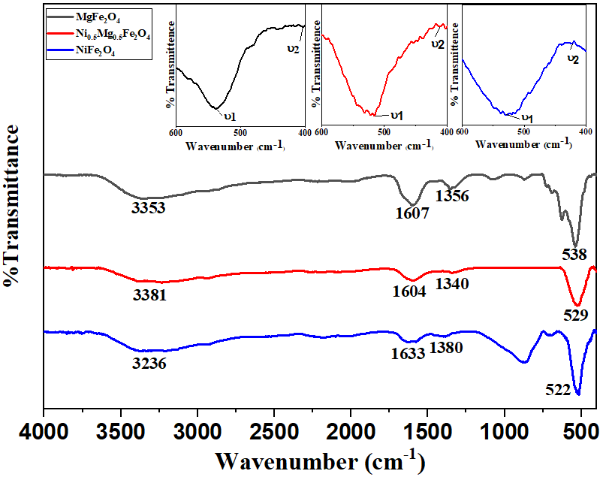
Figure 2: FTIR spectra for prepared ferrite NPs at the range of 400-4000 cm⁻¹ and the inset shows the magnified view at the range of 400-600 cm⁻¹.
In the 400-600 cm⁻¹ range of the FTIR spectra, two distinct absorption bands ν₁ (516-538 cm⁻¹) and ν₂ (403-423 cm⁻¹) were observed. These correspond to M-O stretching vibrations at the tetrahedral (A) and octahedral (B) sites [9]. Their presence confirms the structure of spinel ferrite. In addition, the force constants (K) of both sites K_{t} (tetrahedral) and K_{o} (octahedral) have been calculated by the Waldron method to determine the strength of the bonding [5]. Calculations of K for both sites are shown in Table 1. The results show how the substitution of Ni affects the bonding dynamics in the spinel structure.
    - TEM analysis
In Figure 3, TEM images reveal that the NPs are almost spherical and show significant agglomeration. This could be caused by the magnetic interactions between particles. However, substitution with Ni has been found to reduce clustering, indicating that Ni²⁺ ions with less ionic radius than Mg²⁺ inhibit grain growth and promote better particle dispersion. The particle size distribution analysis obtained using ImageJ software showed a decreasing trend in the average particle size as the Ni content increased. These values are consistent with the crystallite sizes obtained from XRD, reinforcing the correlation between structural and morphological characteristics.

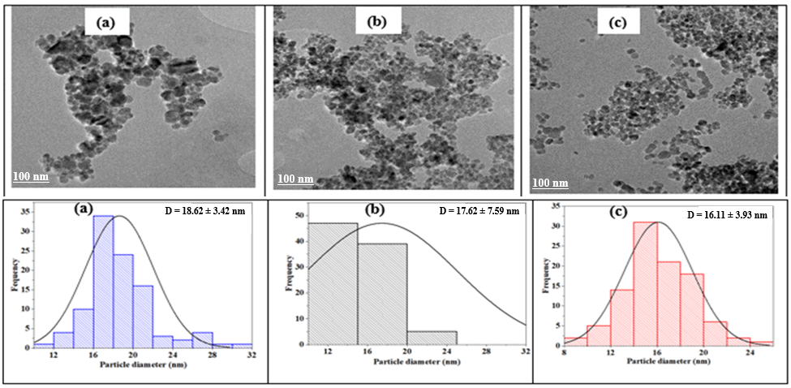
Figure 3: TEM micrographs and ImageJ particle diameter (D) size distribution of (a) MgFe₂O₄, (b) Ni_{0.5}Mg_{0.5}Fe₂O₄, and (c) NiFe₂O₄.

  - Optical Measurements
Optical characterisation of samples was recorded using a UV-visible absorption spectrophotometer. Absorption as a function of wavelength spectra for MgFe₂O₄, Ni_{0.5}Mg_{0.5}Fe₂O₄, and NiFe₂O₄ NPs were obtained at room temperature at a wavelength of 200-800 nm and are shown in Figure 4. Absorption intensity is increased from 3.84-4.70 a.u. This suggests that substitution of Ni increases optical absorption. According to Ateia et al. [10], substitution with smaller crystallites may increase surface area, leading to better absorption and scattering of light. Figure 4 shows the energy bandgap estimated using Tauc plots, which were found to be decreasing from 4.52 eV to 4.06 eV as the concentration of Ni increased.
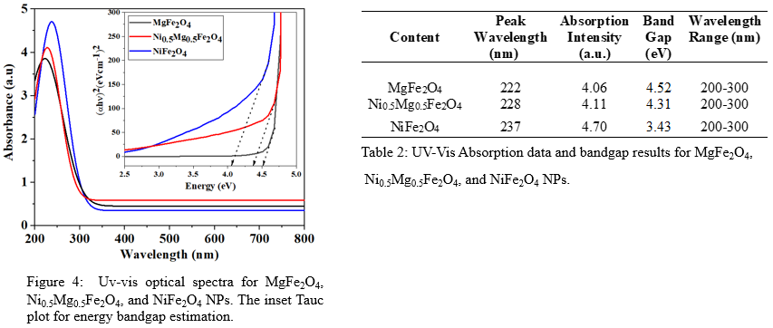
These changes reflect the effect of cation distribution on the optical properties of the spinel ferrites. Table 2 shows the variation in peak wavelength, absorption intensity, energy bandgap, and the absorption wavelength range of ferrite samples.

  - Magnetic measurement
To study the distribution state of Fe ions, ⁵⁷Fe MS spectroscopy was performed at room temperature. As shown in Figure 5(a), the spectra were fitted with two sextets and one doublet. Sextets indicate a ferromagnetic phase with iron at sites A and B, while doublets indicate smaller particles with superparamagnetic dispersion, which would indicate a paramagnetic phase. The MS spectra show two distinct sites (A and B) with different isomeric shifts (δ) and hyperfine fields (H), indicating different Fe environments. In MgFe₂O₄, the A-site showed a higher isomer shift (0.95 mm/s) than the B-site (0.18 mm/s). This is probably due to a partial reduction of Fe³⁺ to Fe²⁺, which increases electron density and causes a wider spectral band (0.82 mm/s) [11]. It also has a higher A-site fraction (ƒ_{A} = 81%) than Ni_{0.5}Mg_{0.5}Fe₂O₄ (ƒ_{A} = 51%) and NiFe₂O₄ (ƒ_{A} = 39%) NPs, suggesting a more ordered spinel structure.
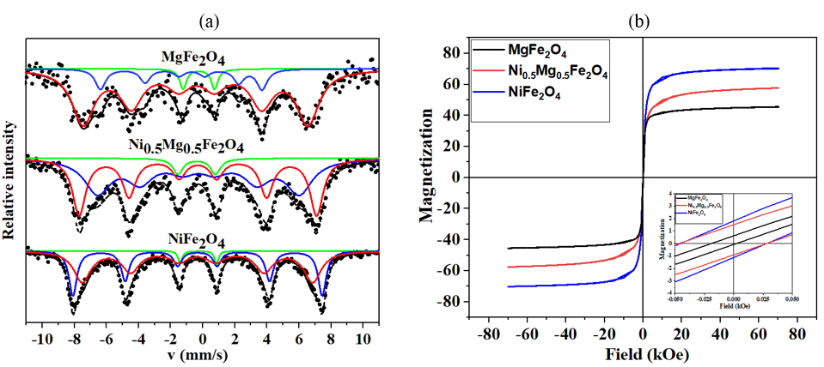
Figure 5: (a) Room temperature ⁵⁷Fe Mӧssbauer spectra and (b) vibrating sample magnetometer results for MgFe₂O₄, Ni_{0.5}Mg_{0.5}Fe₂O₄, and NiFe₂O₄.

In Ni_{0.5}Mg_{0.5}Fe₂O₄ (A-site) and NiFe₂O₄ (B-site), the line broadening was observed to be 0.98 mm/s and 0.64 mm/s, respectively. This is probably due to cation disorder affecting the local electronic and magnetic environments [12]. This disorder causes Fe²⁺ and Fe³⁺ ions to occupy different lattice sites, which increases hyperfine interactions. Hyperfine fields range from 212-325 kOe, which is consistent with ferrimagnetic ordering. Iron ions were predominantly concentrated in the A-site of MgFe₂O₄ and Ni_{0.5}Mg_{0.5}Fe₂O₄, while the B-site was more concentrated for NiFe₂O₄.
Figure 5(b) shows the M–H curves of MgFe₂O₄, Ni_{0.5}Mg_{0.5}Fe₂O₄, and NiFe₂O₄ NPs measured at room temperature using VSM at a range up to 70 kOe. The S-shaped curves confirm their superparamagnetic nature. These NPs exhibit magnetism under external field, which makes them ideal for drug delivery and controlled therapy [13]. Magnetic measurements show an increase with increasing Ni content. Saturation magnetization (M_{S}) from 45.74-70.39 emu/g, indicating enhanced magnetic ordering or crystallinity. Coercivity (H_{C}) also increases from 11-37 Oe, indicating a stronger magnetic anisotropy. The magnetic moment (μ) and remanence ratio (M_{r}/M_{s}) also increase from 1.36-2.51 Oe and 0.0136-0.0257, respectively, reflecting the improved magnetic efficiencies. Similar observations were reported by Jabeen et al. [14], which indicates that this type of behaviour is essential for energy storage applications.
- Conclusion
In summary, we have successfully synthesized Ni_{x}Mg_{1-x}Fe₂O₄ NPs with a Ni concentration of x = 0.0, 0.5, and 1.0 using the glycol thermal method. Ni substitution in MgFe₂O₄ NPs significantly alters their structural, optical, and magnetic properties, as evidenced by reduced crystallite size and lattice parameters. A narrowed optical band gap from 4.52-4.06 eV and enhanced saturation magnetisation from 45.74-70.39 emu/g. These changes were confirmed through XRD, FTIR, TEM, UV-Vis, Mӧssbauer spectroscopy, and VSM. The findings suggest that Ni incorporation enhances light absorption and magnetic response, which makes the materials promising for applications in medical diagnostics, magnetic devices, and optoelectronics.

Acknowledgments
The National Research Foundation (NRF), Pretoria, South Africa, for the funding through the Thuthuka Grant.

References
[1] S. V. Rathod, V. U. Magar, S. V. Rajmane, D. R. Sapate, and K. M. Jadhav, “Structural and optical characterization of Mg-doped nickel ferrite thin films,” Journal of Materials Science: Materials in Electronics, vol. 36, no. 3, p. 191, Jan. 2025, doi: 10.1007/s10854-025-14227-x.
[2] T. Ajeesha et al., “Nickel substituted MgFe₂O₄ nanoparticles via co- precipitation method for photocatalytic applications,” Physica B Condens Matter, vol. 606, Apr. 2021, doi: 10.1016/j.physb.2020.412660.
[3] Z. Jabeen et al., “Hydrothermal synthesis of nickel substituted magnesium ferrites (Ni_{x}Mg_{1-x}Fe₂O₄) and insight into the detailed structural, magnetic and electrochemical properties,” Surfaces and Interfaces, vol. 40, Aug. 2023, doi: 10.1016/j.surfin.2023.103130.
[4] R. M. Meshram, P. N. Ukey, D. S. Choudhary, and Y. S. Bopche, “A Review on Nanoscale Substitutional Nickel Spinel Ferrite,” vol. 20, 2022, doi: 10.48047/NQ.2022.20.1. NQ22437.
[5] S. Z. H. Hashmi et al., “Synthesis of Nickel-doped Magnesium spinel ferrites (Ni_{x}Mg_{1-x}Fe₂O₄) nanomaterials and study of their structural, electrical and magnetic properties,” Mater Chem Phys, vol. 305, Sep. 2023, doi: 10.1016/j.matchemphys.2023.127912.
[6] M. Safaei et al., “Antibacterial effect of polylactic-co-glycolic acid/selenium nanocomposite against dental biofilm,” Polimery/Polymers, vol. 70, no. 3, pp. 186–193, 2025, doi: 10.14314/polimery.2025.3.4.
[7] D. Ramnandan, S. Mokhosi, A. Daniels, and M. Singh, “Chitosan, polyethylene glycol and polyvinyl alcohol modified MgFe₂O₄ ferrite magnetic nanoparticles in doxorubicin delivery: A comparative study in vitro,” Molecules, vol. 26, no. 13, Jul. 2021, doi: 10.3390/molecules26133893.
[8] M. De, G. Bera, and H. S. Tewari, “Characterization of Magnesium Substituted Nickel Ferrites Nano-Particles Synthesized Using Combustion Technique,” 2015. [Online]. Available: www.researchpublish.com
[9] M. P. Dojcinovic et al., “Humidity and Temperature Sensing of Mixed Nickel–Magnesium Spinel Ferrites,” Chemosensors, vol. 11, no. 1, Jan. 2023, doi: 10.3390/chemosensors11010034.
[10] E. E. Ateia, A. A. H. El-Bassuony, G. Abdellatif, and A. T. Mohamed, “The Impact of Ni Substitution on the Structural and Magnetic Properties of Mg Nano-Ferrite,” Silicon, vol. 10, no. 4, pp. 1687–1696, Jul. 2018, doi: 10.1007/s12633-017-9653-7.
[11] J. K. Desmarais, W. Bi, J. Zhao, M. H. Hu, E. Alp, and J. S. Tse, “⁵⁷Fe Mössbauer Isomer Shift of Pure Iron and Iron Oxides at High Pressure-an Experimental and Theoretical Study.”
[12] B. Wareppam, E. Kuzmann, V. K. Garg, and L. H. Singh, “Mössbauer spectroscopic investigations on iron oxides and modified nanostructures: A review,” Feb. 28, 2023, Springer Nature. doi: 10.1557/s43578-022-00665-4.
[13] A. Ali et al., “Review on Recent Progress in Magnetic Nanoparticles: Synthesis, Characterization, and Diverse Applications,” Jul. 13, 2021, Frontiers Media S.A. doi: 10.3389/fchem.2021.629054.
[14] Z. Jabeen et al., “Hydrothermal synthesis of nickel substituted magnesium ferrites (Ni_{x}Mg_{1-x}Fe₂O₄) and insight into the detailed structural, magnetic and electrochemical properties,” Surfaces and Interfaces, vol. 40, Aug. 2023, doi: 10.1016/j.surfin.2023.103130.

