Synthesis, structural, magnetic, and gas sensing properties of rare earth-substituted cobalt and zinc ferrites: A comparative study

N L Ndlovu¹, P S Mkwae², and W B Mdlalose¹
¹ Discipline of Physics, University of KwaZulu-Natal, Private Bag X54001, Durban 4000, South Africa
² Discipline of Physics, University of Zululand, Dlangezwe, South Africa

E-mail: 23216006188@stu.ukzn.ac.za, MdlaloseW@ukzn.ac.za

Abstract. The as-prepared ferrites (CoFe₂O₄ and ZnFe₂O₄) are commonly well known for their ease tuning of structural, morphological, and magnetic properties. They were synthesized to evaluate rare earth (RE) element substitution effect on the properties of cobalt and zinc ferrites for the investigation of gas sensing properties using the glycol-thermal method. Results demonstrated favourable properties for ammonia (NH₃) and liquid petroleum gas (LPG) sensing, response, and sensitivity. Characterization techniques such as XRD, FTIR, HRTEM, and VSM confirmed the presence of single cubic spinel structure nanoparticles, with average crystallite sizes of 10.2 ± 0.5 nm for CoRE_{x}Fe₂-xO₄ and 9.26 ± 1.0 nm for ZnRE_{x}Fe₂-xO₄ (RE = gadolinium (Gd), neodymium (Nd), and x = 0, 0.1). The Gd cobalt and Nd zinc ferrites substitutions exhibited competitively optimal results for NH₃ and LPG gases, respectively. These results were promising for further investigation of the relationship between gas exposure and sensor material behaviour.
- Introduction
Detection of hazardous and flammable gases such as liquid petroleum gas (LPG) is important for safety in residential, commercial, and industrial settings [1]. Metal oxide semiconductors, especially spinel ferrites, have lately attracted considerable attention due to their chemical stability, low cost, and tuneable properties [1, 2]. Among them, CoFe₂O₄ (CF) and ZnFe₂O₄ (ZF) ferrites stands out due to their unique comparable magnetic and semiconducting nature, which enhances surface reactivity essential for gas sensing [1]. The CF is a hard magnetic material with a cubic spinel structure that combines high chemical stability, moderate electrical conductivity, and catalytic activity [3]. These properties make it an ideal candidate for gas sensors, data storage, catalysis, and biomedical applications. For gas sensing, the interaction between target gas molecules and the active surface of the sensing material plays a critical role. The surface of CF nanoparticles can adsorb oxygen molecules, which react well with either reducing or oxidizing gases to produce a measurable change in charge transfer resistance, forming the basis of detection [1-3]. Whereas ZF, another member of the spinel ferrite family, has also been extensively studied for gas sensing due to its excellent chemical stability, semiconducting behaviour, and lower magnetic coercivity compared to CF [1, 2], [4, 5]. Studies have demonstrated that ZF nanoparticles exhibit promising sensitivity towards gases like ethanol, ammonia, and LPG. However, CF superior magnetic properties and catalytic potential give it an edge in certain applications, particularly where rapid gas detection and recovery are crucial [4, 5].

Recent studies have revealed that nanoparticle-based sensors exhibit higher sensitivity and faster response times than their bulk counterparts [6]. This is largely due to the increased surface-to-volume ratio, which enhances the interaction between the sensor surface and gas molecules. Additionally, the tunability of cobalt ferrite through synthesis parameters or substitution strategies further widens the gap for improving sensor selectivity and performance [6]. In this work, cobalt and zinc ferrite nanoparticles were synthesized via a simple and cost-effective glycol-thermal method [7]. The structural, magnetic, and gas sensing properties were thoroughly examined using X-ray Diffraction (XRD), Fourier-transform infrared spectroscopy (FTIR), high-resolution transmission electron microscopy (HRTEM), vibrating sample magnetometer (VSM), and gas sensor measurements. The core aim was to evaluate the potential of these nanoparticles in detecting NH₃, H₂, CO₂, and LPG at 1000 ppm and operating at temperatures of 225 ºC, contributing to the advancement of affordable and reliable gas sensing technologies.

- Experimental
The synthesis precursors used to synthesize CoRE_{x}Fe₂-xO₄ and ZnRE_{x}Fe₂-xO₄ were cobalt nitrate hexahydrate (Co(NO₃)₂·6H₂O, 98%), zinc nitrate hexahydrate (Zn(NO₃)₂·6H₂O, 98%), ferric iron (III) chloride (FeCl₃, 98%), gadolinium (III) chloride hexahydrate (GdCl₃·6H₂O, 99.0%), neodymium (III) chloride hexahydrate (NdCl₃·6H₂O, 99.9%), sodium hydroxide (NaOH) as a precipitating reagent. The deionized water, ethanol (C₂H₅OH, 99 %), and ethylene glycol ((CH₂OH)₂, 99 %) were used as solvents. All were bought from Sigma-Aldrich and were used without any further purification.

  - Synthesis Process
The synthesis followed the conventional co-precipitation and glycol thermal method mentioned by [7], with the stoichiometric ratio of 1:2 not being changed by the RE element substitution. The total trivalent cations remained the same maintaining the overall charge balance.

  - Characterization Techniques
The characterization of the ferrite samples involved several techniques. XRD measurements were conducted with a Mini Flex 300/600 Cu X-ray tube at 40 kV, with phase identification verified using the ICDD: PDF database and analyzed with EVA software and the average crystallite size estimated through the Debye-Scherrer equation. FTIR confirmed the presence of reactive surface sites by identifying characteristic functional group peaks. The JEOL 1400 at 200 kV, HR/TEM provided insights into particle size distribution, morphology, and crystallinity. The magnetic properties were confirmed via VSM, and gas exposure behaviour was conducted. These combined techniques gave a comprehensive understanding of the structural, surface, magnetic, gas sensing properties of the crystalline powders.

- Results and Discussion
XRD patterns in Figure 1(a, b) confirmed the formation of a single-phase cubic spinel structure across all samples. The diffraction peaks at specific 2θ values matched well with magnetite ferrite’s standard ICDD card number (ICDD No. 1534941). A slight shift of diffraction peaks to lower 2θ values with Gd- and Nd- substitution indicated lattice expansion due to the incorporation of larger rare-earth ions [8]. This structural distortion is consistent with the reported lattice parameter (Table 1), especially in CoNd_{0.1}Fe_{1.9}O₄ (CFNd) and ZnNd_{0.1}Fe_{1.9}O₄ (ZFNd). The Debye–Scherrer equation exhibited crystallite sizes ranged from 8.98 nm to 11.1 nm, showing slight refinement due to RE-substitution. FTIR spectra (Figure 1(c, d)) displayed characteristic metal oxygen (Fe–O) vibrations at tetrahedral (~580 cm⁻¹) and octahedral (~430 cm⁻¹) sites [9]. Additional bands related to O–H and H–O–H confirmed surface hydroxyl groups, which are important for gas sensing via surface adsorption [9].
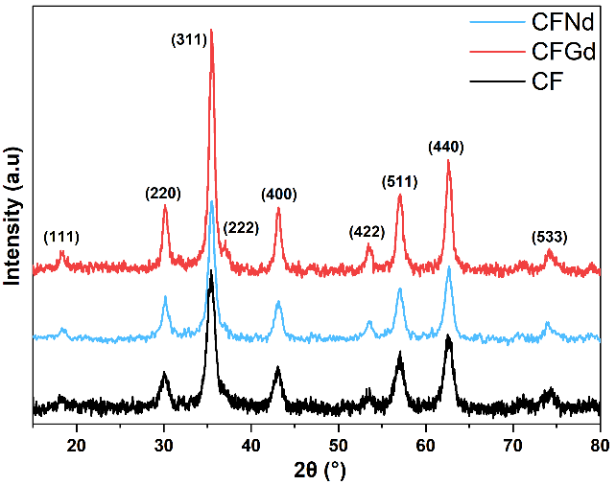  (a) | 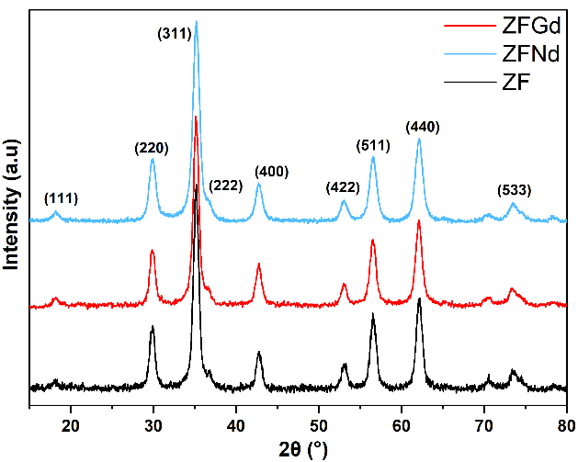  (b)
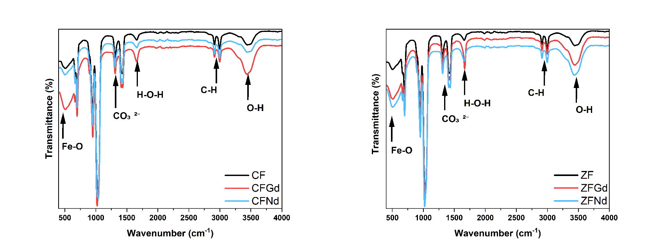  (c) | (d)
Figure 1. (a) and (b) XRD patterns of synthesized ferrite samples showing phase purity and crystallinity. (c) and (d) FTIR spectra identifying characteristic Fe–O and RE–O vibrational modes.
Sample | a (Å) | D_{XRD} (nm) | ɛ (%) | D_{TEM} (nm)
CF | 8.40 | 9.10 ± 0.5 | 1.50 | 9.50 ± 0.2
CFGd | 8.39 | 10.3 ± 0.5 | 1.20 | 10.8 ± 0.3
CFNd | 8.40 | 11.1 ± 0.5 | 1.00 | 12.2 ± 0.2
ZF | 8.46 | 8.98 ± 1.3 | 1.10 | 7.01 ± 0.2
ZFGd | 8.45 | 9.50 ± 0.7 | 1.17 | 9.72 ± 0.1
ZFNd | 8.47 | 9.30 ± 1.1 | 1.30 | 9.87 ± 0.2
Table 1. Crystallographic a (cubic lattice parameter), D_{XRD} (crystallite size), ɛ (micro strain), and D_{TEM} (particle diameter size) for RE-substituted zinc and cobalt ferrites.
In confirmation of the cubic spinel ferrite structure with XRD and FTIR correlating, the presence of residual precursors CO₃²⁻ was primarily due to incomplete removal of the byproducts and the detailed approximation of vibrational and stretching wavenumbers of the functional groups are reported in Table 2. Shifts due to Gd- and Nd-substitution suggest altered lattice dynamics and enhanced surface functionality which is beneficial for gas sensing performance. HRTEM analysis confirmed the nanoscale nature and size refinement of the ferrites, with Gd- and Nd-substituted samples showed slightly smaller particle diameter size distribution as represented in Figure 2 with the inserts demonstrating the diameter size distributions fitted through the gaussian fit and the average sizes reported in Table 1. This was consistent with the XRD data, suggested that rare-earth substitution not only did distorts the lattice parameters but also hindered the grain growth. Furthermore, confirmed the structural impact of RE-substitution observed in XRD and TEM.

Site | Fe-O Stretching (cm⁻¹) | C-H Stretching (cm⁻¹) | CO₃²⁻ Symmetric bend (cm⁻¹) | O-H Bending (cm⁻¹) | H-O-H Bending (cm⁻¹)
Octahedral | ~400- 450 | ~2800- 3000 | ~1380- 1450 | ~3400- 3500 | ~1600- 1630
Tetrahedral | ~580- 600

Table 2. FTIR absorption bands and functional group assignments.

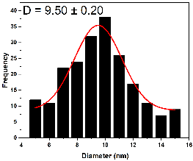 | 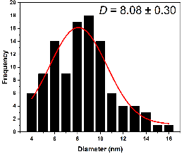 | 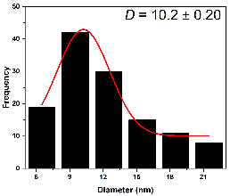
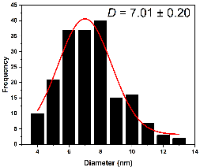 | 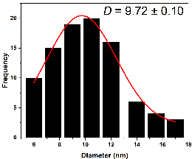 | 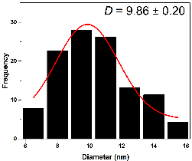
Figure 2. Comparative TEM and particle diameter distributions (inserts) patterns of (a) CF, (b) CFGd, (c) CFNd, (d) ZF, (e) ZFGd, and (f) ZFNd ferrites substituted nanoparticles.
The magnetization hysteresis (M-H) loops for the ferrite samples in Figure 3 revealed ferromagnetic and paramagnetic behaviour with distinct hysteresis. RE-substitution modified the saturation magnetization (Ms) to decrease, likely due to the influence of RE ions on the superexchange interactions between Fe³⁺ ions. While an increase in coercivity (Hc) was observed clearly for the cobalt RE-substituted ferrite as a results of the lattice distortion owing to the larger ionic radii. This variation reflected potential as slightly higher Hc values are good for sensing at higher temperatures and improved surface reactivity. The ZF ferrites revealed an opposite behaviour as to that observed for CF, and this is due to the inconclusive measurement of as-prepared compound.

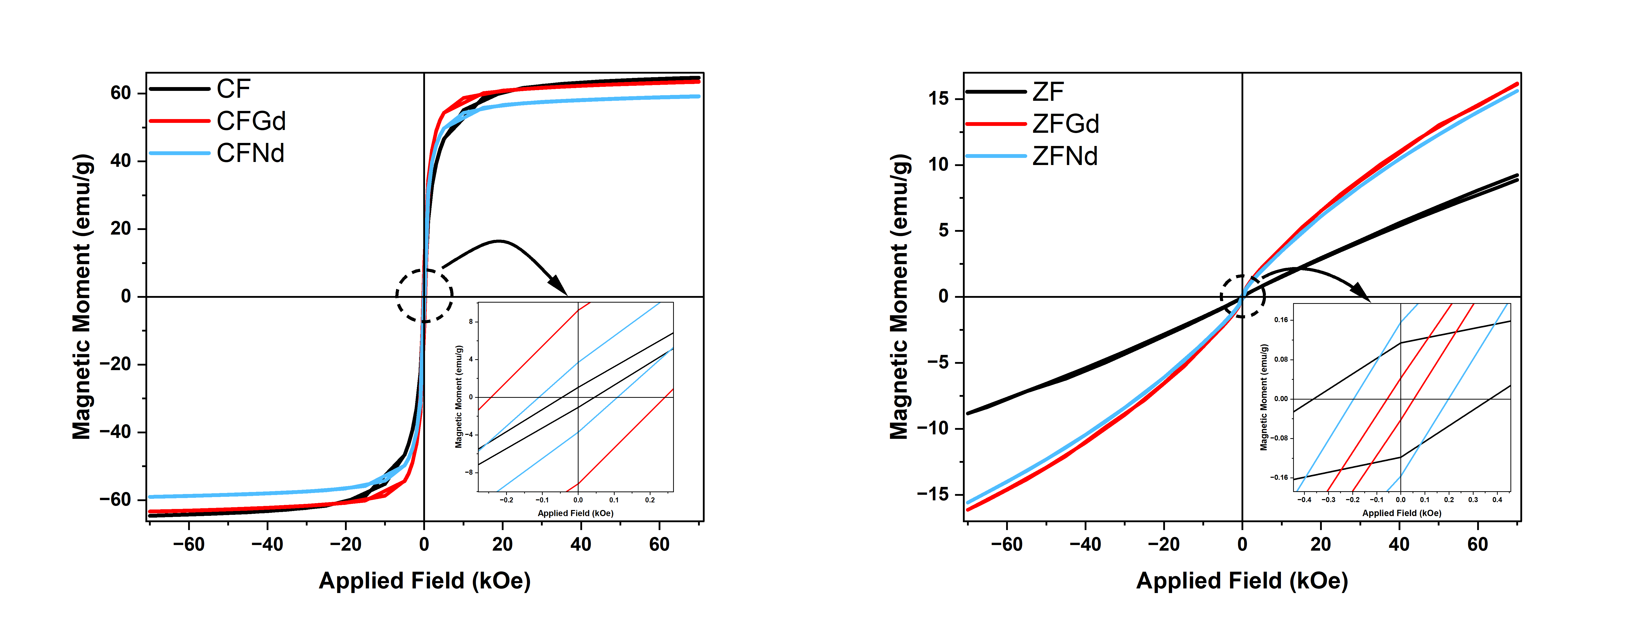  (a) | (b)
Figure 3. M–H curves from VSM measurements showing magnetic hysteresis behaviour.
Table 3 compares the gas response, response time, and recovery time for selected ferrite sensors against ammonia (NH₃), hydrogen (H₂), carbon dioxide (CO₂), and liquid petroleum gas (LPG) gases at concentration of 10 k ppm at 225 ºC. CFGd exhibited a significantly high response to LPG (975) and moderate sensitivity to NH₃, with fast response and recovery times. ZFNd, on the other hand, demonstrated a rapid and strong response to NH₃ (11.0), H₂ (5.2), and LPG (42.1), suggesting efficient surface interaction due to enhanced surface area and defect density. These observations correlate with the increased oxygen adsorption inferred from FTIR and particle size reduction from TEM.
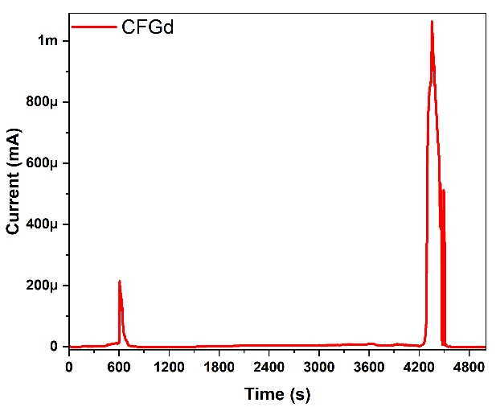  LPG  (a)  NH₃ | 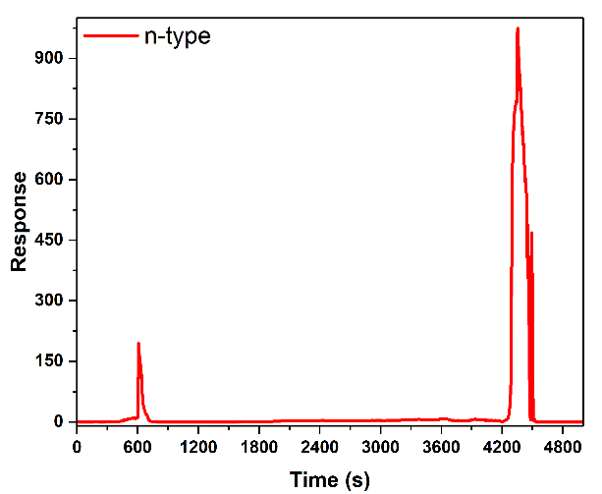  (b)  NH₃  LPG
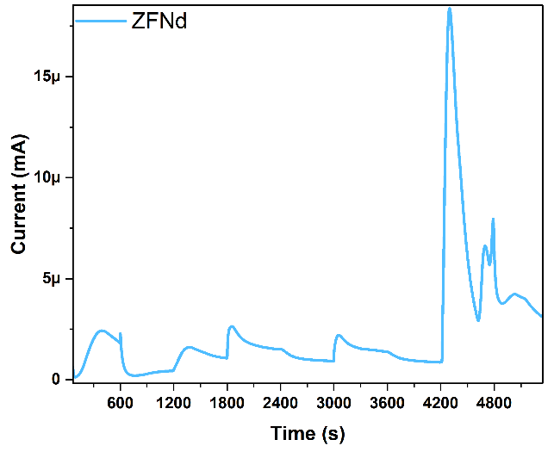  NH₃  H₂  CO₂  (c)  LPG | 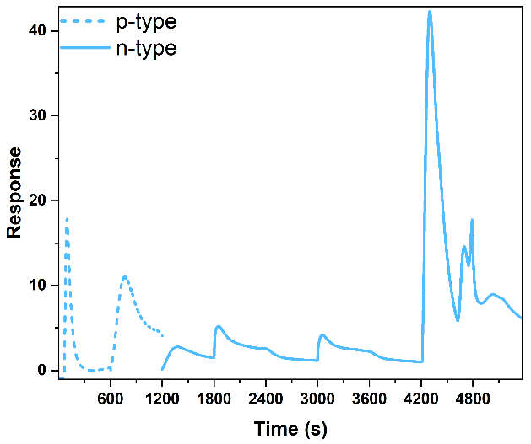  CO₂  NH₃  H₂  LPG  (d)
Figure 4. (top) CFGd and (bottom) ZFNd ferrites (a) and (c) exposure, (b) and (d) response to different gases concentration of 10 k ppm at 225 ºC.

Sample | Gases response |  |  |  | Response time (s) |  |  |  | Recovery time (s)
 | NH₃ | H₂ | CO₂ | LPG | NH₃ | H₂ | CO₂ | LPG | NH₃ | H₂ | CO₂ | LPG
CFGd | 195 | -- | -- | 975 | 9.60 | -- | -- | 160 | 3.90 | -- | -- | --
ZFNd | 11.0 | 5.20 | 4.15 | 42.1 | 0.00 | 10.9 | 31.7 | 119 | 387 | 268 | 10.9 | 574
Table 3. Response and recovery times of ferrite-based sensors to different target gases concentration of 10 k ppm at 225 ºC.
- Conclusion
In this study, rare-earth-substituted cobalt and zinc ferrites were successfully synthesized using a glycol-thermal method and thoroughly characterized to evaluate their structural, morphological, magnetic, and gas sensing properties. XRD confirmed the formation of a single-phase cubic spinel structure with slight lattice distortion upon Gd- and Nd-substitution. TEM analysis validated nanoscale particle formation and revealed particle size refinement in substituted samples, which was consistent with XRD results. FTIR results confirmed enhanced surface functionality and adsorption attributed to the potential in enhanced gas exposure interaction. Magnetic measurements demonstrated substitution-dependent in magnetization variations, indicated changes in magnetic anisotropy and superexchange interactions. Gas sensing experiments revealed that CFGd exhibited excellent LPG response and fast dynamics, while ZFNd showed high and rapid sensitivity to NH₃ and other gases, highlighted the role of rare-earth elements in enhancing gas-sensing behaviour. Overall, the results suggested that rare-earth doping offered a viable strategy to tailor ferrite properties for targeted gas sensing applications. The study provided a strong foundation for further optimization of doped ferrite nanoparticles in smart sensor systems.

Acknowledgements
The National Research Foundation (NRF), University of KwaZulu-Natal, University of Zululand and iThemba Labs are responsible for the financial support and data acquisition.

References
[1] P. S. Mkwae, “Comparative study of rare- earth based ferrites for flammable and volatile organic compound gas sensors,” 2023. Accessed: Jul. 29, 2025. [Online]. Available: https://uzspace.unizulu.ac.za/handle/10530/2540
[2] S. J. Salih and W. M. Mahmood, “Review on magnetic spinel ferrite (MFe₂O₄) nanoparticles: From synthesis to application,” Heliyon, vol. 9, no. 6, p. e16601, Jun. 2023, doi: 10.1016/J.HELIYON.2023.E16601.
[3] F. Azam, H. Ali, and M. Anis-Ur-Rehman, “Investigation of structural, electrical, and resistive switching effect of Co-Gd ferrites by substituting Nd +3 for RRAM applications”, Accessed: Jul. 28, 2025. [Online]. Available: https://ssrn.com/abstract=5129776
[4] M. W. A. Khan et al., “Gas Sensing Performance of Zinc Oxide Nanoparticles Fabricated via Ochradenus baccatus Leaf,” Chemosensors 2024, Vol. 12, Page 28, vol. 12, no. 2, p. 28, Feb. 2024, doi: 10.3390/CHEMOSENSORS12020028.
[5] A. R. Jalalvand and M. M. Karami, “Roles of nanotechnology in electrochemical sensors for medical diagnostic purposes: A review,” Sens Biosensing Res, vol. 47, p. 100733, Feb. 2025, doi: 10.1016/J.SBSR.2024.100733.
[6] S. J. C. Masuku, J. Z. Msomi, T. A. Nhlapo, and T. Moyo, “The effect of particle size on structural and magnetic properties of Zn_{0.5}Co_{0.5}Fe₂O₄ prepared by glycol-thermal technique,” Solid State Sci, vol. 148, p. 107424, Feb. 2024, doi: 10.1016/J.SOLIDSTATESCIENCES.2023.107424.
[7] L. Reddy, “The Role of Anions in Rare-earth Activated Inorganic Host Materials for its Luminescence Characteristics,” J Fluoresc, vol. 35, no. 3, pp. 1205–1240, Mar. 2025, doi: 10.1007/S10895-023-03561-0/FIGURES/36.
[8] M. Hussain et al., “Tuning the Magnetic Behavior of Zinc Ferrite via Cobalt Substitution: A Structural Analysis,” ACS Omega, vol. 9, no. 2, pp. 2536–2546, Jan. 2024, doi: 10.1021/ACSOMEGA.3C07251/ASSET/IMAGES/LARGE/AO3C07251_0009.JPEG.

