Design and Characterization of Polymer-Coated Mg-Zn Ferrite Nanoparticles: A Glycol-Thermal Approach for Biomedical Application
S S Mthimkhulu¹ and W B Mdlalose¹
¹Discipline of Physics, University of KwaZulu-Natal, Private Bag X54001, Durban 4000, South Africa

E-mail: 224193376@stu.ukzn.ac.za

Abstract. This study presents the synthesis and comprehensive evaluation of MgFe₂O₄, Mg₀.₅Zn₀.₅Fe₂O₄, and ZnFe₂O₄ nanoparticles for potential use in anticancer therapy. Nanoparticles were synthesized via a glycol-thermal method and coated with chitosan (CHI) to enhance biocompatibility and stability. Structural and magnetic properties were characterized using XRD, FTIR, TEM, Mössbauer spectroscopy, and VSM. XRD confirming the formation of a single-phase cubic spinel structure, with chitosan coating increasing crystallite size and lattice parameters. FTIR confirmed chitosan coating. TEM analysis revealed spherical morphology with reduced agglomeration post-coating. Mössbauer spectroscopy showed that MgFe₂O₄ and Mg_{0.5}Zn_{0.5}Fe₂O₄ led to ferrimagnetic behaviour, while ZnFe₂O₄ resulted in paramagnetism. Magnetic measurements via VSM indicated superparamagnetic behaviour in all samples, with Mg₀.₅Zn₀.₅Fe₂O₄ exhibiting the highest saturation magnetization (68.49 emu/g). Cytotoxicity assays on CaCo-2 cells demonstrated that chitosan coating significantly improved biocompatibility, particularly for ZnFe₂O₄, raising cell viability above 100%. These findings highlight the potential of chitosan-coated Mg-Zn ferrite nanoparticles as promising candidates for targeted drug delivery and anticancer applications.
1 Introduction
Nanoferrites have gained significant attention in biomedical applications, including drug delivery, magnetic hyperthermia, targeted therapy, and imaging resonance, due to their distinctive magnetic properties [1]. These nanoferrites have promising structural and magnetic properties; hence, they are utilized at the nanoscale. However, they have shown drawbacks. One of the major drawbacks is the cytotoxicity brought by different factors such as synthesis methods, types of materials, reaction time, and temperature. However, their potential cytotoxicity, which varies based on synthesis conditions, poses a challenge for medical use. To mitigate or eliminate these toxic effects, natural polymers such as chitosan, polyvinyl alcohol (PVA), and polyethylene glycol (PEG) are commonly employed to coat nanoferrites [2]. The polymer-coated nanoferrites are promising for targeting drug delivery and other treatments for cancer cells due to their safer delivery and reducing the side effects on healthy tissues. The incorporation of nanoferrites with polymers brought enhancement in the visibility of growing tumours and other abnormalities [3]. This surface modification enhances biocompatibility, making them safer and more effective for clinical applications. In this study, we aim to synthesize MgFe₂O₄, Mg₀.₅Zn₀.₅Fe₂O₄, and ZnFe₂O₄ nanoparticles (NPs) and coat them with chitosan (CHI) for potential applications in cancer treatment, using the glycol-thermal method. The nanoparticles were synthesized and subsequently coated with chitosan via the glycol-thermal and wet coating methods, respectively. Comprehensive characterization of the structural, morphological, and magnetic properties of the NPs was conducted using various techniques, including X-ray diffraction (XRD, MinFlex 300/600 with Cu X-ray tube), transmission electron microscopy (TEM, JEOL 1400 operated at 200 kV), Fourier-transform infrared spectroscopy (FTIR, PerkinElmer Spectrum IR Version 10.7.2), Mössbauer spectroscopy, and vibrating sample magnetometry (VSM).

2 Experimental
2.1 Synthesis method
All compounds were synthesized using the same procedure. For the synthesis of MgFe₂O₄, magnesium chloride (MgCl₂) and iron(III) chloride hexahydrate (FeCl₃·6H₂O) were dissolved in deionized water under continuous stirring. Sodium hydroxide was added dropwise to the solution to induce precipitation, maintaining the pH between 9 and 10. The resulting precipitate was transferred into a Büchner funnel and filtered under vacuum. Multiple washes with deionized water were performed to remove residual chlorides. The solvent was then replaced with 200 mL of ethylene glycol, chosen for its high boiling point (197 °C). The mixture was transferred to a stainless-steel pressure reactor (Watlow Series, PARR 4843) and heated at 200 °C for 6 hours. After the reaction, the product was washed again to remove ethylene glycol, followed by a final wash with ethanol. The resulting powder was dried under an infrared lamp for 24 hours, then ground and weighed using an agate mortar and pestle.
2.2 Coating method
The obtained MgFe₂O₄, Mg₀.₅Zn₀.₅Fe₂O₄, and ZnFe₂O₄ NPs were coated with chitosan using a modified version of the wet chemistry method described by Mngadi et al. [4]. To prepare the chitosan solution, 1 g of chitosan was dissolved in 200 ml of acetic acid, and the pH was adjusted to 4.8 by adding sodium hydroxide. The synthesized nanoparticles 0.4 g were then dispersed in the chitosan solution and stirred for 30 minutes. The mixture was further stirred at room temperature for 18 hours using an IKA RW 20 Digital Dual-Range Mixer System. The resulting homogenous mixture was centrifuged with deionized water five times at 300 rpm for 30 minutes. After centrifugation, the sample was dried under infrared radiation for 24 hours, ground, and labeled as CHI-MgFe₂O₄, CHI-Mg₀.₅Zn₀.₅Fe₂O₄, and CHI-ZnFe₂O₄.

3 Results
3.1 Structural and Morphological properties
X-ray Diffraction exhibits all the synthesized and coated NPs patterns as shown in Figure 3.1. All diffraction planes (hkl) (111), (220), (311), (222), (400), (422), and (440) were confirmed by the original magnetite pattern that was for a single cubic spin structure [4]. No impurities were detected after chitosan coating. The crystallite sizes were calculated using Scherrer's equation. It was found to be decreasing after chitosan coating, except for the doped sample, which was increasing. The increase of crystallite size in the Mg_{0.5}Zn_{0.5}Fe₂O₄ sample was due to the substitution of the ionic radii of magnesium (0.65 $Å$) with zinc (0.83 $Å$ ), since zinc has a greater ionic radius than magnesium, which leads to lattice expansion [5]. FTIR spectra are seen in Figure 3.2. A broad peak around 3000-3500 cm⁻¹ is associated with hydrogen bonding. Around 2800-3000 cm⁻¹ and 1650-1660 cm⁻¹, there are two stretching bands that represent the amid groups. Two chitosan peaks bonding at 3300-3400 cm⁻¹, which are associated with N-H stretching bonding, appear at the chitosan-coated CH-MgFe₂O₄, CH-Mg_{0.5}Zn_{0.5}Fe₂O₄, CH-ZnFe₂O₄ NPs, while they were not present on as-prepared samples, which confirms that the coating was successful. Strongest peak at 500-550 cm⁻¹, which is due to Fe-O bonding.
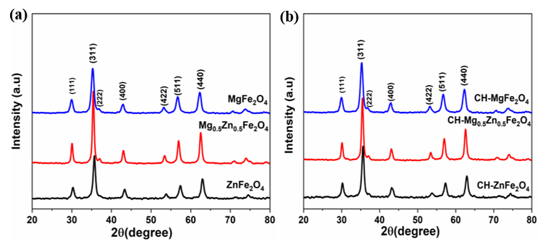
Figure 3.1: X-ray diffraction pattern of (a) as-prepared and (b) chitosan-coated nanoparticles.

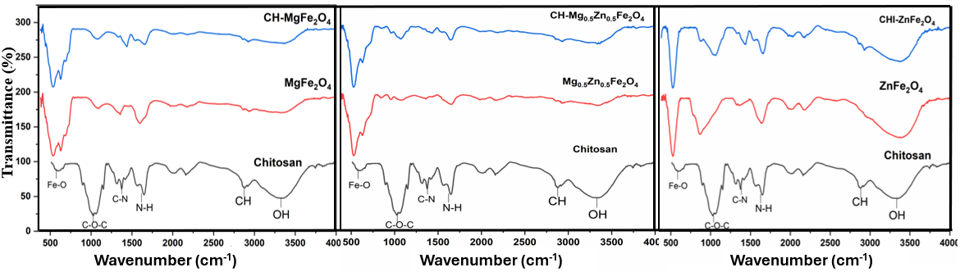
Figure 3.2: Fourier Transform Infrared images of as-prepared and chitosan-coated NPs.
TEM exhibited spherical shapes particles with an average particle distribution of 15.67 nm and 13.66 nm for as-prepared and chitosan coated NPs, respectively. All NPs exhibited spherical shapes, as seen in Figure 3.3. The chitosan-coated NPs are less agglomerated. On the doped Mg_{0.5}Zn_{0.5}Fe₂O₄, the bigger particles were associated with Mg²⁺, whereas the small NPs were for Zn²⁺. Magnesium has bigger particles due to the high synthesis temperature of 200℃, which caused them to be bigger in shape and size [6]. The decrease in particle sizes of MgFe₂O₄ and ZnFe₂O₄ after chitosan and an increase in Mg_{0.5}Zn_{0.5}Fe₂O₄ were observed, which affects the magnetic properties.

Samples | D_{XRD} (nm) | D_{TEM} (nm) | a ($Å$) | $M_{S}$(emu/g) | $H_{C}$(Oe)
MgFe₂O₄ | 13.78 | 15.01 | 8.348 | 62.95 | 10.00
CHI-MgFe₂O₄ | 12.95 | 13.02 | 8.358 | 64.47 | 13.00
Mg_{0.5}Zn_{0.5}Fe₂O₄ | 16.24 | 21.00 | 8.404 | 68.49 | 33.00
CHI-Mg_{0.5}Zn_{0.5}Fe₂O₄ | 16.76 | 17.02 | 8.399 | 58.81 | 26.00
ZnFe₂O₄ | 11.68 | 11.02 | 8.426 | 25.19 | 66.00
CHI-ZnFe₂O₄ | 11.17 | 10.96 | 8.431 | 27.16 | 69.00
Table 1. Crystallite size (D_{XRD}), particle size (D_{TEM}), lattice parameter (a), saturation magnetization ($M_{S})$, coercivity field ($H_{C})$ parameters.
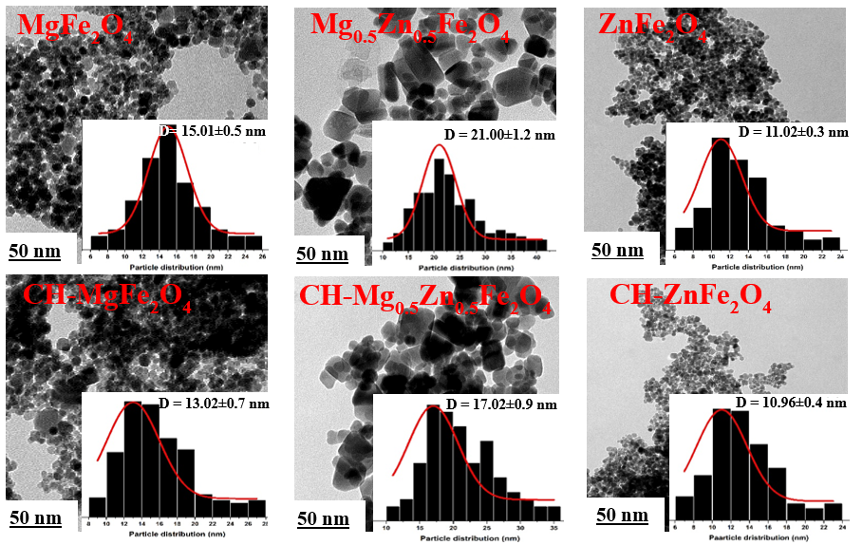
Figure 3.3: TEM images of as-prepared and chitosan-coated NPs

3.2 Magnetic properties
Magnetic properties are revealed by Mossbauer spectroscopy and the vibrating sample magnetometer. Mössbauer spectroscopy investigates the dominance of Fe-ions in a sample and the type of magnetization behavior [7]. The Mössbauer spectra obtained for the MgFe₂O₄ and Mg₀.₅Zn₀.₅Fe₂O₄ samples were successfully fitted with two sextets, indicating ferromagnetic behaviour. Based on the average of isomer shifts (IS) and hyperfine fields (H_{f}) for MgFe₂O₄ sample, Sextet A (IS = 0.31 mm/s, H_{f} = 296 kOe) was attributed to Fe²⁺ ions occupying tetrahedral sites, while Sextet B (IS = 0.32 mm/s, H_{f} = 325 kOe) corresponded to Fe²⁺ ions located on the octahedral sites [8]. A similar analysis was conducted for the Mg₀.₅Zn₀.₅Fe₂O₄ sample, where Sextet A (IS = 0.37 mm/s, H_{f} = 337 kOe) was attributed to Fe ions occupying the tetrahedral sites, while Sextet B (IS = 0.36 mm/s, H_{f} = 306 kOe) was assigned to Fe ions located at the octahedral sites. Notably, the MgFe₂O₄ sample exhibited a predominance of Fe ions in tetrahedral sites, whereas Fe ions were more concentrated in octahedral sites in the Mg₀.₅Zn₀.₅Fe₂O₄ sample. In contrast, the ZnFe₂O₄ sample displayed a spectrum fitted with two doublets, suggesting that all Fe ions were present in paramagnetic states across two distinct sites. Moreover, the magnetic properties of the nanoparticles were validated through VSM measurements, with the results presented in Table 1.
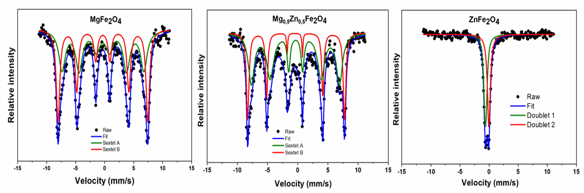
Figure 3.4: Mössbauer spectroscopy of nanoparticles at room temperature.

From the small average values, saturation (M_{s} = 52.21 emu/g) and remanent (M_{r} = 0.81 emu/g) magnetizations exhibited superparamagnetic behaviour in all samples, as seen in Figure 3.4. However, an increase in the values of M_{s} was observed, which is attributed to the action of chitosan as a stabilizing agent [9]. Moreover, the decrease in saturation of the Mg_{0.5}Zn_{0.5}Fe₂O₄ sample was due to the new non-magnetic layer added, which caused disturbance in the magnetization interaction, leading to a decrease in magnetization [9]. MgFe₂O₄ and Mg_{0.5}Zn_{0.5}Fe₂O₄ NPs have higher saturation magnetization than zinc, which was revealed by Mossbauer spectroscopy with ferromagnetic behaviour. ZnFe₂O₄ has a hysteresis loop of the lowest saturation magnetization (26.17 emu/g), revealing pure superparamagnetic Fe-ions, as confirmed by Mossbauer results. All synthesized and chitosan-coated nanoparticles exhibited superparamagnetic behaviour, as indicated by low saturation (M_{s}) and remanent (M_{r}) magnetization values. Chitosan coating enhanced M_{s} by stabilizing the particles and improving domain alignment. However, Mg₀.₅Zn₀.₅Fe₂O₄ showed reduced M_{s} due to the presence of a non-magnetic layer disrupting magnetic interactions. MgFe₂O₄ and Mg₀.₅Zn₀.₅Fe₂O₄ had higher M_{s} than ZnFe₂O₄, which showed the lowest M_{s} and purely superparamagnetic behaviour, consistent with Mössbauer results. Since low M_{s} can be linked to cytotoxicity, the superparamagnetic nature of these nanoparticles suggests potential for cancer treatment, though further evaluation on different cell lines was necessary to assess toxicity. One of the features of suitable magnetic materials for medical applications is that the particles are superparamagnetic. Hence, VSM results suggest that these materials could be used in cancer treatment applications. However, their toxicity to healthy cells, hence, their evaluation in different cell lines was done.
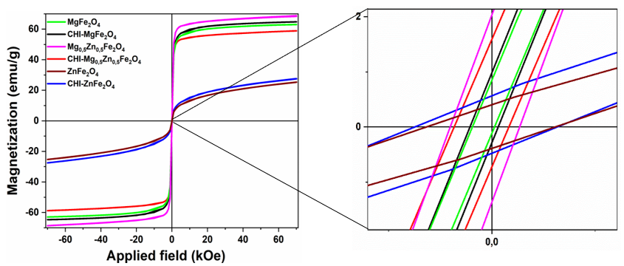
Figure 3.5: Hysteresis loop of as-prepared and chitosan-coated (CHI) nanoparticles measured at room temperature.

3.3 Cytotoxicity (MTT) assay
A cytotoxicity study using the MTT assay on CaCo-2 cells showed that MgFe₂O₄ and Mg₀.₅Zn₀.₅Fe₂O₄ nanoparticles had low toxicity, maintaining over 75% cell viability, while ZnFe₂O₄ showed higher toxicity with viability below 60%. Chitosan-coated nanoparticles significantly improved biocompatibility, with CHI-MgFe₂O₄ showing over 90% viability and both CHI-Mg₀.₅Zn₀.₅Fe₂O₄ and CHI-ZnFe₂O₄ exceeding 100%. The chitosan coating effectively reduced nanoparticle-induced toxicity, making these nanocomposites promising for drug delivery and gene therapy applications.

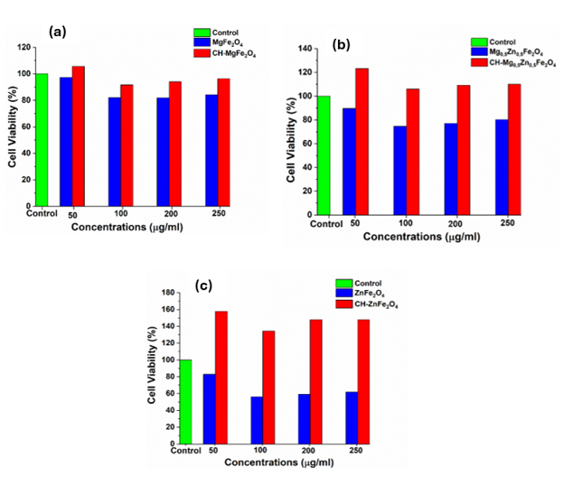

Figure 3.6: MTT Cell viability assay in the Human Colorectal Adenocarcinoma (CaCo-2) cell line.
4 Conclusion
All synthesized and chitosan-coated MgFe₂O₄, Mg₀.₅Zn₀.₅Fe₂O₄, and ZnFe₂O₄ nanoparticles exhibited a cubic spinel structure and spherical morphology, with reduced agglomeration after chitosan coating. Magnetic characterization showed ferrimagnetic behaviour for MgFe₂O₄ and Mg₀.₅Zn₀.₅Fe₂O₄, and paramagnetic behaviour for ZnFe₂O₄. All samples displayed superparamagnetic properties. Cytotoxicity studies on CaCo-2 cells revealed that uncoated nanoparticles were more toxic at higher concentrations, while chitosan-coated nanoparticles significantly improved cell viability [10]. These results highlight the potential of chitosan-coated nanoparticles for safe and effective use in gene delivery and drug nanocarrier applications.

References
[1] S. Bucak, B. Yavuztürk, A. D. Sezer, S. Bucak, B. Yavuztürk, and A. D. Sezer, “Magnetic Nanoparticles: Synthesis, Surface Modifications and Application in Drug Delivery,” Recent Advances in Novel Drug Carrier Systems, Oct. 2012, doi: 10.5772/52115.
[2] N. L. Ndlovu, W. B. Mdlalose, B. Ntsendwana, and T. Moyo, “Evaluation of Advanced Nanomaterials for Cancer Diagnosis and Treatment,” Apr. 01, 2024, Multidisciplinary Digital Publishing Institute (MDPI). doi: 10.3390/pharmaceutics16040473.
[3] R. Verma, A. Chauhan, R. Kalia, K. M. Batoo, and R. Kumar, “Magnetic nanoferrites as an alternative for magnetic resonance imaging application,” Magnetic Nanoferrites and their Composites: Environmental and Biomedical Applications, pp. 237–256, Jan. 2023, doi: 10.1016/B978-0-323-96115-8.00013-1.
[4] S. Mngadi, S. Mokhosi, M. Singh, and W. Mdlalose, “Chitosan-functionalized Mg_{0.5}Co_{0.5}Fe₂O₄ magnetic nanoparticles enhance delivery of 5-fluorouracil in vitro,” Coatings, vol. 10, no. 5, May 2020, doi: 10.3390/COATINGS10050446.
[5] K. O. Abdulwahab, M. M. Khan, and J. R. Jennings, “Ferrites and ferrite-based composites for energy conversion and storage applications,” 2023, Taylor and Francis Ltd. doi: 10.1080/10408436.2023.2272963.
[6] M. A. Durand, “The Coefficient of Thermal Expansion of Magnesium Oxide,” Physics (College Park Md), vol. 7, no. 8, pp. 297–298, Aug. 1936, doi: 10.1063/1.1745396.
[7] E. J. Choi, Y. Ahn, and K. C. Song, “Mössbauer study in zinc ferrite nanoparticles,” J Magn Magn Mater, vol. 301, no. 1, pp. 171–174, Jun. 2006, doi: 10.1016/J.JMMM.2005.06.016.
[8] E. Tunable Ge et al., “Mössbauer effect study of a polycrystalline Fe_{1+x}Cr_{2-x}O₄ spinel grown by solid-state synthesis You may also like Fracture of Porous Ceramics: Application to the Mechanical Degradation of Solid Oxide Cell During Redox Cycling Mössbauer effect study of a polycrystalline Fe_{1+x}Cr_{2-x}O₄ spinel grown by solid-state synthesis,” J Phys Conf Ser, vol. 2164, p. 12067, 2022, doi: 10.1088/1742-6596/2164/1/012067.
[9] T. M. Freire et al., “Fast ultrasound assisted synthesis of chitosan-based magnetite nanocomposites as a modified electrode sensor,” Carbohydr Polym, vol. 151, pp. 760–769, Oct. 2016, doi: 10.1016/J.CARBPOL.2016.05.095.
[10] F. Salehi, H. Behboudi, G. Kavoosi, and S. K. Ardestani, “Chitosan promotes ROS-mediated apoptosis and S phase cell cycle arrest in triple-negative breast cancer cells: evidence for intercalative interaction with genomic DNA,” RSC Adv, vol. 7, no. 68, pp. 43141–43150, Sep. 2017, doi: 10.1039/C7RA06793C.

