Structural and optical properties of rare-earth doped magnesium ferrite
N.O Ngubelanga¹, S.A Ogundipe¹, D. Hile¹, S. Masikane², C.L Ndlangamandla¹ and P.S Mkwae¹
¹Department of Physics, University of Zululand, Private Bag X1001, KwaDlangezwa 3886, South Africa.
²Department of Chemistry, University of Zululand, Private Bag X1001,KwaDlangezwa 3886, South Africa.
E-mail: 201815897@stu.unizulu.ac.za
Abstract. Nanoparticles of magnesium ferrite (MgFe₂O₄) and rare earth-doped variants, (Mg(RE)_{0.2}Fe_{1.8}O₄, RE=La,Sm) were synthesized via a hydrothermal method and annealed at 500$℃$, 700$℃$ and 900$℃$. Structural and optical characterization were performed using XRD, UV-Vis, HRTEM, and PL spectroscopy. XRD confirmed the formation of cubic spinel structure, with sharper preferable diffraction peaks at 900$℃$ indicating improved crystallinity. Doping with La and Sm reduced crystallinity. Doping with La and Sm reduced crystallite size and bandgap energy, suggesting enhanced structural refinement and electronic properties. HRTEM images supported these improvements, showing clearer lattice fringes at higher annealing temperatures. Photoluminescence results revealed a shift from dual-wavelength emission (495 and 503) in pure MgFe₂O₄ to single suppressed peak at 500nm (2.48 eV) upon doping. These modifications position RE-doped MgFe₂O₄ as a strong candidate for advanced gas sensing applications, where tunable optical and structural features are crucial.

Introduction
Spinel ferrites, especially at the nanoscale, are widely used in sensors, catalysis[1], medicine, and in many more applications. They have caught the eye of researchers[1, 2] due to their high resistivity, moderate permeability, and structural versatility. Among the various forms of spinel ferrites, magnesium ferrite (MgFe₂O₄), a cubic spinel oxide, has gained attention[1, 2] for its promising structural, optical, and gas sensing properties. Its performance depends heavily on factors such as grain size, porosity, and synthesis method. Doping MgFe₂O₄ with elements like rare-earth metals (e.g., La³⁺, Sm³⁺) is a common strategy used to enhance properties[1-4] such as sensitivity, selectivity, and operating temperature by modifying the microstructure and electrical conductivity. Among various synthesis techniques, the hydrothermal method offers a cost-effective and environmentally friendly[2] route to produce doped MgFe₂O₄ with improved characteristics. This study adopts the hydrothermal method to synthesize La³⁺ and Sm³⁺ doped MgFe₂O₄, aiming to enhance its structural and optical properties for advanced functional applications.

Experimental

Material Synthesis
Mg (Re)0.2Fe1.8O4, where Re= La3+, Sm3+ rare earth elements, were synthesized via hydro-thermal technique using high purity metal chlorides as starting materials. The desired stoichiometric ratio of MgCl2.6H2O (99%), LaCl3.6H2O (99%), SmCl3.6H2O (99%) and FeCl3.6H2O (99%) were dissolved in 400ml of distilled water under constant magnetic stirring. When the solutes had completely dissolved, Ammonia solution (25%) was added dropwise until a stable PH of approximately 8.39 was reached to form a precipitate. The precipitate was then filtered and washed several times with deionized water over a Whatman glass microfiber filter (GF/F) with the aid of suction flask operating on a vacuum pump. The absence/presence of chloride ions was tested using AgNO3. The mixture was then transferred to an Autoclave bottle of 80 ml, closed and incubated at 100℃ for 4hrs. The samples were allowed to cool down and washed with deionized water and ethanol and was left to dry under 80℃ ultraviolet light for 24 hours. The samples were then ready for characterization.

Results and Discussion

Structural properties

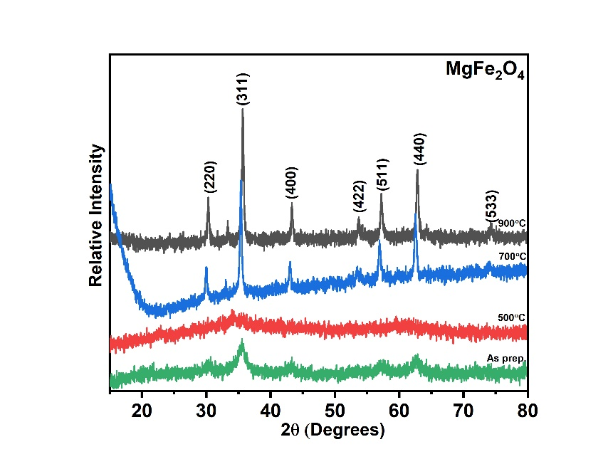
To study the structural properties of Mg (Re)_{0.2}Fe_{1.8}O₄ where Re=La or Sm, X-ray diffraction and HR-TEM were used. The XRD spectrums showed notable diffraction peaks of pure magnesium ferrite, that appeared at approximately 35.6$°$ corresponding to the diffraction plane of (311) which indicates the formation of MgFe₂O₄. However, a trace of another phase, denoted with an asterisk (*), can be observed at around 33$°$. This phase belonging to hematite (Fe₂O₃)[5] in Figure 1(a) is brought about by the increase in annealing temperature. It is very weak and narrow suggesting a small amount of that phase with a large crystallite size. This means that the higher temperature may help new phases to form, likely starting from small amounts of hematite already in the sample because the material wasn’t perfectly mixed[5]. In contrast, the secondary phase peak observed in Figure 1(b) is much stronger and more intense and is observed in the unannealed samples also. This phase belongs to the ortho-ferrites, which is brought about by the high doping concentration. A similar observation was noted by Kumbhar R.N et al.[4] who concluded that as the doping concentration increased so did the intensity of the orthoferrite phase. Interestingly, Figure 1(c) showed broadened diffraction peaks at low temperature as compared to Figure 1(b). This means that Sm doping brought greater micro strains to the material than La doping, which led to a decrease in crystallite size. Again, Kumbhar, R.N[4] attests to similar findings when he did an Sm³⁺ and Dy³⁺ substitution on MgFe₂O₄. Figure 1(d) compares doping effects at an annealing temperature of 900$℃$, where the intensity of diffraction peaks was easier to compare. From this diagram it can be observed that upon La and Sm doping the crystallite planes (311), (400), (422), (440), (511) belonging to MgFe₂O₄ are maintained. However, the intensity decreases with increasing molar mass, implying reduced crystallite size. XRD parameters were calculated and recorded in Table 1. Aanalysis of results showed the crystallite size to range from ~24.44 nm (undoped) to as low as ~3.97nm (Sm-doped), confirming nanoparticle formation. Crystallite size and X-ray density results were observed at an annealing temperature of $900℃$ and were plotted in Figure 2. The trend was consistent with literature findings[2].
Figure 1: XRD patterns of (a)MgFe₂O₄ (b) MgFe_{1.8}La_{0.2}O₄, (c) MgFe_{1.8}Sm_{0.2}O₄, as prepared and annealed at temperatures 500˚, 700˚ and 900˚, and (d) MgFe_{1.8}(Re)_{0.2}O₄ annealed at 900$℃$
(a)
(b)
(c)
(d)

Composition | Annealing temperature(˚C) | Crystallite size(nm) | Lattice parameter(Å) | Xrd density(g/cm³)  (${×10}^{-11}$)
MgFe₂O₄ | - | 5.46±0.002 | 8.750±0.006 | 4.10
MgFe₂O₄ | 500 | 8.98±0.002 | 8.745±0.011 | 4.11
MgFe₂O₄ | 700 | 15.10±0.002 | 8.778±0.009 | 4.06
MgFe₂O₄ | 900 | 24.44±0.0004 | 8.433±0.0008 | 4.58
MgFe_{1.8}La_{0.2}O₄ | - | 11.0710±0.002 | 8.450±0.017 | 5.10
MgFe_{1.8}La_{0.2}O₄ | 500 | 8.239±0.002 | 8.461±0.025 | 5.08
MgFe_{1.8}La_{0.2}O₄ | 700 | 23.99±0.002 | 8.444±0.013 | 5.11
MgFe_{1.8}La_{0.2}O₄ | 900 | 21.536±0.002 | 8.573±0.015 | 4.87
MgFe_{1.8}Sm_{0.2}O₄ | - | 3.969±0.003 | 8.626±0.016 | 4.42
MgFe_{1.8}Sm_{0.2}O₄ | 500 | - | - | -
MgFe_{1.8}Sm_{0.2}O | 700 | 11.527±0.008 | 8.344±0.002 | 4.91
MgFe_{1.8}Sm_{0.2}O₄ | 900 | 18.144±0.003 | 8.339±0.0006 | 4.92

Table 1: calculated XRD parameters for MgFe2O4 and MgFe2-x(RE)xO4 where RE= La, Sm at different annealing temperatures.

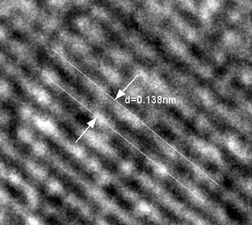
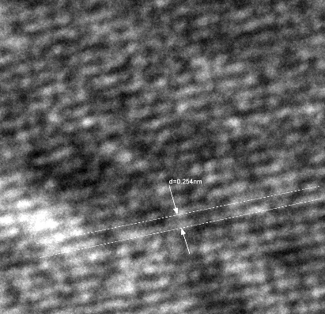
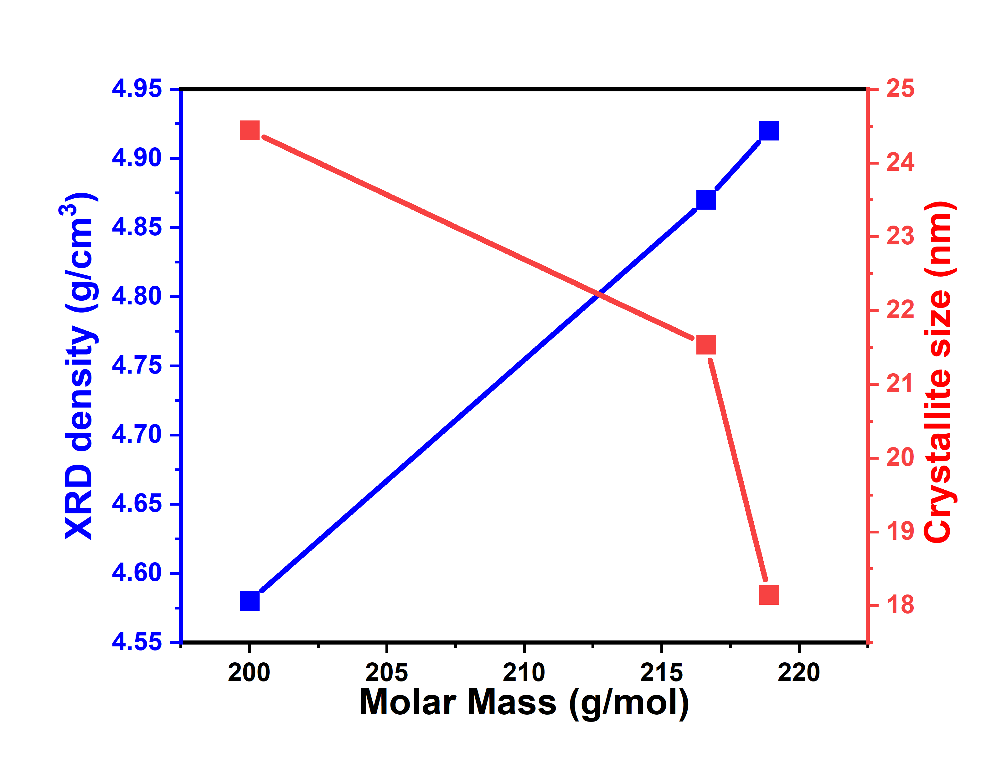
Figure 3: HRTEM micrograph of (a)MgFe₂O₄ (b)MgFe_{1.8}La_{0.2}O₄ (c) MgFe_{1.8}Sm_{0.2}O₄ annealed at 900˚C
d=0.138nm
(a)
(b)
d= 2.84nm
d=0.254nm
(c)
Figure 2: Shows the trend in crystallite size and XRD density with increasing dopant molar mass at 900 °C annealing temperature.

The HRTEM images in Figure3 revealed clear lattice fringes suggestive of the high crystallinity of the samples. In the undoped MgFe₂O₄ (Figure 3a), well-defined lattice fringes were observed with an interplanar spacing (d-spacing) of 0.138 nm. The corresponding SAED pattern shows common center diffraction rings with distinct bright spots, an indication of polycrystalline nature, co-relating with the XRD results discussed above. La doping (Figure 6b) slightly increased the lattice spacing (d = 0.284 nm), which can be attributed to the introduction and presence of the larger La³⁺ ion (1.032 Å) compared to Fe³⁺ (0.645 Å) into the crystal lattice. Sm-doped sample (Figure 3c) showed lattice fringes with a d-spacing of 0.254 nm. The slightly smaller d-spacing compared to the La-doped sample can be related to the smaller ionic radius of Sm³⁺ (0.958 Å) compared to La³⁺, but still larger than Fe³⁺, causing a fair lattice expansion. The SAED patterns for both doped samples confirm the polycrystalline nature with preserved spinel symmetry, yet with broadened and slightly scattered diffraction rings in the Sm-doped case, confirms increased lattice disorder and reduced crystallite size, consistent with the XRD analysis above and with the finding of Kumbhar, R.N et al.[4].

Optical analysis

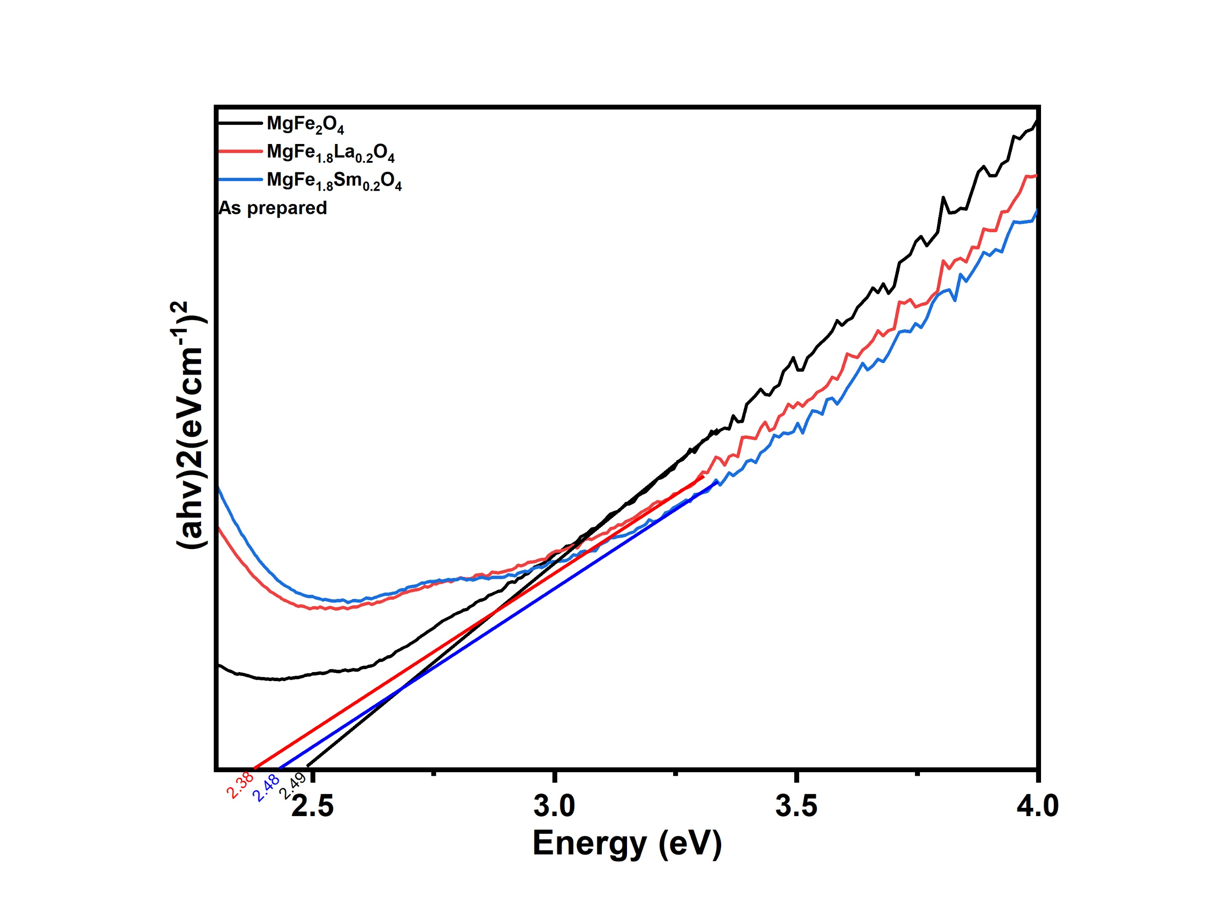
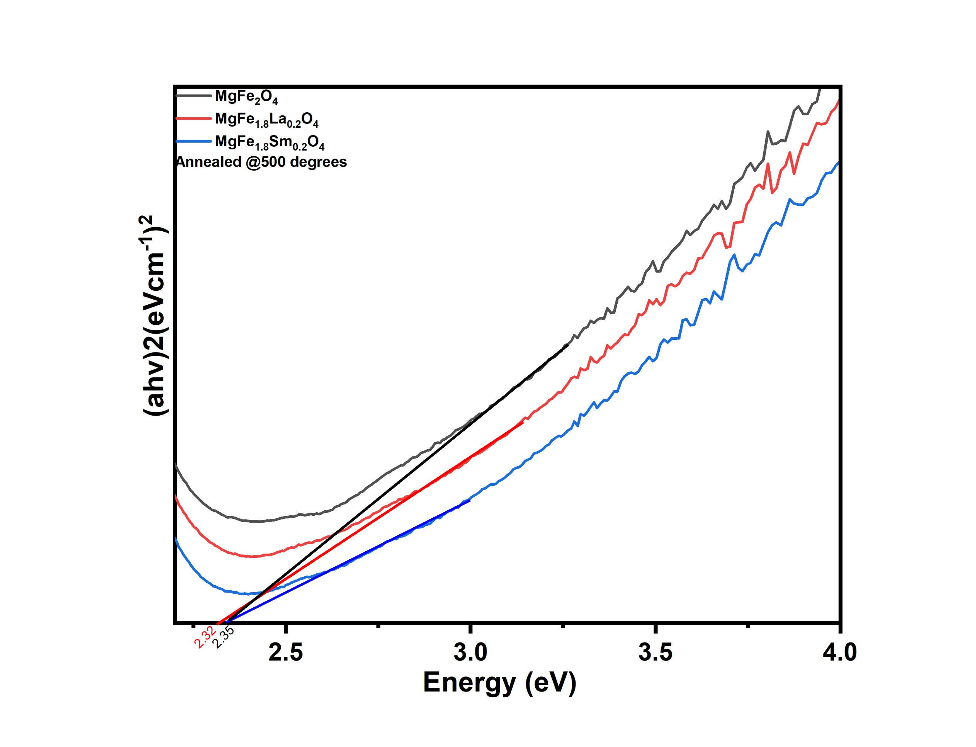
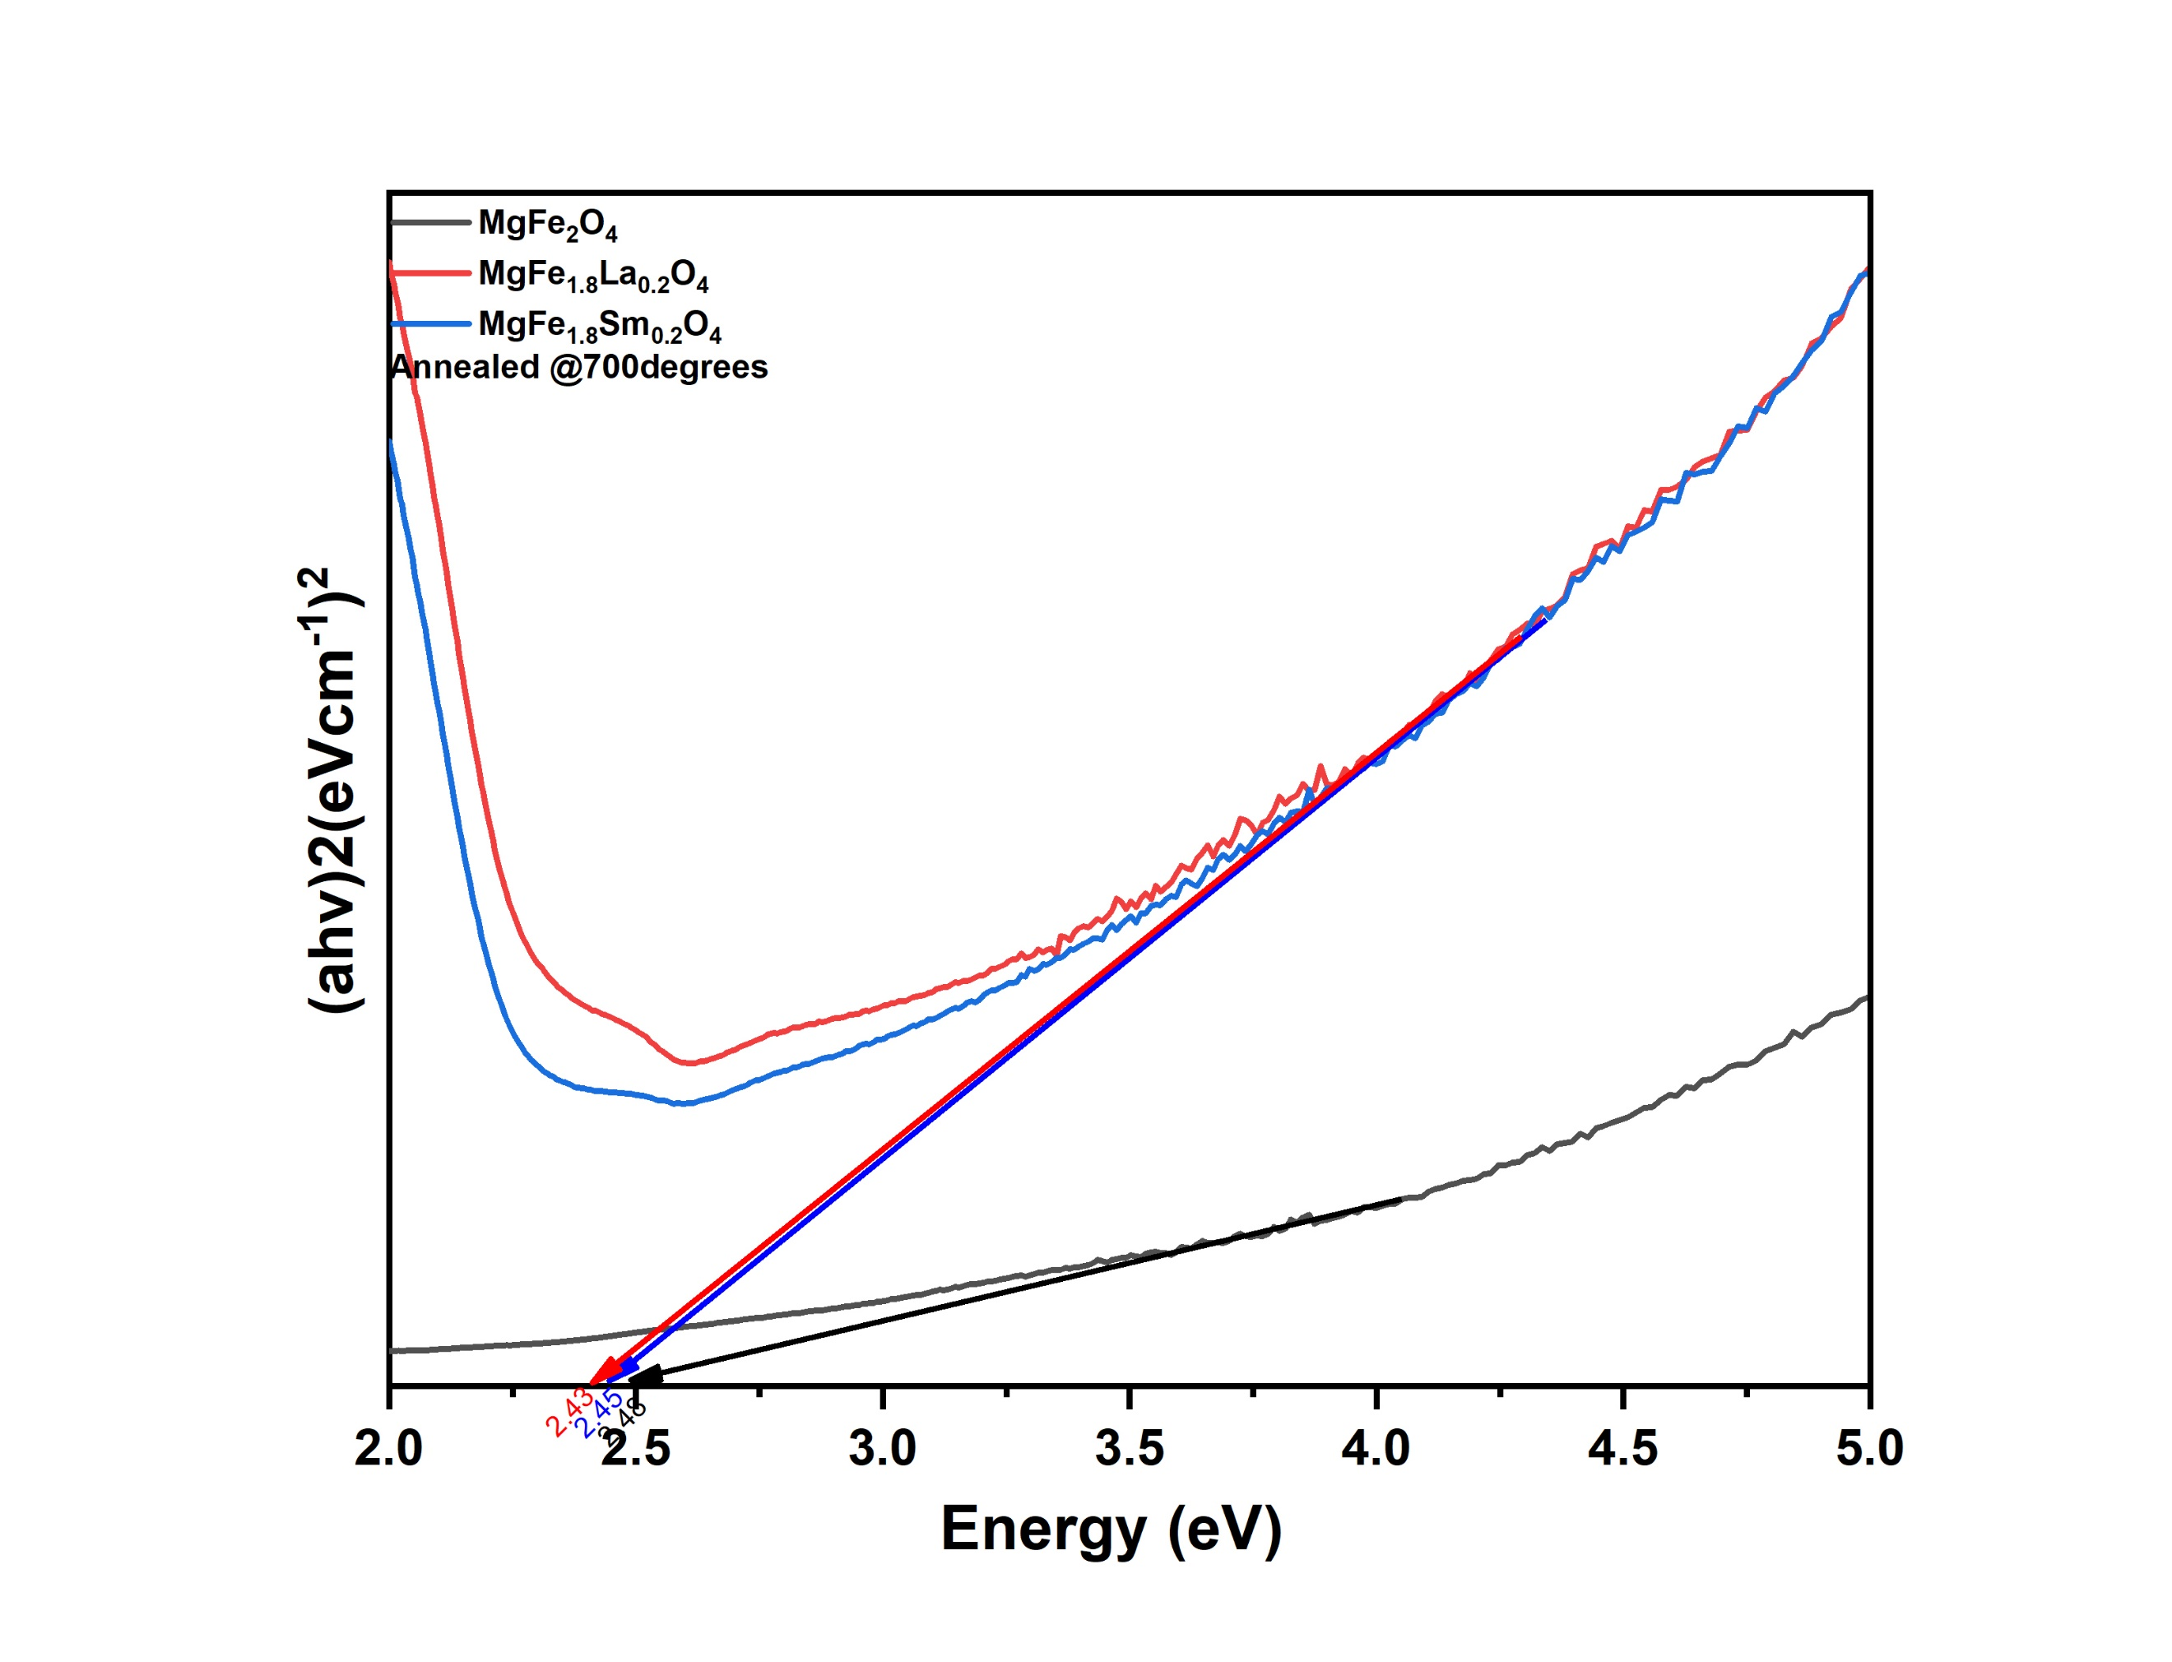
The optical properties of the samples were studied using UV-Vis and Photoluminescence spectroscopy. The bandgap from UV-visible spectroscopy was estimated using Tauc’s plot. The estimated values of the band gap were observed to decrease with increasing molecular formula of the dopant. Additionally, it can be observed that annealing temperatures greatly affect the band gap. From Figure 4 (a-d), the bandgap of MgFe2O4 is observed to be widening with increasing annealing temperature, which can be attributed to increasing crystallinity and ordered lattice arrangement. On the other hand, the La, Sm-Variants of MgFe2O4. fluctuate between widened and reduced bandgap. Of interest are the results found at an annealing temperature of 900℃, where a difference in bandgap energy of undoped and doped samples can easily be observed. At this temperature, the band gap for undoped magnesium ferrite was found to be 2.60eV and rare earth substitution showed to reduce the band gap. As the atomic weight of the rare earth increased so did the band gap, this was suggested by the band gap of Magnesium doped with lanthanum and samarium being 2.11 & 2.35 respectively. The PL spectra, shown in Figure 5(a–d), show notable emission peaks in the visible region (∼490–510 nm), with peak intensities centered at 495nm and 505nm. Figure 5(a) shows the undoped sample to have dual light emission while doping seems to suppress the duality into a single peak emission. Additionally, doping with La³⁺ lowered the PL intensity while doping with Sm³⁺ made no impact. As the annealing temperature increased (Figures 5b–d), the PL intensity of undoped MgFe₂O₄ first increased at 500 °C and 700 °C, then slightly reduced at 900 °C. This trend indicates improved crystallinity and reduction of surface defects at intermediate temperatures, followed by potential dopant diffusion or grain growth-induced quenching at higher temperatures [1]. In contrast, both La- and Sm-doped samples consistently exhibited suppressed PL intensity across all annealing stages, which implies lower-electron-hole recombination[1]. These findings are consistent with those of Tony A.R et al [1]who concluded that higher doping concentrations suppresses PL intensity, and this reveals efficient charge carrier separation, an excellent photocatalytic ability property.
(b)
(a)
(c)
(d)
Figure 4: Tauc’s plots of MgFe₂O₄, MgLa₀.₂Fe₁.₈O₄, and MgSm₀.₂Fe₁.₈O₄ at different annealing temperatures: (a) As-prepared, (b) 500 °C, (c) 700 °C, and (d) 900 °C

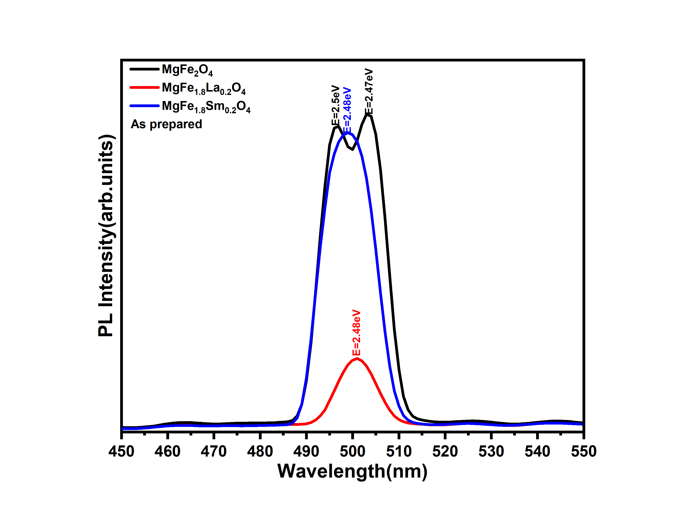
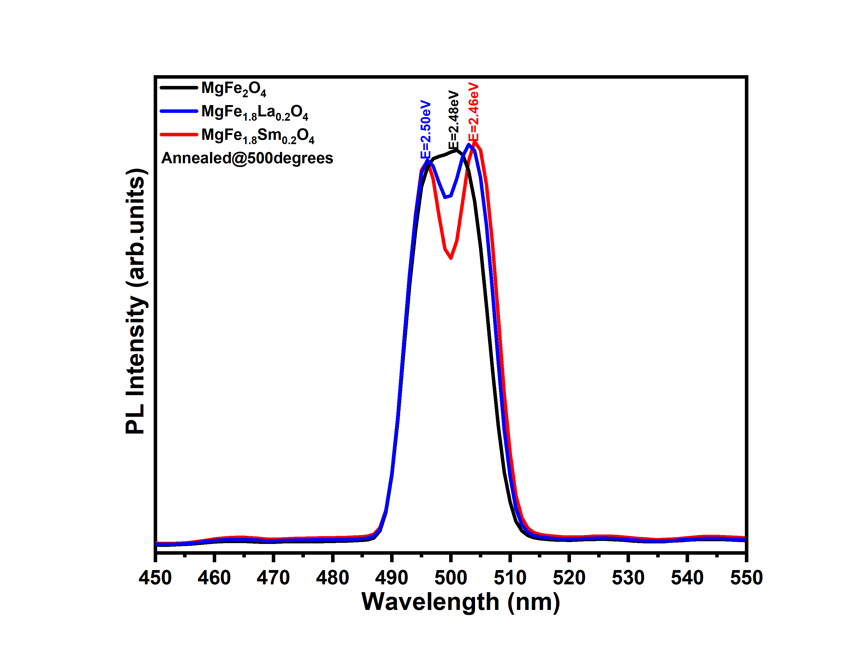
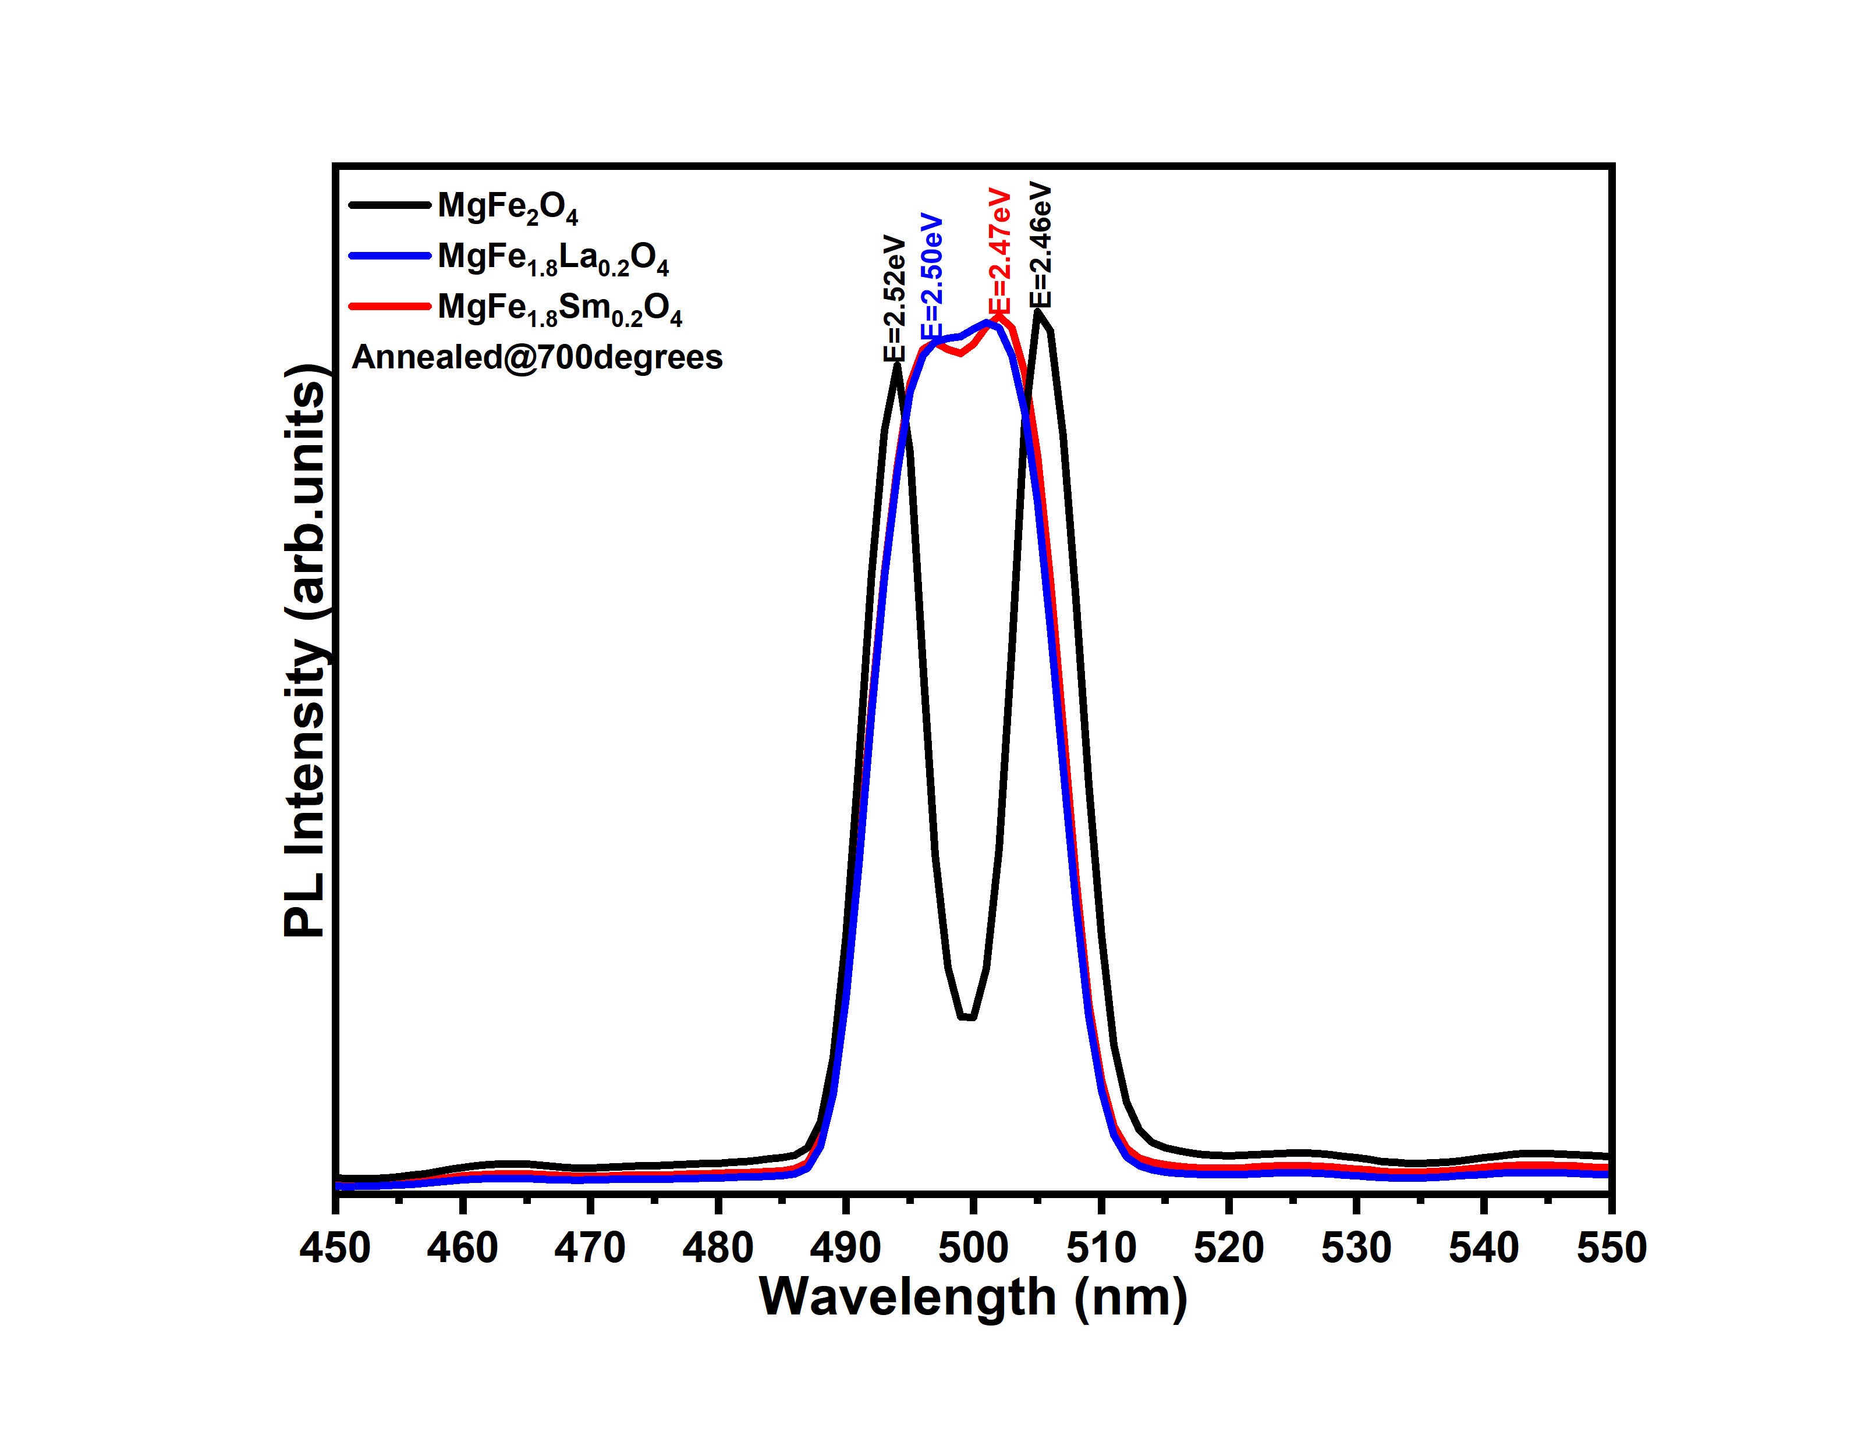
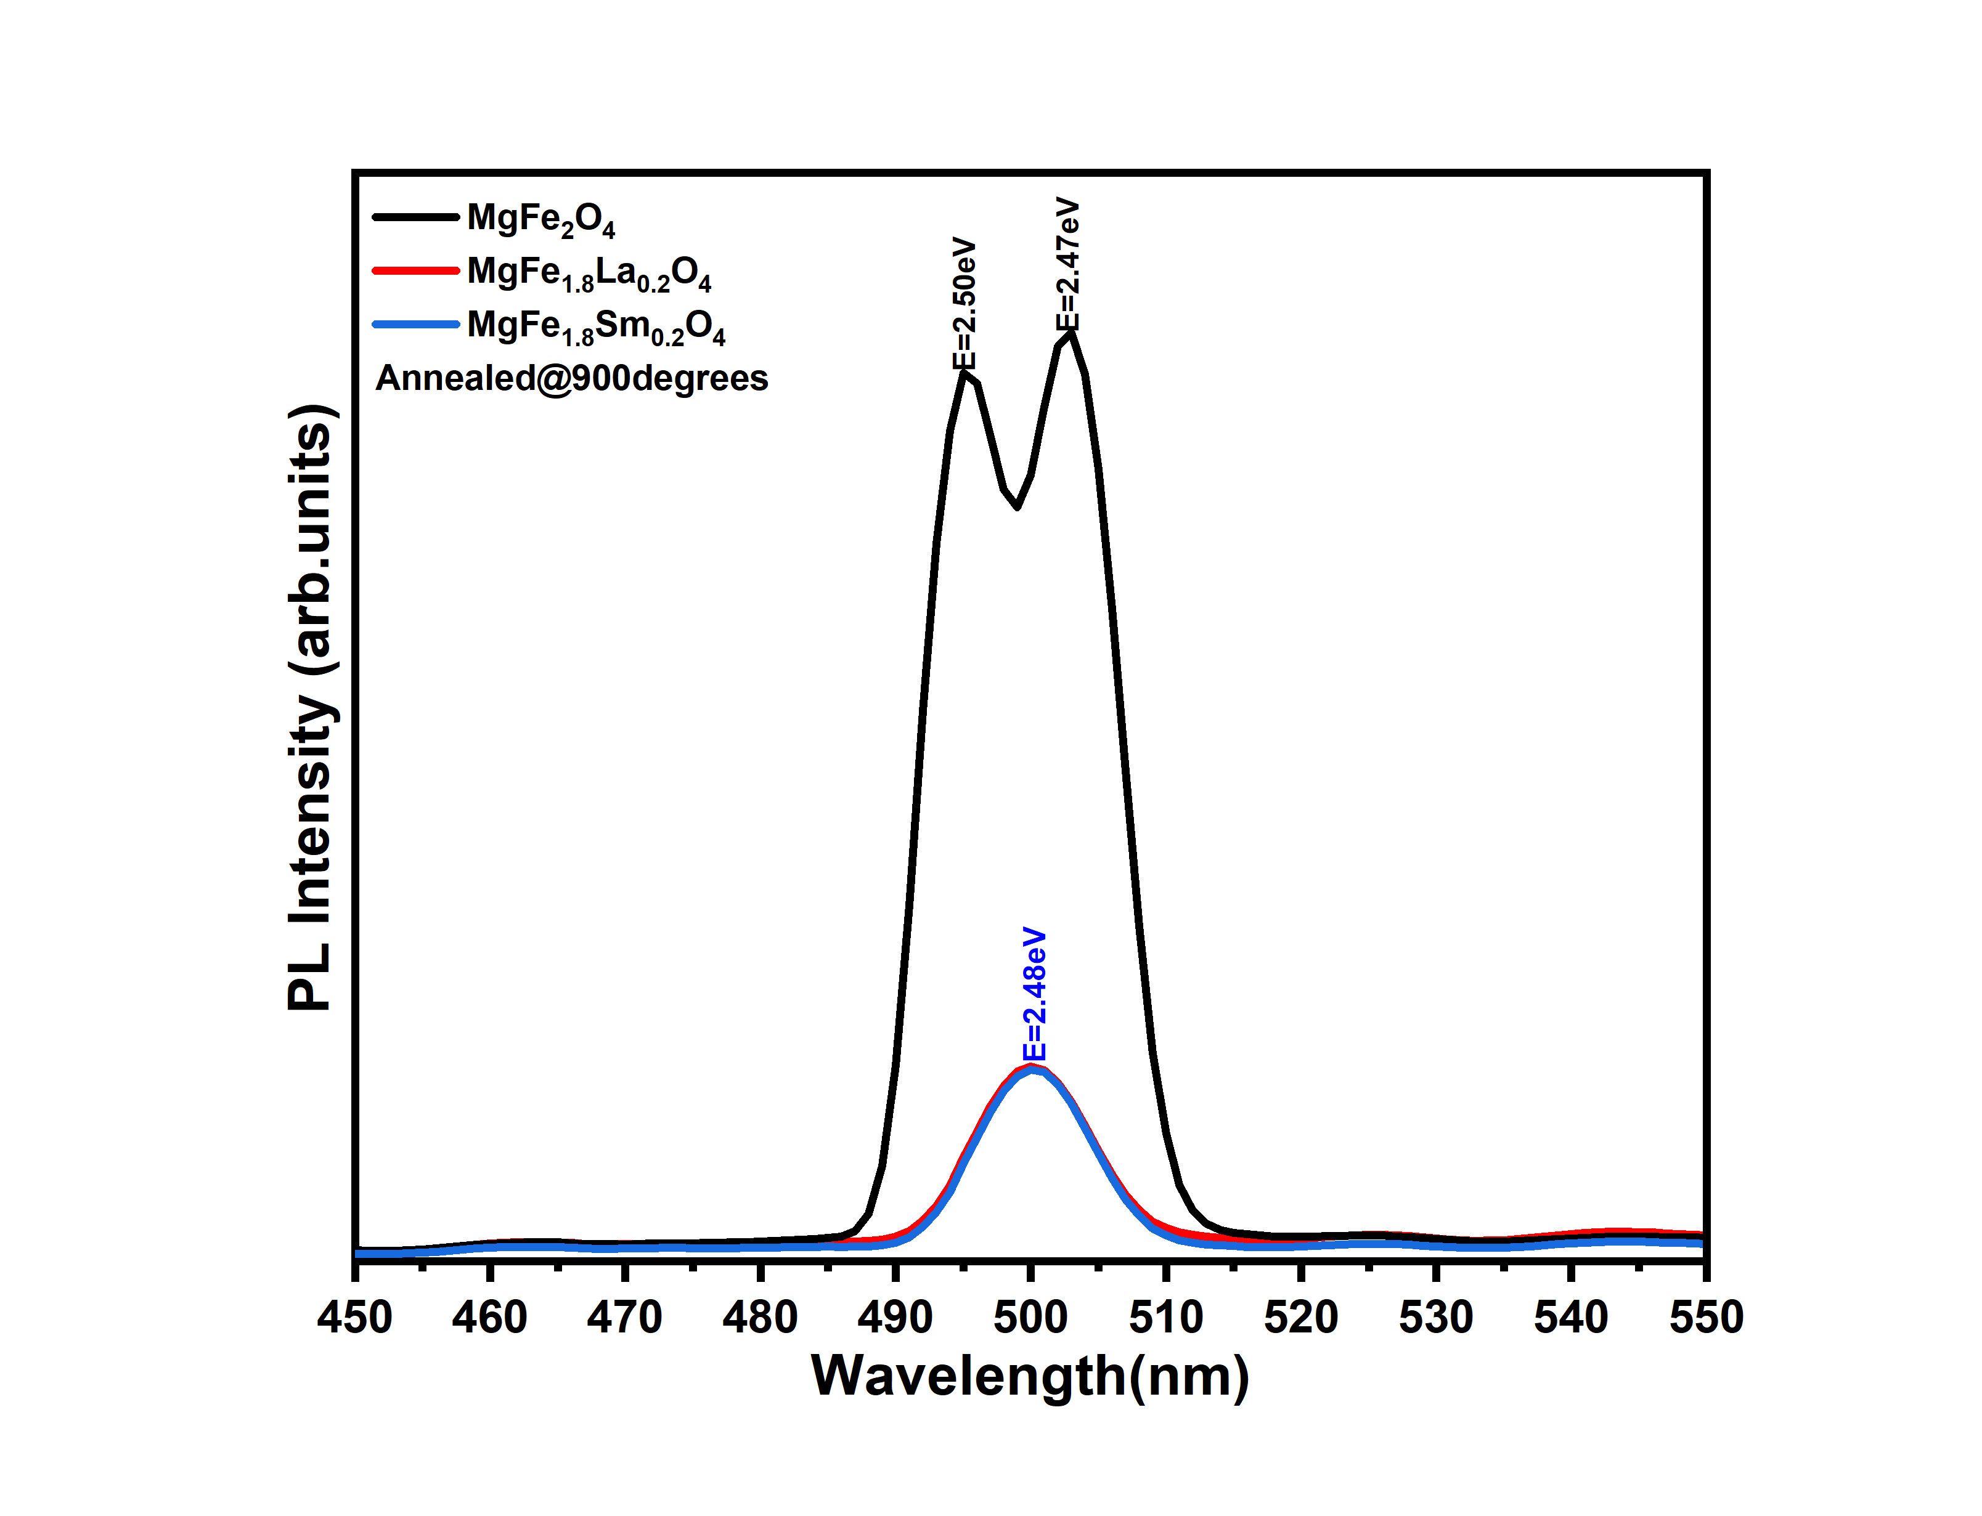
Conclusion
(a)
(b)
(c)
(d)
Figure 5: Deconvoluted emission spectra of the samples (a) as prepared and (b) 500$℃$ ,(c) 700$℃$, (d) 900$℃$
Rare-earth (Re=La,Sm) doped magnesium nano ferrites were effectually synthesized following a hydrothermal approach. XRD authenticated the formation of spinel ferrite with varying crystallite sizes ranging from 3nm to 24nm. Doping with La³⁺ and Sm^{3+,} decreased the crystallite size from 24nm to 21,5nm and 18,1nm respectfully and increased XRD density. The band gas was reduced from 2.60eV to 2.11eV (La3+) and 2.35eV (Sm3+). The PL spectra showed an increased electron-hole pair separation with rare-earth doping. Therefore, MgFe2O4 can be proposed as a good candidate for advanced application in sensors.
References
[1] A. R. Tony and A. J. Verjhula, "Yttrium doped magnesium ferrite nanoparticles: a potential solar light driven photocatalyst for deterioration of hazardous dyes," Journal of Materials Science: Materials in Electronics, vol. 35, no. 7, p. 481, 2024.
[2] P. S. Mkwae et al., "Insightful acetone gas sensing behaviour of Ce substituted MgFe2O4 spinel nano-ferrites," Journal of Materials Research and Technology, vol. 9, no. 6, pp. 16252-16269, 2020.
[3] R. Kumbhar, T. Shinde, S. Kamble, V. Mathe, and J. Ghodake, "Influence of rare earth ions (Sm3+, Dy3+) substitution on magnetic and microwave performance of magnesium ferrite," Physica B: Condensed Matter, vol. 619, p. 413161, 2021.
[4] R. Kumbhar et al., "Structural, magnetic and dielectric properties of rare earths (Sm3+, Dy3+) substituted MgFe2O4," Indian Journal of Physics, vol. 98, no. 9, pp. 3251-3258, 2024.
[5] E. Fantozzi, E. Rama, C. Calvio, B. Albini, P. Galinetto, and M. Bini, "Silver doped magnesium ferrite nanoparticles: physico-chemical characterization and antibacterial activity," Materials, vol. 14, no. 11, p. 2859, 2021.

