Ab initio studies of Pt-Cr alloys for jewellery applications: energetic stabilities and structural properties

Mawisha Mafifi¹, Donald Mkhonto², Chewe Fwalo¹, Maje Phasha², and Edwin Mapasha¹
¹Department of Physics, University of Pretoria, Private bag X20, Hatfield, 0028, South Africa,
²Advanced Materials Division, MINTEK, Private bag X3015, Randburg, 2125, South Africa

E-mail: mawisham@gmail.com
Abstract. The platinum (Pt)-based materials are widely used in various industries applications; including metallurgy, medicine, jewellery, fuel cells, and hydrogen evolution reactions due to their excellent electrochemical properties. However, in its pristine form, Pt is relatively soft, thus prone to surface scratching, a concern in jewellery applications. Hence, alloying to enhance its mechanical integrity is key to improving scratch resistance. This study employs density functional theory (DFT) within Quantum Expresso package calculations to investigate the effect of alloying Pt with high corrosion resistant chromium (Cr) element on phase stability, structural and mechanical properties. Moreover, the computed energetic and electronic properties provided an insights perspective into Pt_{100−x}Cr_{x} material stability as alloy composition of Cr soar.

Introduction
Since the resurgence of platinum (Pt)-based jewellery before the 1990s, Pt has become one of the key precious metals in jewellery manufacturing. It is often regarded as a cornerstone of the jewellery industry, particularly in the global market for marriage and engagement rings [1, 2]. This is due to its unique lustrous white colour [3], purity and consistency [2], as well as its resistance to wear and alteration over time [1].
In its pure form (1000 parts per thousand, or ppt), Pt is relatively soft. The hardness of pure Pt is relatively low, reaching only around 40 on the Vickers hardness scale [3]. For this reason, pure Pt is not commercially viable for jewellery applications, especially items like engagement and wedding rings, are precious objects often passed down through generations [1]. To address this issue, Pt is alloyed with other metals to increase its hardness and overall durability, making it more suitable for long-lasting.
Recently, the jewellery industry has classified Pt-based alloys into three main categories based on their Pt content: Pt at 950, Pt at 900, and Pt at 850 parts per thousand. These alloys typically range in Pt content from 95% to 85%. However, this narrow range leaves minimal room for further modification of Pt, as even small changes in composition can significantly alter the physical and mechanical properties required for jewellery applications. A 95% Pt can be alloyed with up to 5% of a chosen alloying element, due to its natural softness, it is prone to surface scratching, which poses a concern in jewellery applications. Therefore, alloying Pt is essential to enhance its mechanical properties, particularly to improve scratch resistance [1-3].
Despite significant research on Pt-based alloys, there remains a gap in understanding the atomic-scale interactions between Pt and chromium (Pt-Cr) and how these interactions affect the alloy's mechanical performance. Additionally, the long-term stability and phase behaviour of Pt-Cr alloys under operational conditions are not fully understood. This study, using DFT calculations within the Quantum Espresso package, aims to address this gap by providing a comprehensive analysis of Pt-Cr alloy formation, electronic structure modifications, and their influence on mechanical properties.

Methodology
The DFT approach was employed for carrying out calculations using the PWscf code from the Quantum ESPRESSO distribution [4]. The Perdew-Burke-Ernzerhof (PBE) [5]functional within the general gradient approximation (GGA) was used to construct the exchange-correlation potential energy. Methfessel-Paxton smearing (MP) was applied with a broadening value of 0.05 eV [5]. A converged cutoff energy of 400 eV was determined to yield reliable results. For Brillouin zone integration, a Monkhorst-Pack special k-point grid of 7×7×7 was utilized for the 2×2×2 supercell containing 32 atoms. This methodological framework was employed to explore the structural properties and energetic stabilities of the Pt_{100-x}-Cr_{x} alloys for various compositions. The corresponding crystal structures of various alloys compositions are shown in Figure 1.

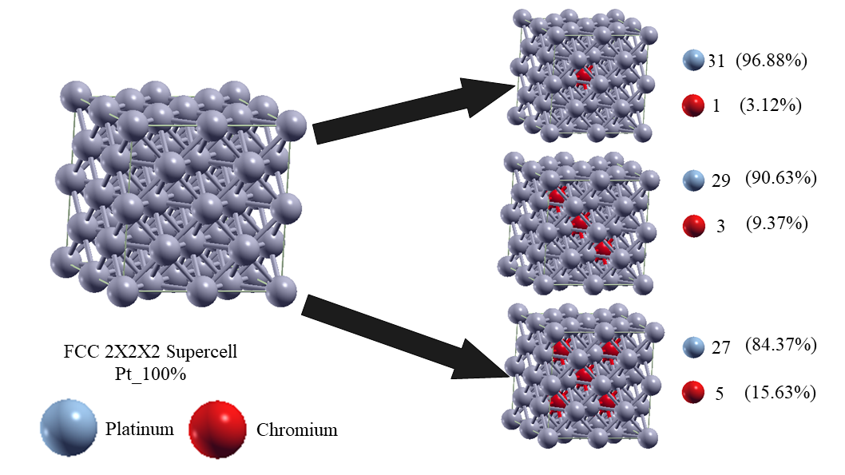

Figure 1: The ball and stick geometry models of pristine 2×2×2 Supercell of Pt (100% Pt composition) as well as Pt_{100−x}Cr_{x,} where X = 3.13, 9.38, and 15.63.

Results and Discussion
In this study, a 2×2×2 face-centered cubic supercell containing 32 Pt atoms was used, as shown in Figure 1. Before introducing any Cr alloying, full structural optimization was performed on the 1×1×1 (unit cell) pristine FCC structure to obtain its ground state properties, ensuring that they are comparable to experimental values. Table 1 presents the calculated equilibrium lattice parameter and cohesive energy of the pristine Pt FCC structure. The predicted lattice constant is 3.99 Å, which is in good agreement with previously reported experimental values of 3.93 Å [6] and DFT results of 3.98 Å [7]. At the equilibrium lattice constant, the corresponding cohesive energy is 5.42 eV, slightly lower than the experimental value of 5.84 eV[8]. These results, obtained using full geometry optimization criteria, are further supported by the manual variation of cohesive energy with respect to changes in lattice constants, as shown in Figure 2, where the red horizontal line indicates the equilibrium structure.

Pt composition | Lattice Constant (Å) | Cell volume  (Å³) | Cohesive energy (eV) | Δ_{Cohesive energy} (eV)
100% (Pristine) | 7.98 | 508.17 | 5.42 | 0.00
96.88% | 7.93 | 498.68 | 4.88 | 0.54
90.63% | 7.84 | 481.89 | 4.73 | 0.15
84.38% | 7.75 | 465.48 | 4.71 | 0.02

Table 1: The calculate equilibrium lattice constants (Å), volume cells (Å³) and cohesive energies (eV) of the pristine Pt and various Pt-Cr alloy compositions in a 2×2×2 FCC supercell. Δ_{Cohesive energy} (eV) is the change in energy relative to subsequence Cr% concentration.

Furthermore, the equilibrium lattice constants and energetic stability of Pt₁₀₀₋ₓCrₓ alloys (their diagrams shown in Figure 1 were investigated and presented in Table 1. As shown in Table 1 and Figure 2, substituting Pt atoms with Cr atoms leads to a slight, approximately linear decrease in the lattice constant, with the extent of reduction depending on the alloy composition. This trend is consistent with the findings of Murakami et al., [7] which studied Pt₁₀₀₋ₓIrₓ and Pt₁₀₀₋ₓRuₓ compositions. Consequently, the cohesive energy also decreases slightly with increasing Cr concentration. For example, the Pt_{84.38}Cr_{15.62} alloy exhibits an equilibrium lattice constant of 7.75 Å and a cell volume of 465.48 Å³, resulting in a cohesive energy of 4.71 eV. The Pt_{90.63}Cr_{9.37} alloy yields a cohesive energy of 4.73 eV from the lattice constant of 7.84 Å and cell volume of 481.89 Å³, while the Pt_{96.88}Cr_{3.13} alloy yields a cohesive energy of 4.88 eV from the lattice constant of 7.93 Å and cell volume of 498.68 Å³. It was confirmed that the slight decrease in lattice parameter is influenced by increasing Cr concentration due to its smaller atomic radius compared to Pt, which consequently reduces the cell volume. This leads to variations in the bonding network between Pt-Pt, Pt-Cr, and Cr-Cr interactions in the Pt₁₀₀₋ₓCrₓ alloy system. Within the Cr concentration range of 0% to 15.62%, the Pt₁₀₀₋ₓCrₓ alloy system still maintains structural integrity as indicated by the negligible change in cohesive energy (Δ _{Cohesive energy}). This suggests that at higher Cr concentrations in the Pt system, the alloy may not lose phase stability, hence encouraging this study to continue examine other properties such as mechanical, energetic, and elastic properties.
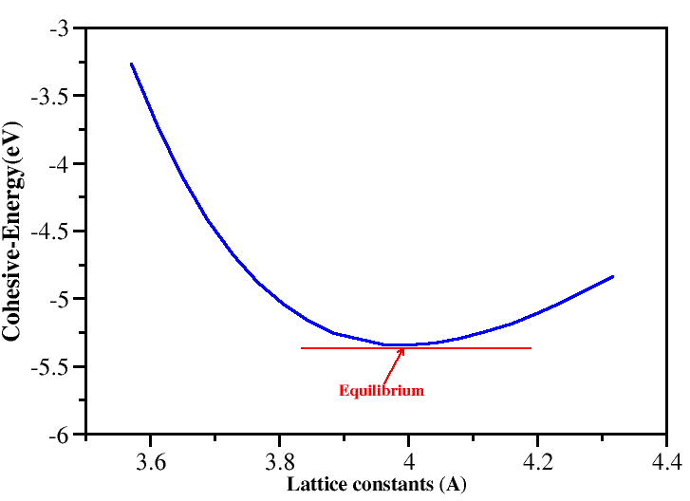
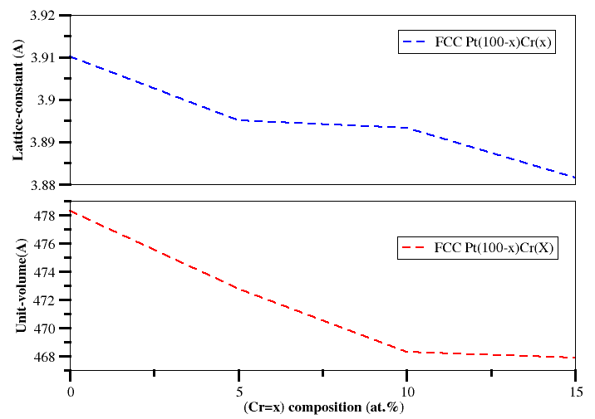
(a) (b)

Figure 2. (a) Variation in cohesive energies (eV) as a function of lattice constants (Å). The red horizontal line (tangent) touches the equilibrium lattice parameter. (b) Lattice constants (top plot) and cell volume (bottom plot) as a function of Pt-Cr compositions.

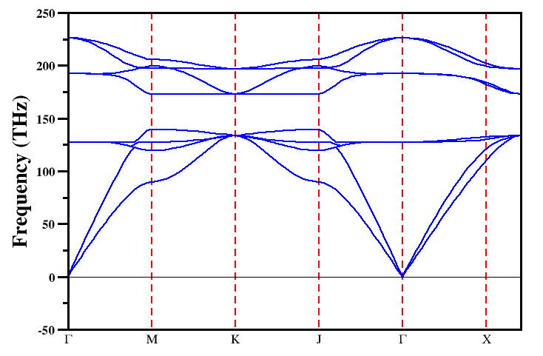
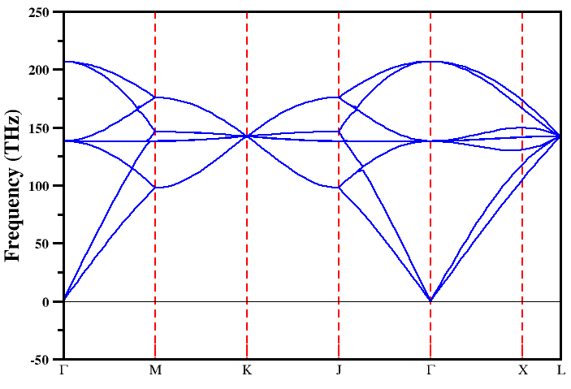

(b) Pt _{84.38} Cr_{15.62} alloy
(a) Pt₁₀₀ composition

Figure 3: The calculated phonon dispersion relations of the (a) Pristine Pt material system and (b) Pt _{84.38} Cr_{15.62} alloy system.

Figure 3 presents the phonon dispersion curves for both the Pt 100% composition and the Pt _{84.38} Cr_{15.62} alloy composition (the structure with the highest Cr content considered in this study), used to evaluate the dynamical stability of the materials. It is noted in Figure 3(a) that Pt 100% composition phase possess positive modes through the entire spectrum of wave vectors, in agreement with the previous studies. The Pt _{84.38} Cr_{15.62} alloy composition (Figure 3(b)) retains the positive modes dispersions which confirms dynamical stability under ambient conditions.

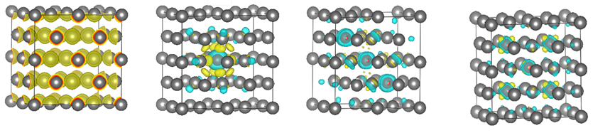
- Pt₁₀₀ (b) Pt_{96.88}Cr_{3.13} (c) Pt_{90.63}Cr_{9.37} (d) Pt_{84.38} Cr_{15.62}

Figure 4: The charge density distribution of (a) Pristine Pt material system, (b) Alloyed Pt system (Pt₁₀₀) (Pt_{96.88}Cr_{3.13}), (c) Alloyed Pt system (Pt_{90.63}Cr_{9.37}) and (d) Alloyed Pt system (Pt _{84.38} Cr_{15.62})

Figure 4(a) presents the charge density distribution for the Pt 100% composition. It can be observed that the charge is uniformly distributed across all Pt atoms within the unit cell. This suggests that the bonding in the Pt 100% composition structure is likely covalent in nature. To investigate the charge interaction between Cr dopants and the Pt host atom in Pt-Cr alloy compositions, the charge density differences were calculated, as shown in Figure 4(b-d). In this figure 4(b-d), the yellow clouds represent charge depletion, while cyan clouds indicate charge accumulation. These calculations were performed at an iso-value of 0.002 e/Å³. It is evident that the majority of the charge is transferred from the Cr atoms to their nearest neighbour Pt atoms. As the Cr percentage increases (9.37% and 15.62%), the accumulated charge extends over a larger region of the cell.
The charge interactions between Pt and Cr alloys were quantified using Bader charge analysis [9] to better understand the electron transfer between the overlapping d-orbitals and s-orbitals of Pt and Cr. For the Pt₃₁Cr₁ alloy composition, a charge transfer of 1.38 e⁻ was observed from the Cr atom to the Pt atom. This charge transfer slightly decreased as the Cr content increased; for instance, the Pt_{96.88}Cr_{3.13} alloy showed a transfer of 1.16 e⁻, while the Pt₈₄.₃₈Cr₁₅.₆₂ alloy showed a transfer of 1.15 e⁻. These results are not particularly surprising, given that Pt (2.28) is more electronegative than Cr (1.66) on the Pauling scale.

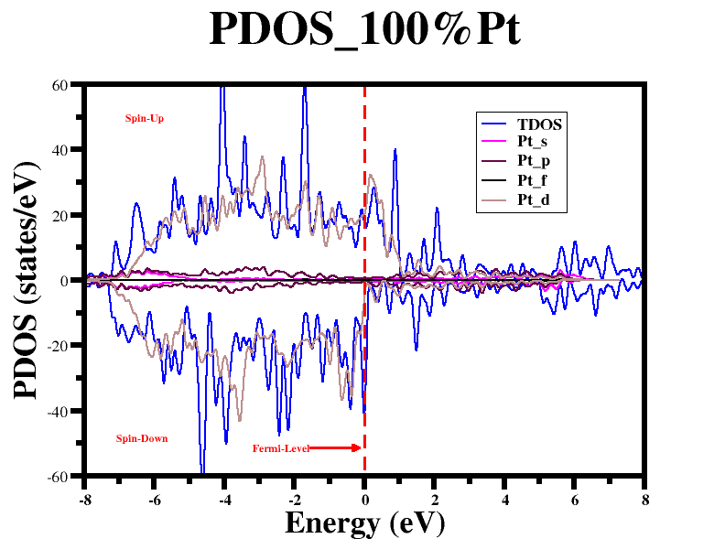
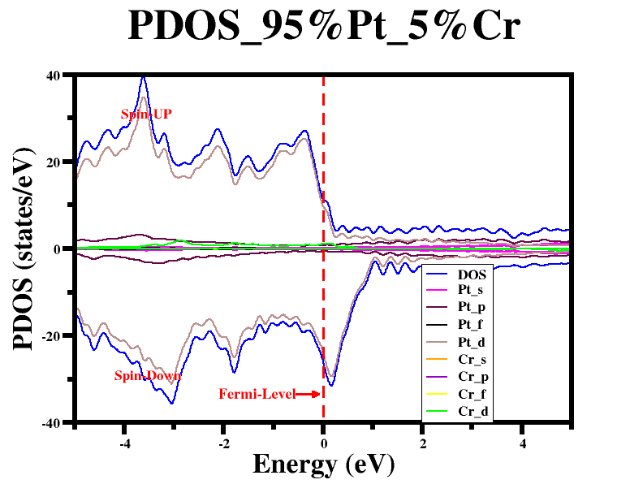

Pt₁₀₀
(b) Pt_{96.88}Cr_{3.13}
(a) Pt₁₀₀
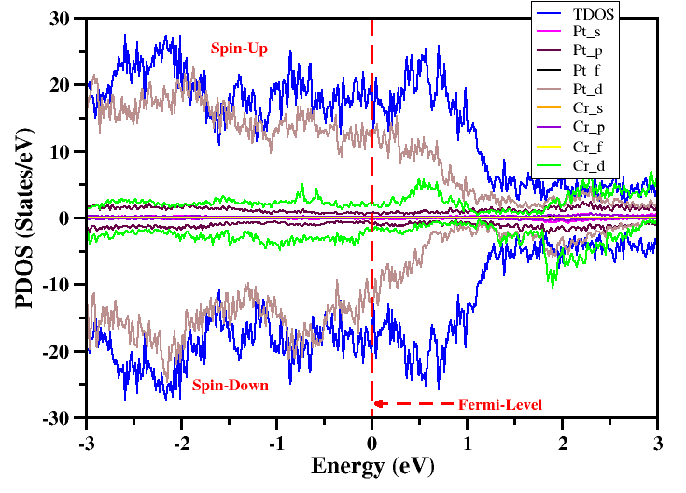
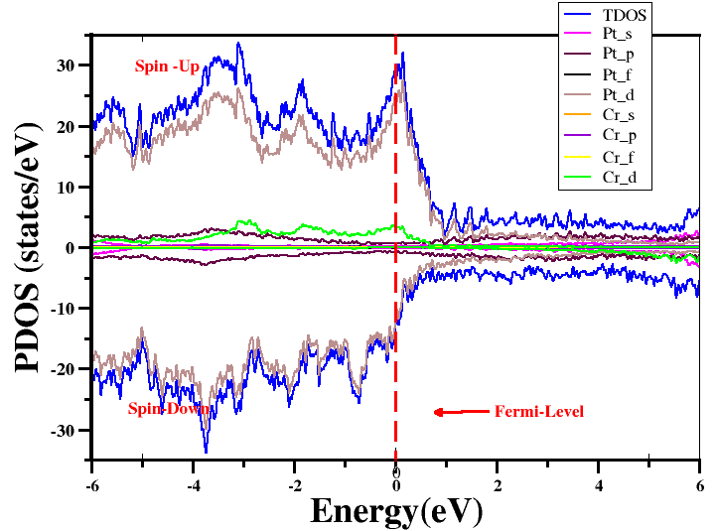

(c) Pt_{90.63}Cr_{9.37}
(d) Pt_{84.38} Cr_{15.62}

Figure 5: The calculated total and partial density of states for (a) Pt₁₀₀ composition, (b) Pt_{96.88}Cr_{3.13} composition, (c) Pt_{90.63}Cr_{9.37} composition, and (d) Pt_{84.38} Cr_{15.62} composition.

The electronic properties are crucial in jewellery applications, where conductivity plays a key role. To explore this, we investigated the enhancement of electrical conductivity in pristine Pt material due Cr alloy compositions. This was achieved by calculating the Density of States (DOS) and Partial Density of States (PDOS), as shown in Fig. 5.
The results revealed that for the Pt₁₀₀ composition (Fig. 5a), high peaks of electronic states were observed along the Fermi level, with the valence and conduction bands overlapping. This suggests that Pt exhibits metallic behaviour upon doping with 3.13% Cr, a significant decrease in the electronic states along the Fermi level was observed (Fig. 5b). Despite this reduction, the electronic conductivity of the system remained intact. For the Pt_{96.88}Cr_{3.13} system (Fig. 5c), a slight increase in electronic states along the Fermi level was observed. This could be attributed to the hybridization of Cr d-orbitals with Pt d-orbitals, further suggesting that doping with Cr increases the ductility of the Pt material [10]. Finally, for the Pt_{84.38} Cr_{15.62} system (Fig. 5d), no substantial change in electronic states was observed. This can be attributed to the saturation of the system with Cr. Nonetheless, the metallic nature of the system was preserved, as indicated by the overlapping bands. Ultimately, these findings suggest that alloying Pt with Cr atoms stabilizes its electronic conductivity, even at higher concentrations, which is significant for jewellery applications.

Conclusion
This study aims to enhance the mechanical strength of Pt FCC alloys using Cr as an alloying element, with a focus on jewellery applications, employing first-principles methods. We investigate the structural properties, cohesive energies, and electronic characteristics through DFT calculations. The results reveal a decreasing trend in lattice parameters as the Cr content increases, due to the smaller atomic radius of Cr. This trend also extends to cohesive energy and cell volume, which both decrease with higher Cr composition. Phonon dispersion analysis indicates the material's dynamical stability, as evidenced by positive frequencies. Additionally, strong electronic interactions between Pt and Cr were observed, particularly with charge accumulation around the Pt atoms. An increase in Cr-d orbital density of states at the Fermi level as Cr concentration rises suggests the potential for improved ductility, making the material suitable for jewellery applications.

References
- Stamenkovic, V., et al., Changing the activity of electrocatalysts for oxygen reduction by tuning the
surface electronic structure. Angewandte Chemie International Edition, 2006. 45(18): p. 2897-2901.
- Climent, V., N. Marković, and P. Ross, Kinetics of oxygen reduction on an epitaxial film of palladium
on Pt (111). The Journal of Physical Chemistry B, 2000. 104(14): p. 3116-3120.
- Marković, N., et al., Surface electrochemistry on an epitaxial palladium film on Pt (111): surface
microstructure and hydrogen electrode kinetics. Surface science, 2000. 465(1-2): p. 103-114.
- Giannozzi, P., et al., QUANTUM ESPRESSO: a modular and open-source software project for
Quantum simulations of materials. Journal of physics: Condensed matter, 2009. 21(39): p. 395502.
- Perdew, J.P., K. Burke, and M. Ernzerhof, Generalized gradient approximation made simple. Physical
review letters, 1996. 77(18): p. 3865.
- Feng, J., Xiao, B., Chen, J., Du, Y., Yu, YJ., Zhou, R.: Stability, thermal and mechanical properties of PtxAly compounds. Mater. Des. 32(6). 3231-3239(2011).
- Murakami, T., et al., The effect of solute elements on hardness and grain size in platinum based binary
alloys. Materials transactions, 2008. 49(3): p. 538-547.
- C Kittel Introduction to Solid State Physics 5th edn (New York : Wiley(1976)
- Tang W., Sanville E., Henkelman G.A grid-based Bader analysis algorithm without lattice bias J. Phys.: Condens. Matter, 21 (8) (2009), Article 084204
- R. Fletcher, Comput. J., 13, 317 (1970)

