Cooperative Energy Transfer and Upconversion Luminescence of Sr₅(PO₄)₃OH:Eu³⁺,Yb³⁺ phosphor powders
P.P. Mokoena^{1*}, B. M. Jaffar², H.C. Swart³, O.M. Ntwaeaborwa¹
¹Department of Physics and Earth Sciences, Sol Plaatje University, Kimberley, South Africa
²School of Physics, University of the Witwatersrand, Private Bag 3, Johannesburg, South Africa
³Department of Physics, Box 339, University of the Free State, Bloemfontein 9300, South Africa
E-mail address: puseletso.mokoena@spu.ac.za

Abstract. In this study, strontium hydroxyapatite (Sr₅(PO₄)₃OH) doped with europium (Eu³⁺) and ytterbium (Yb³⁺) were successfully synthesized by combustion method. The structural, morphological, and optical properties of the phosphors were determined using X-ray diffraction (XRD), high resolution scanning electron microscopy (HRSEM), energy dispersive X-ray spectroscopy (EDS), and photoluminescence (PL) spectroscopy. XRD data confirmed crystallization of pure hexagonal phase of Sr₅(PO₄)₃OH and HRSEM demonstrated a network of particles with uneven shapes having small bright particles on the surfaces of the larger particles. The EDS analysis confirms that bright particles were dominated by rare earth elements, while darker particles are primarily composed of the host material. Upon UV excitation, prominent orange emission and minor red emission peaks corresponding to Eu³⁺ transitions were observed. The red emission was enhanced significantly upon co-doping with Yb³⁺, which facilitated non-radiative energy transfer from Ytterbium (Yb³⁺) to Europium (Eu³⁺). The enhanced red upconversion luminescence of Sr₅(PO₄)₃OH:Eu³⁺,Yb³⁺ phosphors show promising potential for applications in photodynamic therapy (PDT).
Keywords
Sr₅(PO₄)₃OH:Eu³⁺,Yb³⁺ ions; Phosphors; Energy Transfer; Upconversion luminescence

Introduction
The multifunctional inorganic materials have attracted considerable attention due to their wide-ranging prospective uses in the biomedical field, such as drug delivery, sensing, and bioimaging [1]. Inorganic host lattices such as phosphates materials have drawn a significant attention as a host over the years due to their diverse properties, including electric, magnetic, ferroelectric, catalytic, and optical characteristics, along with their strong resistance to heat and moisture. [2]. They have exceptional qualities like crystal structural flexibility, the capacity to incorporate a wide variety of dopant ions, biocompatibility, bioactivity, biodegradability, the lack of immunological, low cytotoxicity and inflammatory reactions [3]. Strontium phosphate (Sr₅(PO₄)₃OH) are the ideal nanomaterials due to their inexpensive nature, availability, safety, and environmental benefits [4]. Sr₅(PO₄)₃OH doped with rare earth ions such as Eu³⁺, Ho³⁺, Er³⁺, Tm³⁺, and Yb³⁺ may generate luminescence that covers from the visible to near-infrared spectrum through an up-conversion process [5]. Rare earth ions upconversion luminescence (UCL) processes depends on the abundant f-electron configurations of rare earth ions at the fundamental intermediate excitation states. They can convert two or more sub-bandgap NIR photons into a single usable above-bandgap photon. Through the decades of research, researchers have discovered that most efficient UCL are from the following rare earth ions: Er³⁺/Ho³⁺/Tm³⁺ and Yb³⁺ in which energy transfer upconversion mechanism plays a prominent role [6]. Europium (Eu³⁺) is commonly used as a red emitting rare earth ion, but it has never been considered an UCL ion in the regime of near infrared (NIR) excitation because it cannot be directly excited by NIR. It has been found that co-doping with an infrared sensitiser (energy donor) such as Yb³⁺ ion results in the red UC emission of Eu³⁺ ion under NIR excitation. The red UCL of Eu³⁺ is due to the cooperative energy transfer (CET) mechanism from the pairs of Yb³⁺ ions to single Eu³⁺ [7]. This study, report on the UCL and CET of Sr₅(PO₄)₃OH:Eu³⁺,Yb³⁺ phosphor powders. The enhanced red emission can be used in light therapy to activate photosensitizers for treatment of tumour cells.
- Materials and methodology
Sr₅(PO₄)₃OH co-doped Eu³⁺/Yb³⁺ phosphor powders were synthesized by combustion process using urea as a fuel. Sr(NO₃)₂∙4H₂O, NH₄)₂HPO₄, Eu(NO₃)₃∙5H₂O, Yb(NO₃)₃∙6H₂O and CO(NH₂)₂ were used as precursors. Under complete reaction conditions, the theoretical equation for the formation of Sr₅(PO₄)₃OH is given by:
15Sr(NO₃)₂∙4H₂O + 9(NH₄)₂HPO₄ + 16CH₄N₂O = 3Sr₅(PO₄)₃OH + 16CO₂ + 131H₂O + 40N₂ ...................(1)
All starting materials, in stoichiometric quantities, were dissolved in 2 ml of distilled water and rapidly agitated until a thick pasty solution was formed. The solution was kept in a furnace at 600 °C. The solution boiled, dehydrated and decomposed producing combustible gases such as CO₂, NH₃ and H₂O by forming the host material. The combustion ashes were cooled to room temperature and gently grounded using a pestle and mortar yielding a fine powder. The materials synthesized were Sr₅(PO₄)₃OH, Sr₅(PO₄)₃OH:Eu³⁺, Sr₅(PO₄)₃OH:Yb³⁺ and Sr₅(PO₄)₃OH:Eu³⁺,Yb³⁺ with different concentrations of Eu³⁺ (1, 2, 3, 5, and 7 mol %), Yb³⁺ (7 mol %), and Eu³⁺:Yb³⁺ (3:7 mol %). All the powders were annealed at 800 °C in air for 2 hours.

Characterization
The phase identification of Sr₅(PO₄)₃OH powder was analysed using a Bruker AXS D8 X-ray Diffraction (XRD) with Cu Kα1 radiation (λ = 1.5406Å) in the 20 - 50° (2θ) range. The functional groups were analysed using Fourier Transform Infrared (FTIR) spectrometer in the range 400 – 2000 cm⁻¹. Particle morphology and corresponding elemental compositions of the phosphors under a vacuum of 9.634×10⁻⁵ Pa were investigated using a JEOL JSM-7800F thermal field emission scanning electron microscope (FE-SEM) equipped with Oxford Aztec 350 X-Max80 Energy x-ray Dispersive Spectroscopy (EDS). The UV-Visible spectra were evaluated using a Perkin Elmer Lambda 950 UV-Vis spectrometer. The spectrometer was operated in the diffuse reflectance mode in the range 200 -1000 nm. The photoluminescence properties were investigated by using and Cary eclipse fluorescence coupled with monochromatized xenon lamp and the upconversion measurements by photoluminescence (PL) system consisting of a fibre-coupled 980 nm NIR (near infrared) laser as the excitation source, iHR320 Horiba Yvon imaging spectrometer, R943 -02 Hamamatsu Photonics photomultiplier (PMT) detector and a SR830 Standford Research System lock-in amplifier.

4. Results and discussion

4.1 Powder X-ray diffraction analysis
The XRD pattern of Sr₅(PO₄)₃OH powder are shown in Fig. 1(a). The main diffraction peaks of Sr₅(PO₄)₃OH powder are corresponding to standard data referenced by ICDD (International Centre for Diffraction Data) Card No. 00-033-1348, with no trace or impurities or additional phases. The Sr₅(PO₄)₃OH powder crystallizes in a hexagonal structure in the P6₃/m space group [8]. The average crystallite size was 43 ± 2 nm. The sharp and narrow peaks confirm the crystallinity of the powder. Fig. 1(b) shows the crystal structure of Sr₅(PO₄)₃OH drawn by VESTA 3D visualization program referenced by ICSD (Inorganic Crystal Structure Database) Code 9011131. The Sr²⁺ ions are present in two non-equivalent cationic sites Sr(1) and Sr(2). The Sr1 and Sr2 atoms are connected to 8 and 9 oxygen atoms to constitute the distorted Sr(1)O8 and Sr(2)O9 polyhedra, respectively [2]. The Sr(1) and Sr(2) atoms crystallographic site with trigonal symmetry (C₃) is coordinated by nine oxygen atoms from the PO₄³⁻ groups, creating [Sr(1)O₉] clusters. The second Sr(2) site is seven coordinated by six oxygen atoms from the PO₄³⁻ groups and one hydrogen ion inside the hexagonal channels of the structure [8].
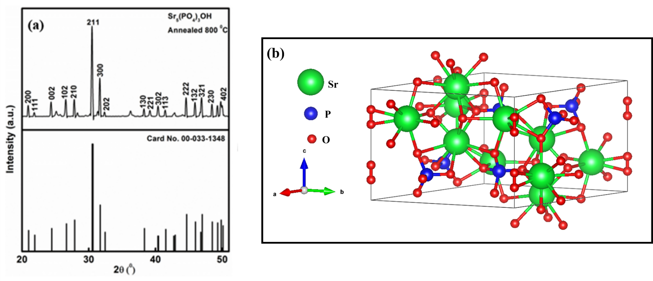
Fig. 1. (a) XRD patterns compared with the ICDD Card No. 00-033-1348; (b) Crystal structure of the Sr₅(PO₄)₃OH unit cell.

4.2 IR analysis and Particle morphology and chemical composition analysis
SEM micrographs and EDS spectra of Sr₅(PO₄)₃OH co-doped Eu³⁺/Yb³⁺ phosphor powder are shown in Figure 2 (b-e). The phosphor powders consist of a network of irregular shaped particles, with small bright particles coated on the surface of the larger particles as shown by Fig. 2 (b). The small bright particles are suspected to be the rare earths (Eu³⁺ and Yb³⁺) ions. The SEM image was taken with backscattered electron detector. The particles with heavy atoms with backscattered electron detector appear brighter, because they are stronger than light particles [9]. Fig. 2 (c) shows the elemental composition of each element in phosphor powders (Sr₅(PO₄)₃OH:Eu³⁺,Yb³⁺) confirming the presence of all the elements in the material. The inset shows the SEM image and the position where the EDS analysis was taken marked with S3 and S4. The bar graph next to it compares the weight % of each element present at the chosen positions. The weight % of rare earths elements (Eu³⁺ and Yb³⁺) in S3 are 3 and 9%, and in S4 Eu³⁺ and Yb³⁺ is 8 and 16% respectively. This confirms that small bright particles are dominated by Eu³⁺ and Yb³⁺, while darker particles are dominated by Sr, O, and Ir. The elemental mapping in Fig. 2 (d-e) shows that the elements are uniformly dispersed on the surface of the Sr₅(PO₄)₃OH:Eu³⁺,Yb³⁺ phosphor powder. The Ir (Iridium = 1.977 keV) element present in the spectra and mapping is overlapping with the electron energy of P (Phosphorus = 2.013 keV).
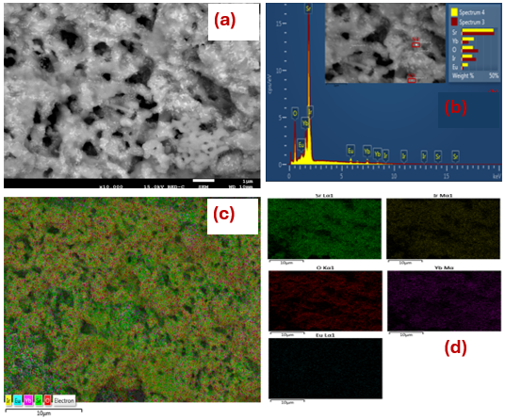
Fig. 2. (a) SEM image, (b) EDS spectrum and (c-d) EDS mapping of Sr₅(PO₄)₃OH co-doped Eu³⁺/Yb³⁺ phosphor powder.

4.4. UV-Vis spectra: optical and bandgap analysis
The UV-Vis diffuse reflectance spectra and bandgap energy (i) Sr₅(PO₄)₃OH, (ii) Sr₅(PO₄)₃OH:Yb³⁺, (iii) Sr₅(PO₄)₃OH:Eu³⁺ and (iv) Sr₅(PO₄)₃OH:Eu³⁺,Yb³⁺ phosphor powders are shown in Fig. 3 (a-b). The Sr₅(PO₄)₃OH spectrum exhibit three prominent bands at 221, 273 and 378 nm nm attributed to interband transition of host and intrinsic defects, respectively [10]. The additional band at 978 nm in Sr₅(PO₄)₃OH:Yb³⁺ spectrum is assigned to ²F_{7/2}→²F_{5/2} transition of Yb³⁺ ion [11]. Furthermore, the other bands observed in the visible region of Sr₅(PO₄)₃OH:Eu³⁺ and Sr₅(PO₄)₃OH:Eu³⁺,Yb³⁺ spectra at 391 and 458 nm are attributed to (⁷F₀→⁵L₆,⁵D₂) transitions of Eu³⁺ ion, respectively [12]. To estimate the optical energy band gap of the phosphor powders, a plot between F(R) and energy was drawn using Kubelka-Munk (KM) method [13]. By extrapolating the value of the function F(R) =0, the optical energy band gap value of the Sr₅(PO₄)₃OH, Sr₅(PO₄)₃OH:Eu³⁺, Sr₅(PO₄)₃OH:Yb³⁺ and Sr₅(PO₄)₃OH:Eu³⁺,Yb³⁺ were estimated to be 5.1, 5.1, 4.7 and 5.2 eV, respectively. The increase in bandgap (blue shift) is due to electrons filling or moving to a high energy state. The excess electrons cause an enlargement of the bandgap, and the process is known as Burstein-Moss effect [11].

Fig. 3. (a) diffuse reflectance spectra and (b) optical energy bandgap of (i) Sr₅(PO₄)₃OH, (ii) Sr₅(PO₄)₃OH:Eu³⁺, (iii) Sr₅(PO₄)₃OH:Yb³⁺ and (iv) Sr₅(PO₄)₃OH:Eu³⁺,Yb³⁺ phosphor powders.

4.5. Photoluminescence spectral analysis.
Fig. 4 (a) presents the excitation and emission spectra Sr₅(PO₄)₃OH with different concentrations of Eu³⁺ (1-7 mol%). The broad band at 245 nm is associated with the charge-transfer band (CTB), arising from the transition of a ligand O²⁻ 2p orbital to the empty states at about 4f⁶ configuration of Eu³⁺ (Eu³⁺-O²⁻ transition) [14]. The other peaks at 361, 380, 395, 412, 464 and 529 nm are due to direct excitation of the f-f transitions of Eu³⁺ ions [15]. The emission peak at 591 nm of the magnetic dipole transition ⁵D₀→⁷F₁ is generated from Eu³⁺ ions, indicating an inversion center site environment for Eu³⁺ ions which correspond to the orange light. The peaks at 613, 652, and 699 nm are corresponding to electric dipole transition (⁵D₀→⁷F_{2,3,4}) transitions of Eu³⁺, respectively [16]. The intensity increased with increasing concentrations from 1 to 3 mol % and decreased at a higher concentration due to concentration quenching effects. Upon the excitation at 980 nm, the prominent emission peaks were observed at 476 nm and 522-700 nm attributed to f-f transitions of Yb³⁺ ion and other additional peaks may be due to the precursors, respectively, as shown in Fig. 4(b). Under 980 nm excitation, the upconversion luminescence in the red region of Eu³⁺ ion from ⁵D₀→⁷F_{j (j=1,2,3,4)} were detected in Sr₅(PO₄)₃OH:Eu³⁺,Yb³⁺ phosphor powders, as shown in Fig. 4(c). The strongest emission peak is observed at 658 nm attributed to ⁵D₀→⁷F₃ transition of Eu³⁺ ion, and this is due to energy transfer from Yb³⁺ to Eu³⁺ [17]. Figure 4(d) shows the schematic diagram of energy transfer between Eu³⁺ and Yb³⁺. Through cooperative energy transfer process, Yb³⁺ act as a sensitizer for Eu³⁺. This suggest that the Eu³⁺ ions are excited due to the presence of Yb³⁺ ions. Consequently, rapid non-radiative relaxation to the metastable ⁵D₀ state can result in a cooperative energy transfer from a pair of Yb³⁺ ions to a single Eu³⁺ ion, and the red Eu³⁺ emission is observed [18]. Dipole-dipole interaction between pairs of Yb³⁺ and the state of Eu³⁺ ions facilitates the energy transfer. After being stimulated from ²F_{7/2} to ²F_{5/2}, two Yb³⁺ ions transfer all their energy to the Eu³⁺ ion's ⁵D₁ state. The Eu³⁺ ion at the ⁵D₁ level undergoes a radiative transition from the various energy states ⁵D₀ to the ground state after relaxing non-radiatively to the luminous level ⁵D₀.

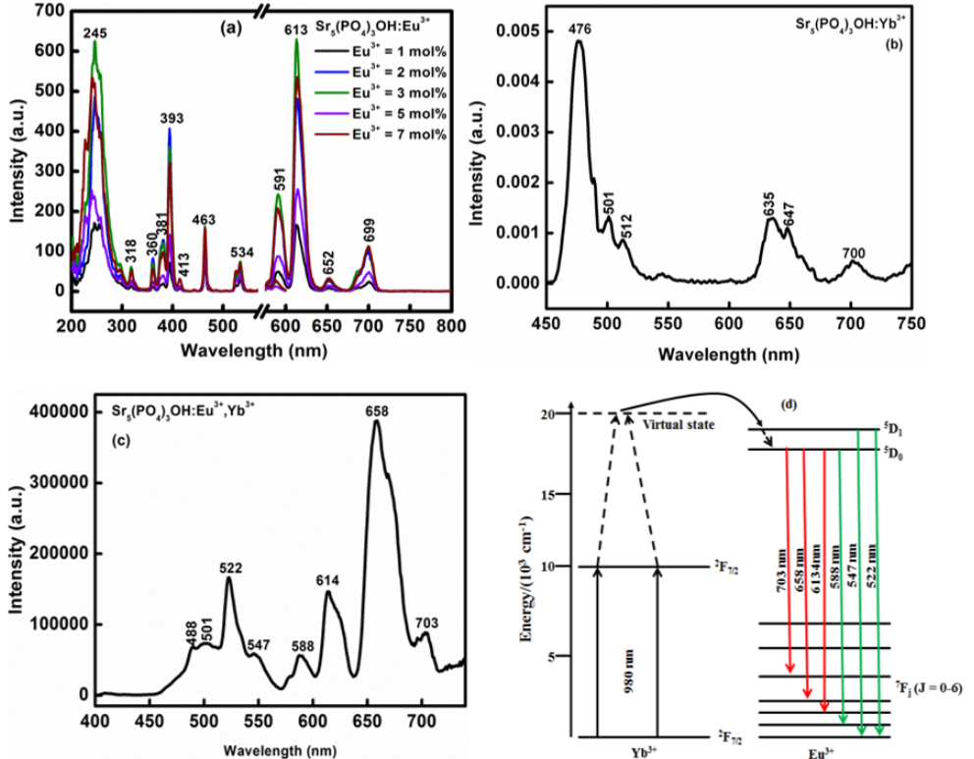
Fig. 4. PL spectral of (a) Sr₅(PO₄)₃OH:Eu³⁺, (b) Sr₅(PO₄)₃OH:Yb³⁺, (c) Sr₅(PO₄)₃OH:Eu³⁺,Yb³⁺ and (d) Energy transfer mechanism.

5. Conclusion
Sr₅(PO₄)₃OH:Eu³⁺,Yb³⁺ phosphor powders were successfully prepared using urea combustion process. The XRD characterization verified the formation of a single phase of Sr₅(PO₄)₃OH when compared to standard data cited by ICDD Card No. 00-033-1348. All of the elements contained in the samples were also confirmed by the EDS spectra. The emission peaks in the 591-699 nm region for the Sr₅(PO₄)₃OH:Eu³⁺ system were attributed to Eu³⁺ transitions. Energy transfer from Yb³⁺ to Eu³⁺ during co-doping with Yb³⁺ increased the red emission peak at 658 nm. Through the use of enhanced red emission, photosensitisers can be activated to treat malignant cells via photodynamic therapy.

6. References
[1] I. Yıldırım , D. Ç. Altındal , A. en Yılmaz, Eu³⁺ doped MB₄O₇ (M= Ca and Sr) nanoparticles for cancer treatment, Journal of Drug Delivery Science and Technology, vol. 105 , pp 106611, 2025, doi: https://doi.org/10.1016/j.jddst.2025.106611
[2] Y.J. Liu, L. Liang, R.R. Wang, J.N. Wu, J.B. Huang, G.M. Cai, J.Y. Si, Crystal structure, electronic structure and thermal stability of new phosphate Sr₂In(PO₄)(P₂O₇), Materials Research Bulletin, vol. 177, pp 112844, 2024, doi https://doi.org/10.1016/j.materresbull.2024.112844
[3] P. Ivanchenko, G. Escolano-Casado, L. Mino, L. Dassi, J. F. Fernandez-Sanchez, G. Martra , J. Gomez-Morales, Structural and surface studies of luminescent Ca/Eu phosphate nanomaterials: From the bulk to surface features, vol. 217, pp 112620, 2022, doi https://doi.org/10.1016/j.colsurfb.2022.112620
[4] M. Eagambaram, K. S. Mani, S. Sahoo, Cobalt intercalated strontium phosphate for cost-effective high-performance supercapacitors, Journal of Energy Storage, vol. 119, pp 116312, 2025, doi https://doi.org/10.1016/j.est.2025.116312
[5] Y. Chen, S.W. Xi, C. Tong, H. hu Tan, L. Xu, N. Li, J.X. Xu, Preparation of NaYF₄:Yb³⁺,Tm³⁺@NaGdF₄:Ce³⁺,Eu³⁺ double-jacket microtubes for dual-mode fluorescent anti-counterfeiting, Transactions of Nonferrous Metals Society of China, vol. 30, pp 3333-3346, 2020 DOI: 10.1016/S1003-6326(20)65465-6
[6] Hsiu-Wen Chiena, Chien-Hsin Yang, Min-Ting Tsai, Tzong-Liu Wang, Photoswitchable spiropyran-capped hybrid nanoparticles based on UVemissive and dual-emissive upconverting nanocrystals for bioimaging, Journal of Photochemistry & Photobiology A: Chemistry, vol. 392, pp 112303, 2020, doi: https://doi.org/10.1016/j.jphotochem.2019.112303
[7] P.A. Loiko, G.E. Rachkovskaya,G.B. Zakharevich, A.A. Kornienko, E.B. Dunina, A.S. Yasukevich, K.V. Yumashev, Cooperative up-conversion in Eu³ ⁺,Yb³ ⁺-doped SiO₂–PbO–PbF₂–CdF₂ oxyfluoride glass, Journal of Non-Crystalline Solids, vol. 392-393, pp 39, 2014, doi; https://doi.org/10.1016/j.jnoncrysol.2014.04.004
[8] Katarzyna Szyszka, Marta Kardach, Damian Szymanski, Rafal J. Wiglusz, Synthesis, characterization, and temperature-dependent luminescence of Tb3+-activated and self-activated Sr10(PO4)6Cl2 phosphors, Journal of Luminescence, vol. 275, pp 120788, doi: https://doi.org/10.1016/j.jlumin.2024.120788
[9] P.P. Mokoena, M. Gohain, B.C.B Bezuidenhoudt, H.C. Swart, O.M. Ntwaeaborwa, Luminescent properties and particle morphology of Ca₃(PO₄)₂:Gd³⁺, Pr³⁺ phosphor powder prepared by microwave assisted synthesis, Journal of Luminescence, vol.155, pp 288-292, 2014, doi: https://doi.org/10.1016/j.jlumin.2014.06.058
[10] P.P. Mokoena, I.M. Nagpure, V. Kumar, R.E. Kroon, E.J. Olivier, J.H. Neethling, H.C.Swart, O.M. Ntwaeaborwa, Enhanced UVB emission and analysis of chemical states of Ca 5(PO4)3OH:Gd3+,Pr3+ phosphor prepared by co-precipitation, Journal of Physics and Chemistry of Solids, vol. 75, pp 998-1003, 2014, doi: https://doi.org/10.1016/j.jpcs.2014.04.015
[11] Z. Huang, M. Yi, H. Gao, Z. Zhang, Y.Mao, Enhancing single red band upconversion luminescence of KMnF₃:Yb³⁺/Er³⁺ nanocrystals by Mg²⁺ doping, Journal of Alloys and Compounds, vol. 694, pp. 241-245, 2017, doi: https://doi.org/10.1016/j.jallcom.2016.09.322
[12] J. Chen, W. Zhao, J. Wang, N. Wang, Y. Meng, J. He, X. Zhang, Energy transfer and thermal stability of K₂Ba(WO₄)₂: Eu³⁺, Sm³⁺ phosphors, Ceramics International, vol. 41, pp 11945-11952, 2015, doi: https://doi.org/10.1016/j.ceramint.2015.06.006
[13] Anindya Pala, Purnendu Naskera, Sudeep Paula, Amit Roy Chowdhury, Arijit Sinhaa, Mitun Das, Strontium doped hydroxyapatite from Mercenaria clam shells: Synthesis, mechanical and bioactivity study, Journal of the Mechanical Behavior of Biomedical Materials, vol. 90, pp 328, 2019, https://doi.org/10.1016/j.jmbbm.2018.10.027
[14] C. Shivakumara, R. Saraf, S. Behera, N. Dhananjaya, H. Nagabhushana, Synthesis of Eu³⁺-activated BaMoO₄ phosphors and their Judd–Ofelt analysis: Applications in lasers and white LEDs, Spectrochimica Acta Part A: Molecular and Biomolecular Spectroscopy, vol. 151, pp 141, 2015, doi: https://doi.org/10.1016/j.saa.2015.06.045
[15] V. Naresh, K. Gupta, C.P. Reddy, B.S. Ham, Energy transfer and colour tunability in UV light induced Tm³ ⁺/Tb³ ⁺/Eu³ ⁺: ZnB glasses generating white light emission, Spectrochimica Acta Part A: Molecular and Biomolecular Spectroscopy, vol. 175, pp 43, 2017, doi: https://doi.org/10.1016/j.saa.2016.12.023
[16] El Mahdi Bouabdalli, Mohamed El Jouad, Samira Touhtouh, Nathalie Gaumer, El Kebir Hlil, Abdelowahed Hajjaji, The effect of europium on structural properties, photoluminescence behavior, and Judd-Ofelt analysis in strontium phosphate glasses for photonic applications, Radiation Physics and Chemistry, vol. 226, pp 112238, 2025, doi: https://doi.org/10.1016/j.radphyschem.2024.112238
[17] H. Rahimian, H. Mokhtari, S.P. Shirmardi, Improvement of Eu3+ emissions in oxyfluoride glass and nano glass-ceramic by electron beam irradiation, Journal of Luminescence, vol. 187, pp 535, 2017, doi: https://doi.org/10.1016/j.jlumin.2017.03.025
[18] H. Xia, J. Feng, Y. Ji, Y. Sun, Y. Wang, Z. Jia, C. Tu, 2.7 μm emission properties of Er³⁺/Yb³⁺/Eu³⁺: SrGdGa₃O₇ and Er³⁺/Yb³⁺/Ho³⁺: SrGdGa₃O₇ crystals, Journal of Quantitative Spectroscopy & Radiative Transfer, vol. 173, pp 7, 2016, doi: https://doi.org/10.1016/j.jqsrt.2015.12.018

