Reimagining Curriculum Renewal: A case study of Physics and Astronomy
Audu B.N.¹, Herbert M¹, Conana C.² Marshall D.¹, Sabata S.³ Holgate D.², Dube A.², Volkwyn T.¹ and Zwane M.³
¹Department of Physics and Astronomy, UWC, Cape Town, South Africa
²Faculty of Natural Sciences, UWC, Cape Town, South Africa
³Academic Planning Unit, UWC, Cape Town, South Africa
E-mail: baudu@uwc.ac.za
Abstract. This study provides an introduction to the University of the Western Cape case study on curriculum renewal. It explores different conceptions of curriculum and curriculum renewal. It offers a critique of existing thinking about curriculum renewal as something that occurs within refined phases within the education system, where the thinking often sees curriculum renewal as occurring through linear and hierarchical chains of command from policy to practice. Drawing upon previous conceptualizations of curriculum renewal at the Faculty of Natural Sciences of the University of the Western cape, this study explores a bottom-up approach to curriculum renewal. A rather non-linear process, framed around the concept of intertwined phases of engagements within the higher education system and national imperatives, noting that disciplinary actors, social actors and organizational bodies envision curriculum in different ways for different historical, political, sociocultural and economic reasons. The study contradicts widespread perceptions of the curriculum as a text designed by government official authorities to be implemented in the institutions. It illustrates how the physics and astronomy curriculum renewal involves dynamic processes of interpretation, mediation, negotiation and institutional quality assurance processes across multiple departments and interconnected discipline-applicable arrangements.

Introduction
The preparation of physics and astronomy graduates for a rapidly evolving global and local landscape has become a critical concern in higher education, particularly in contexts marked by scientific advancement and socio-economic transformation [14]. In South Africa, the South African Institute of Physics (SAIP) Benchmark Statement emerged to address concerns about graduate quality by promoting standardized content knowledge and skills across institutions [15]. However, its flexible implementation has raised questions about its effectiveness, especially as universities like the University of the Western Cape (UWC) navigate tensions between national standards and local priorities [1].
UWC, a historically disadvantaged institution with a strong physics and astronomy department, is deeply connected to transformative research initiatives like the Square Kilometre Array (SKA) and committed to educational redress. This study examines how UWC is engaging in curriculum renewal through a faculty-wide "Degree Renewal Project," leveraging the SAIP framework while addressing institutional limitations. Traditional curriculum models—linear and hierarchical [17] —often fail to meet the holistic needs of contemporary education, prompting a shift toward dynamic, non-linear models that emphasize stakeholder collaboration and contextual responsiveness [2,16].

Curriculum Renewal Frameworks
Curriculum can be conceptualized as the structure and content of a programme of study that integrates various components aligned with disciplinary knowledge and learning goals. Ratcliff views it as the coherent core of a discipline [12], while Fraser and Bosanquet emphasize the importance of programme structure, content, and sequencing [7]. As Cornbleth argues, "How we conceive of curriculum and curriculum making is important because our conceptions... shape how we see, think and talk about, study and act on the education made available to our students" [5].
Linear models like those of Tyler and Taba prioritize content over adaptability [17], which does not align with the fast-evolving nature of physics and astronomy [9]. Non-linear, outcome-driven models such as Barnett and Coate's "spaces of engagement" [2] and Wiggins and McTighe’s backward design [19] offer more flexible alternatives. Institutions like Surrey map skills systematically; UWC, by contrast, requires a hybrid approach that balances structure with adaptability. This study builds on these frameworks and Audu and Marshall’s emphasis on graduate attribute mapping to propose a tailored renewal strategy [1].

Statement of the Problem
Two key challenges drive curriculum renewal at UWC. First, the Senate Academic Planning (SAP) committee identified rigidity in the current BSc structure as a barrier to interdisciplinary exploration. The UWC Curriculum Transformation and Renewal Policy calls for more flexible frameworks. This rigidity restricts student mobility (e.g., between physical sciences and mathematics), often leading to extended study durations or blocked pathways due to prerequisites, limiting interdisciplinarity. Second, there is a strategic push to produce graduates responsive to the Fourth Industrial Revolution (4IR) and capable of addressing global challenges such as climate change and inequality. This policy emphasizes fostering adaptability, critical citizenship, and technological fluency.

Aim and Objectives
To investigate how UWC’s Faculty of Natural Sciences is navigating national and institutional frameworks to renew its BSc curriculum in alignment with transformation, inclusivity, and academic excellence. The study explores implications for producing interdisciplinary, inclusive, and future-ready graduates in physics and astronomy.
Research question
i, What institutional factors are shaping curriculum renewal in physics and astronomy at UWC?

2. Literature Review and Theoretical framework
The proposed theoretical framework integrates Barnett and Coate’s (2005) Curriculum Engagement Framework, Taba’s (1962) Curriculum Development Model, Slattery’s (2006) Postmodern Curriculum Theory, and Le Grange’s (2016) Decolonizing Curriculum Framework in the context of the Transformation agenda of the university. The adopted integration features, as the working theoretical framework are;:
Barnett and Coate's Curriculum Engagement Framework [2]:
Feature: Knowing: Disciplinary depth (e.g., quantum mechanics); Acting: Practical applications (e.g., experiments); Being: Developing scientific identity
This relates to a deep disciplinary knowledge (e.g., physics and astronomy), practical application of knowledge through skills and practices and the development of students’ identities as critical, reflective learners capable of navigating uncertainty and complexity in their disciplines
Taba's Curriculum Development Model [17]:
Featurs: Student-centered, inquiry-driven design; Iterative evaluation and revision
This model ensures that curriculum renewal is grounded in students’ needs, such as addressing common misconceptions and continuously evaluating and refining the curriculum to incorporate new scientific discoveries or pedagogical approaches.
Slattery's Postmodern Curriculum Theory [16]:
Feature: Holistic and interdisciplinary learning; Critical and contextual reflection
Slattery’s theory supports incorporating interdisciplinary connections (e.g., linking physics to philosophy, modern scientific knowledge and applications) and encouraging students to critically reflect on the cultural and historical development of scientific knowledge.

Le Grange's Decolonizing Framework [8]:
Feature: Challenges Eurocentrism; Integrates indigenous knowledge; Promotes equity and inclusion
This framework encourages integrating indigenous and environmental knowledge and local scientific contributions (e.g., South Africa’s Square Kilometre Array) to make the curriculum more inclusive and contextually relevant.

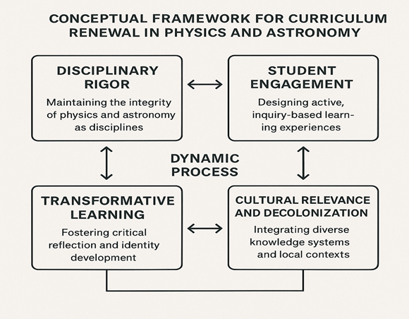

reserved for figure
Figure 1: Conceptual framework for the integration of Barnett and Coate’s Triad (Knowing, Acting, Being) with Taba’s Systematic Process, Slattery’s Postmodern perspective, and Le Grange’s Decolonizing lens for curriculum renewal.
Priestley and Philippou [11] conceptualize curriculum making as a social practice, emphasizing the complex, multi-layered interactions between teachers, materials, and contexts in enacting curricula. In the context of physics and astronomy curriculum renewal, this model offers a powerful framework for moving beyond top-down, prescriptive approaches to curriculum reform, which often prioritize standardized content delivery over contextual relevance and expertise. describe curriculum making as a dynamic process involving “multi-layered social practices, including infrastructure, pedagogy, and assessment, through which education is structured, enacted, and evaluated” (p. 152).
The non-linear aspect of Figure 1 is evident as the intended and enacted curricula interact dynamically, with feedback loops (shown by the arrows) between the two processes. The UWC Degree Renewal Project acts as the central hub, facilitating a continuous, iterative exchange where insights from both inquiry/development and inclusivity shape and refine the curriculum. This allows for ongoing adaptation and alignment with both academic standards and social justice goals, rather than a one-directional progression

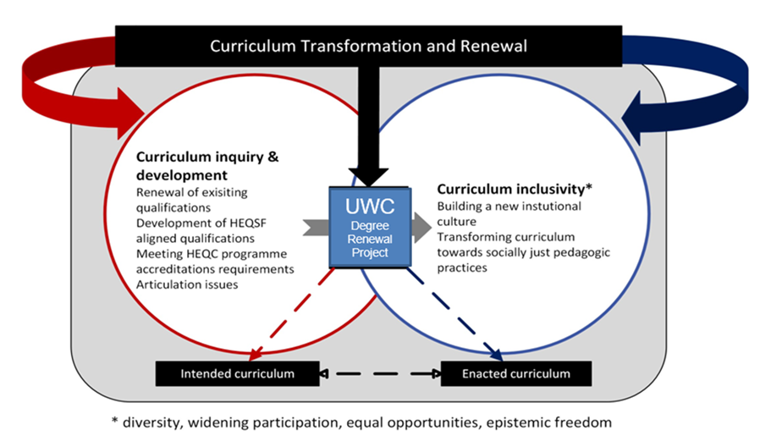
Figure 2: Curriculum transformative framework for UWC (UWC Degree Renewal Project).
Figures 1 and 2 (above) illustrate the frameworks and how these are integrated within UWC's Degree Renewal Project to support iterative, responsive, and inclusive curriculum design.

3. Institutional factors shaping curriculum renewal: Role of academic leadership
The Working Group and the Department of Physics and Astronomy along with the stakeholders conceptualize curriculum making as a social practice, multi-layered interactions between all stakeholders, materials, and contexts in enacting curricula. This bottom-up, social practice model provides a robust context for reimagining curriculum renewal in physics and astronomy. By embracing a bottom-up approach, leaders provided the stakeholders and the project – agency to work towards curricula that is inter-disciplinary and discipline grounded, and adapt to diverse student needs, and that reflect the dynamic nature of physics and astronomy and scientist of the 21st century. Academic leadership in the context of physics and astronomy curriculum renewal involves guiding faculty toward a forward-thinking vision that prepares students for the complexities of 21st-century science while addressing local and global challenges. This model underscores the importance of leadership in facilitating social practices that enable the department to develop, interpret and enact curricula in contextually relevant ways. Values, such as adaptability, inclusivity, and innovation, are critical in physics and astronomy, where rapid advancements (e.g., gravitational wave detection, exoplanet discoveries) and interdisciplinary connections (e.g., with data science or environmental science) demand curricula that are dynamic and responsive [6]. UWC's academic leadership fosters a collaborative, bottom-up approach.

3.1 Operationalization of the BSc curriculum renewal process
- Interdisciplinary Collaboration: Double-major pathways (e.g., physics and data science)
- Graduate Attribute Alignment: Embeds critical thinking, social justice, and scientific skills [1, 3]
- Curriculum Innovation: Introduces emerging fields in physics and astronomy [6, 13]
- Change-Supportive Culture: Committees and partnerships with institutions (e.g., iThemba Labs) support innovation and sustainability [18]
- Design a flagship module, "Science-In-Focus,": integrates academic literacy, computational skills, and career readiness across three years.
The Working Group acknowledge this process for ensuring that the physics and astronomy curriculum reinforces UWC’s graduate attributes, which include critical thinking, social responsibility, global citizenship, and adaptability, as well as disciplinary attributes specific to physics and astronomy, such as problem-solving, mathematical proficiency, and scientific inquiry [1]. For instance, to foster critical thinking, the curriculum encourage the design of inquiry-based modules, and to address social responsibility.

3.2 Discipline Content, Practices, and Engagements: At the heart of the ‘Reimagining Curriculum Renewal’ is the incorporation of innovative discipline content, practices, and engagements, such as flexible electives, to keep the physics and astronomy curriculum relevant to contemporary scientific advancements. Author’s such as Priestley and Drew [10] argue that innovative curriculum design involves creating opportunities for students to engage with cutting-edge content and practices that reflect the evolving nature of the discipline. In physics and astronomy, this mean introducing electives on emerging fields like quantum computing, gravitational wave astronomy, or astrochemistry, which allow students to explore specialized topics while developing transferable skills [6] and to engage with authentic scientific processes [13] such as radio astronomy or quantum computing. Prioritizing innovation ensure that the curriculum remains forward-looking and aligned with the demands of the global scientific landscape.
3.3 Entrenching a Change-Supportive Culture: ‘Reimagining Curriculum Renewal’ in physics and astronomy means developing and sustaining a change-supportive culture that is critical for the long-term success of curriculum renewal in physics and astronomy. This effort will set the path and prepare UWC physics and Astronomy graduates to excel while contributing to South Africa’s scientific, economic and social development.
4. Reimagined curriculum renewal recommendations
- The requirement for academics and stakeholders to adopt a visionary, collaborative, and inclusive approach with the creation of a curricula that reflect the interconnected nature of modern science.
- The reinforces UWC’s graduate and disciplinary attributes to ensures that students develop both technical expertise and social and environmental awareness.
- The incorporation of flexible electives to keep the curriculum relevant and engaging.
- Entrenching a change-supportive culture empowers departments and the faculty to take ownership of the renewal process, fostering a dynamic and adaptive BSc program for Physics and Astronomy.
- A module that combine’s foundational modules for English/academic literacy, computer literacy, computational skills, financial skills and career advice into a “Science-In-Focus” module to support scientific skill development across the entire degree. This module will develop and build in our graduates, the 21st century skills such as computational fluency, collaboration and teamwork, communication and other essential skills from year one to year 3 of study, enabling students to graduate as future-ready scientists.

4.1 Implications of reimagined curriculum renewal
- Encourages visionary, inclusive curriculum development
- Incorporates flexible electives to remain relevant
- Supports departmental ownership and long-term innovation
- Aligns curriculum with graduate attributes for socially engaged science

5. Conclusion
Reimagining UWC's physics and astronomy curriculum involves a shift from static, prescriptive models to dynamic, collaborative frameworks. A non-linear, inclusive, bottom-up approach engages stakeholders at all levels and aligns with both disciplinary imperatives and institutional transformation goals. These efforts will ensure UWC produces scientifically proficient, socially conscious, and globally competitive graduates.

References
[1] B.N. Audu and D. Marshall, “The South African Institute of Physics (SAIP) Benchmark Statement and physics graduate preparedness: A case study of the University of the Western Cape”. SAIP2021 Proceedings. page 484 - 489
[2] R. Barnett and K. Coate, Engaging the Curriculum in Higher Education. McGraw-Hill Education, 2005.
[3] L. Bencze and D. Hodson, "Towards a socially responsible science education," in Science and Technology Education Promoting Wellbeing, L. Bencze, Ed. Springer, 2017, pp. 11–30.
[4] Council on Higher Education and South African Institute of Physics, Review of Undergraduate Physics Education in Public Higher Education Institutions. CHE, 2013.
[5] C. Cornbleth, Curriculum in Context. Falmer Press, 1990.
[6] R. Duit, H. Gropengießer, U. Kattmann, M. Komorek, and I. Parchmann, "The model of educational reconstruction," in Making Learning Visible, Springer, 2010, pp. 13–37.
[7] S. P. Fraser and A. M. Bosanquet, "The curriculum? That’s just a unit outline, isn’t it?," Stud. High. Educ., vol. 32, no. 1, pp. 89–104, 2007.
[8] L. Le Grange, "Decolonising the university curriculum," S. Afr. J. High. Educ., vol. 30, no. 2, pp. 1–12, 2016.
[9] J. Osborne and J. Dillon, Science Education in Europe: Critical Reflections. Nuffield Foundation, 2008.
[10] M. Priestley and V. Drew, "Professional enquiry: An ecological approach," in SAGE Handbook of Curriculum, Pedagogy and Assessment, SAGE, 2016, pp. 96–112.
[11] M. Priestley and S. Philippou, "Curriculum making as social practice," in Curriculum Making in Europe, Emerald, 2018, pp. 151–169.
[12] J. L. Ratcliff, "What is curriculum and why do we need one?," in Handbook of the Undergraduate Curriculum, Jossey-Bass, 1997, pp. 5–29.
[13] T. D. Sadler, J. A. Foulk, and P. J. Friedrichsen, "Evolution of a model for socioscientific issue teaching," Int. J. Educ. Math. Sci. Technol., vol. 4, no. 2, pp. 75–87, 2016.
[14] South African Institute of Physics, Strategic Plan for the Transformation of Physics Education in South Africa, SAIP, 2004.
[15] South African Institute of Physics, Benchmark Statement for Undergraduate Physics Programmes, SAIP, 2015.
[16] P. Slattery, Curriculum Development in the Postmodern Era, 2nd ed., Routledge, 2006.
[17] H. Taba, Curriculum Development: Theory and Practice. Harcourt, Brace & World, 1962.
[18] C. Wieman, K. Perkins, and S. Gilbert, "Transforming science education," Change, vol. 40, no. 6, pp. 30–35, 2008.
[19] G. Wiggins and J. McTighe, Understanding by Design, 2nd ed., ASCD, 2005.

